1. Introduction to MVC Pattern
   1. Why MVC
   2. 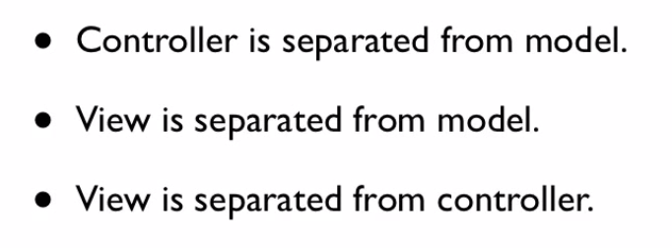
   3. 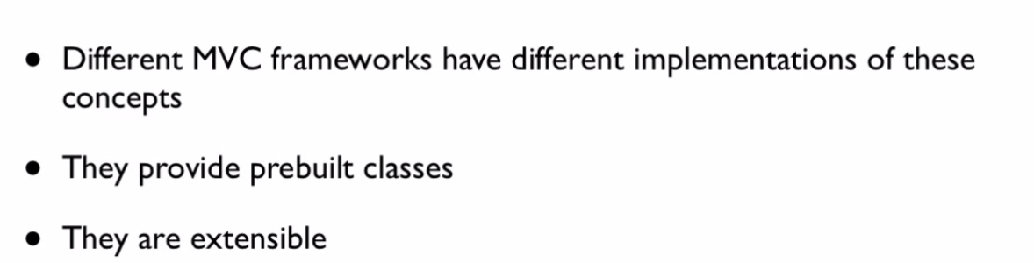
   4. 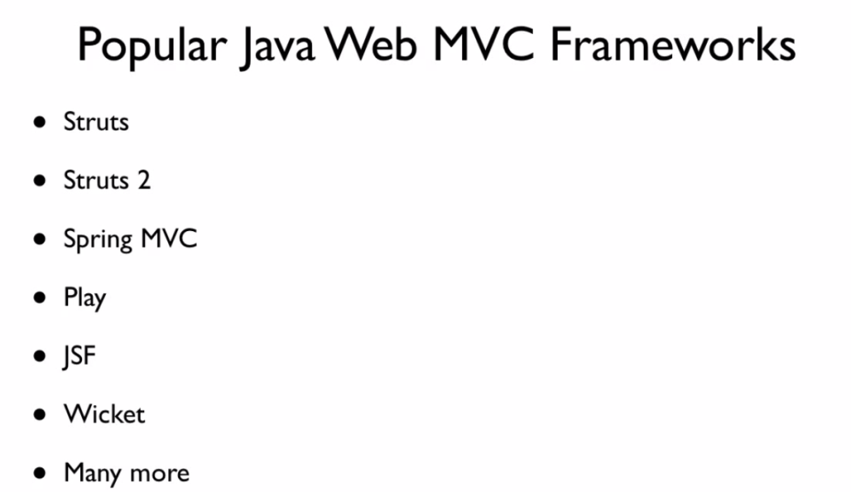
2. Introduction to Struts 2
   1. Framework Vs Pattern
   2. 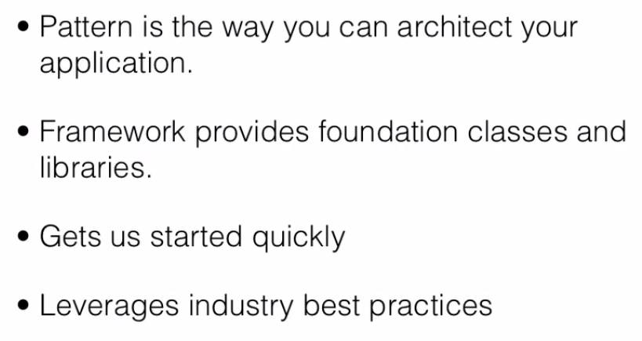
   3. How to build ur own MVC Pattern
   4. 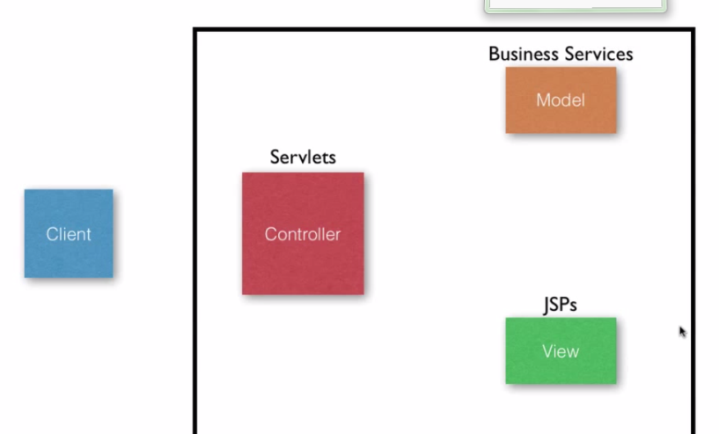
   5. 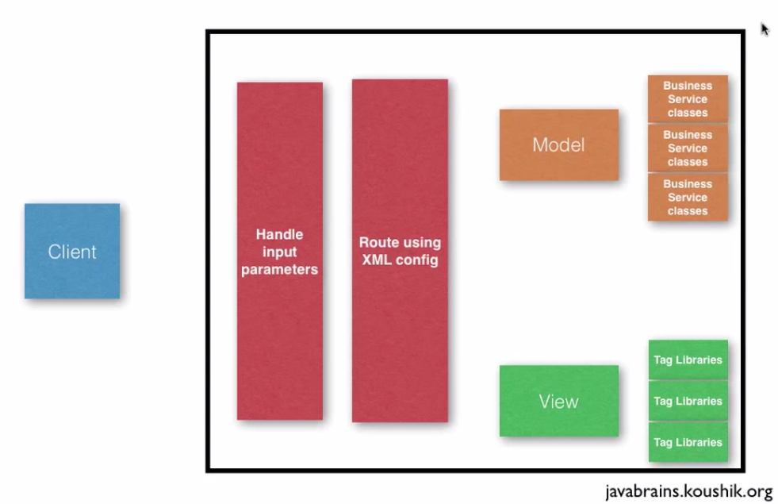
   6. 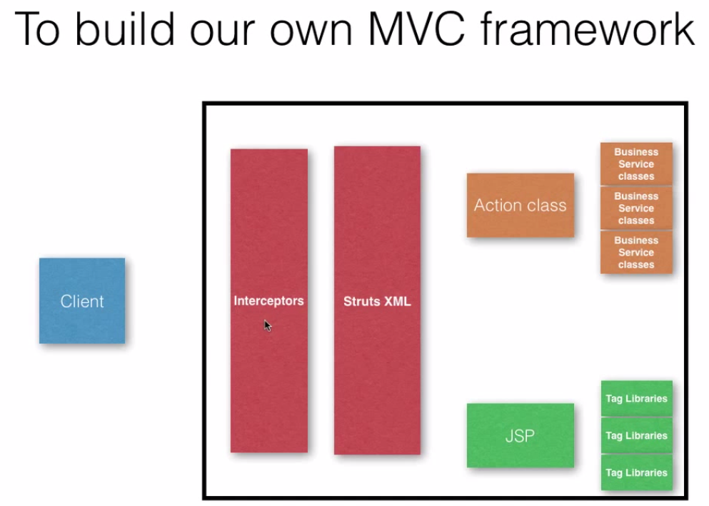
   7. About Struts 2
   8. 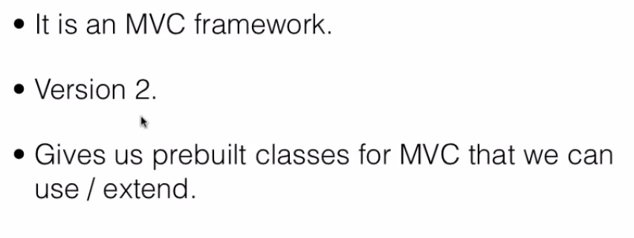
3. Environment setup(Download struts jar files)

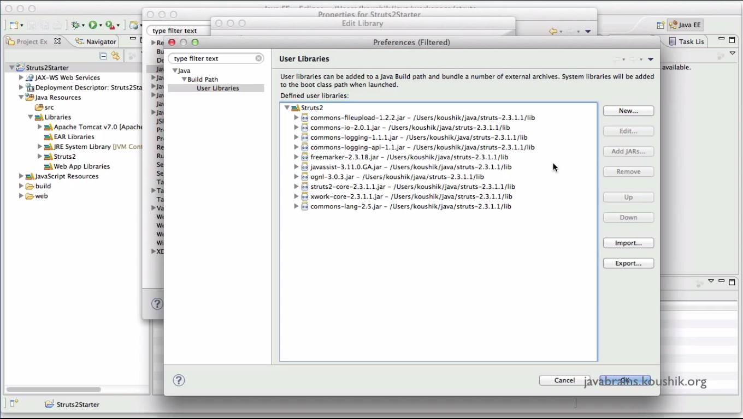

1. Writing Application
   1. Struts XML, Action Class and JSP.
   2. 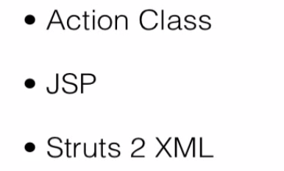
   3. Struts XML Configuration
      1. URL and its action class is mapped in the XML.
      2. Whenever a URL is entered the execute() method of the mapped class will gets executed.
      3. 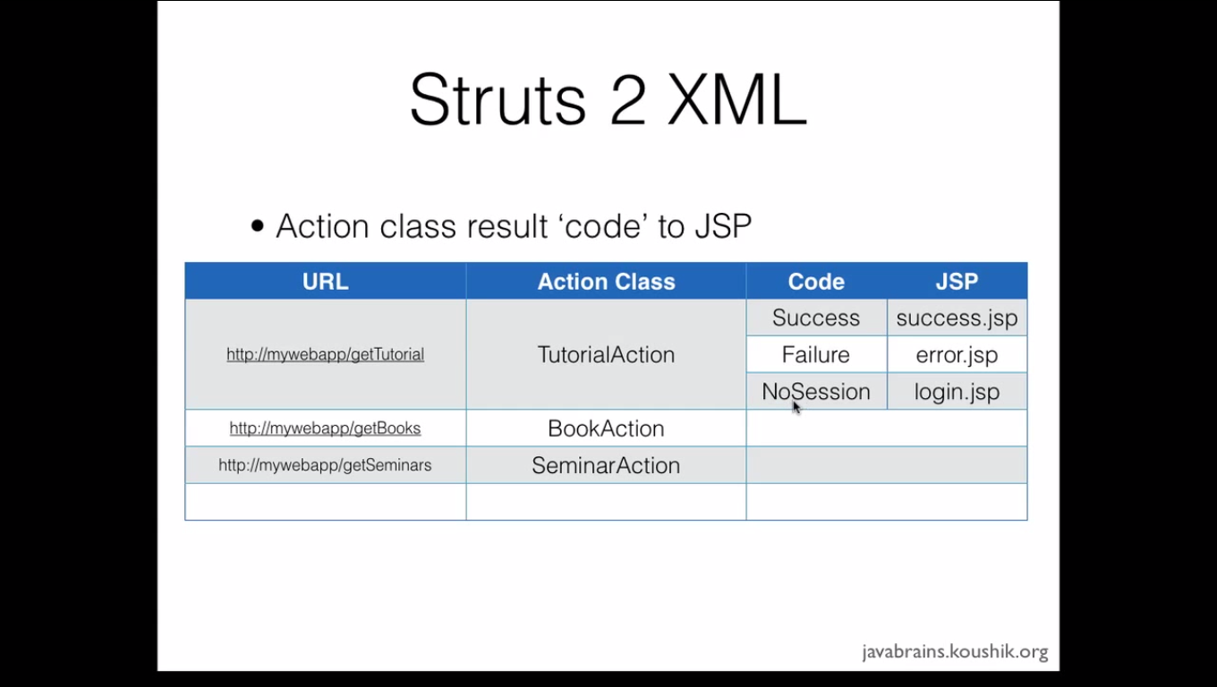
      4. 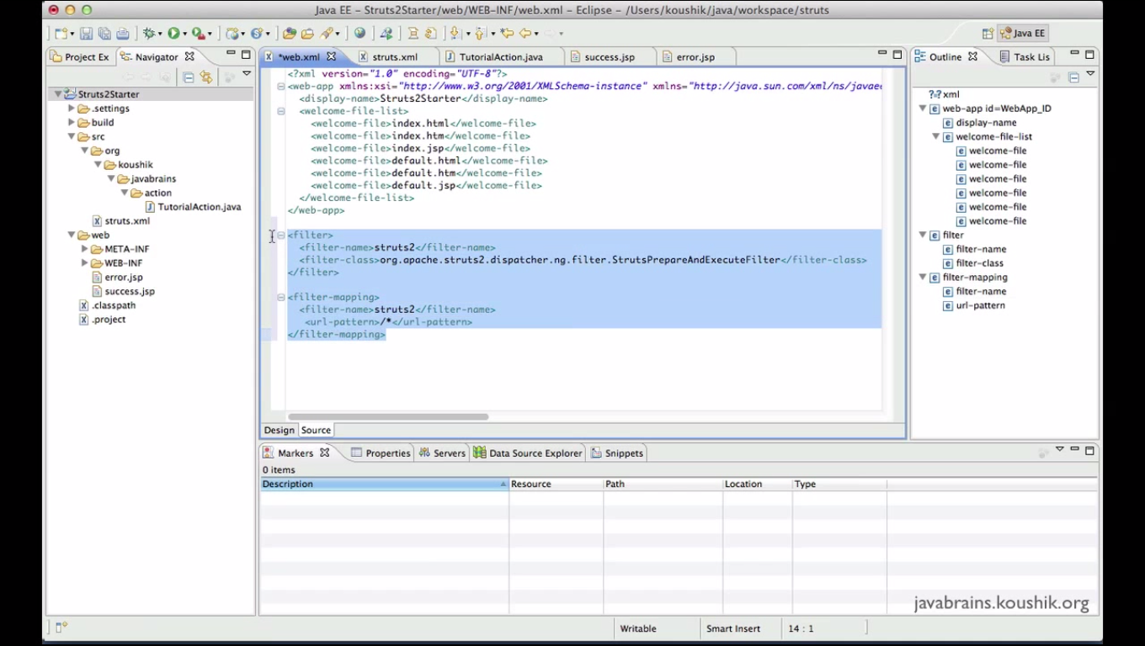
      5. The filter and Filter-Mapping tag in Web.xml will redirect all the URL to look the struts.xml in the Application. So it need to be compulsorily placed in the web.xml.
      6. 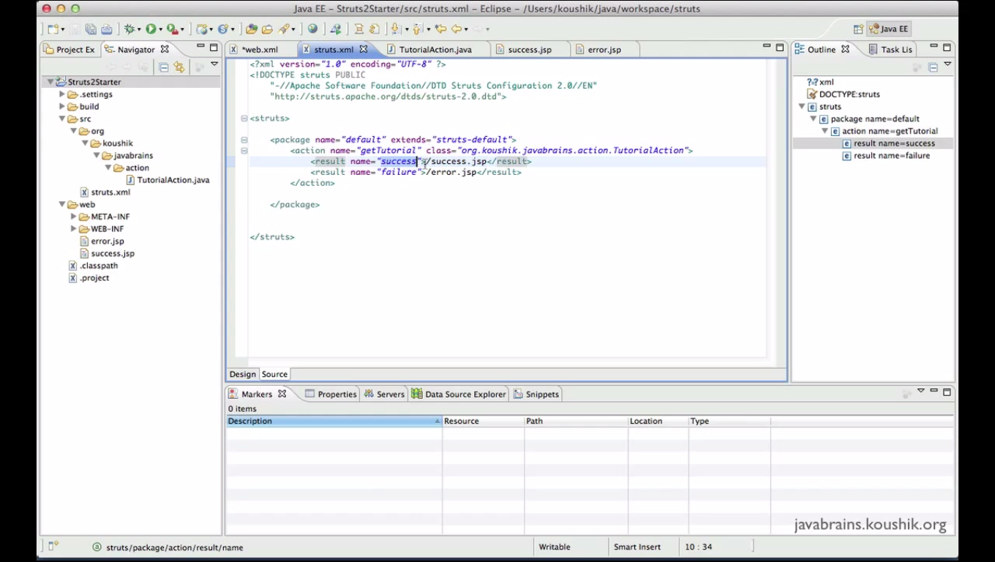
      7. Once the control is passed from web.xml to struts.xml, it looks for URL and go to the execute() method of the class mapped for that URL.
      8. From the return string from the execute() method, the controls move to the concordant JSP File mapped in the above XML.
2. Understanding Namespace
   1. Namespace Attribute can be added along with Package tag to specify the URL Namespace
   2. 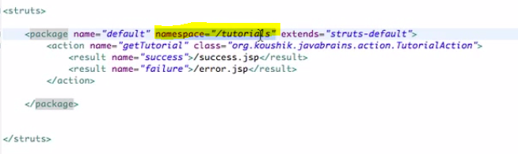
   3. 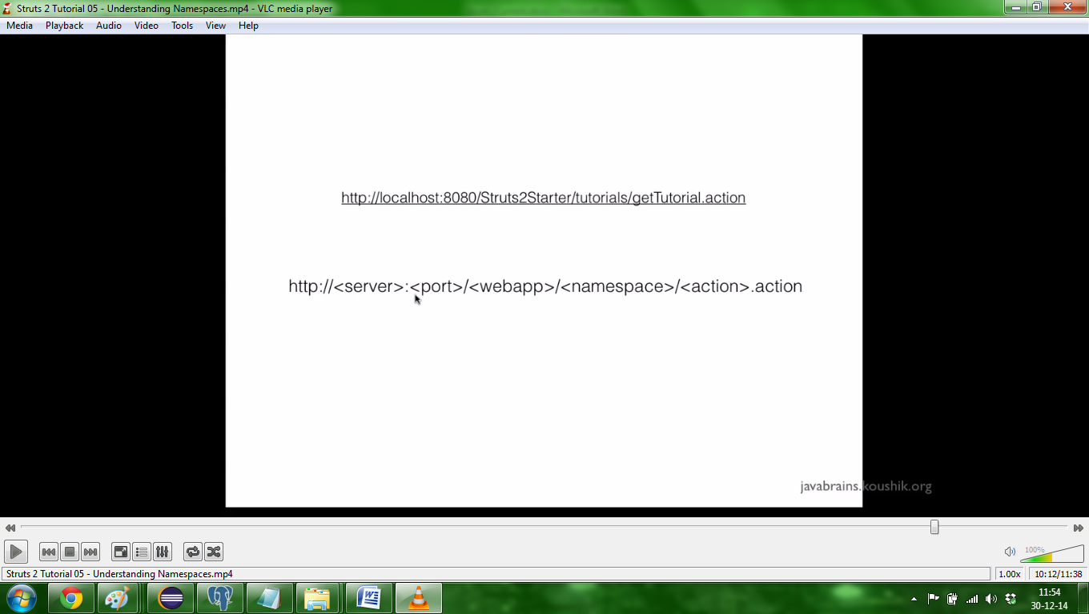
3. Tag and a business library
   1. <%@ taglib prefix ="s" uri="/struts-tag" %>
   2. The above tag the library for all struts classes. it needs to be added in all jsp.
   3. 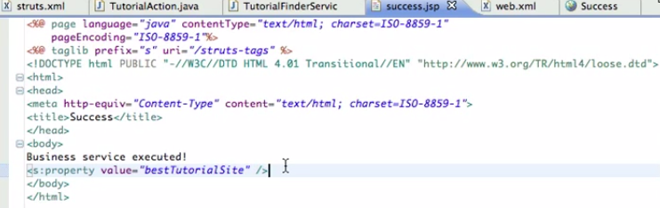
   4. 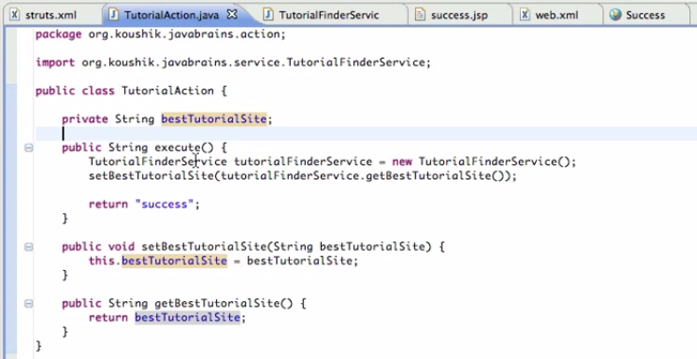
4. The value stack
   1. 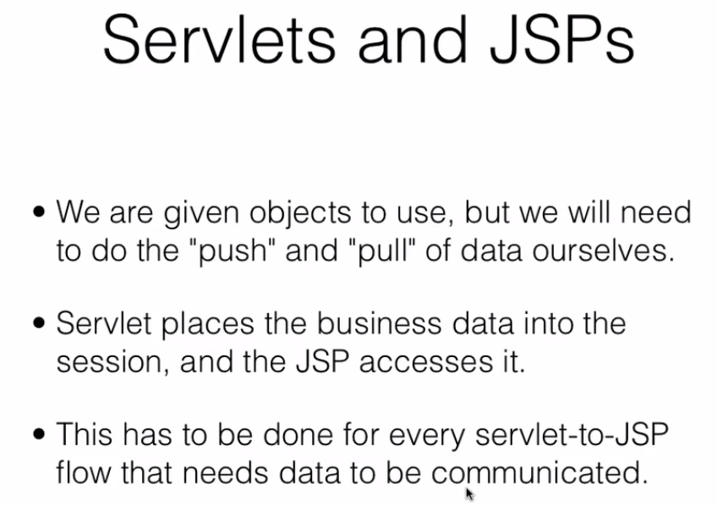
   2. the value stack is the place where the Struts 2 will store the objects and the member variable of different request
   3. 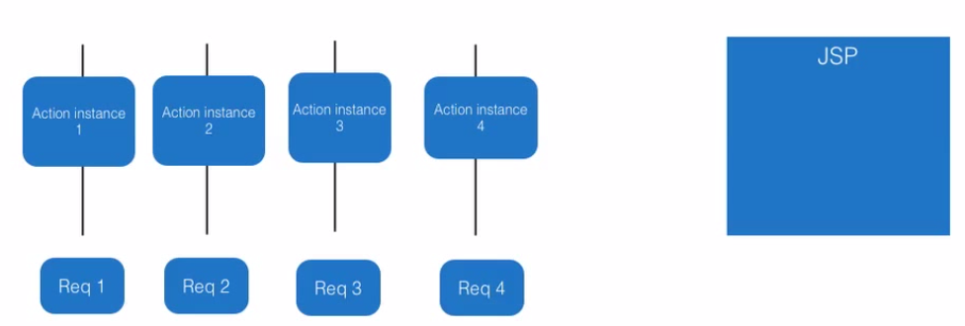
   4. 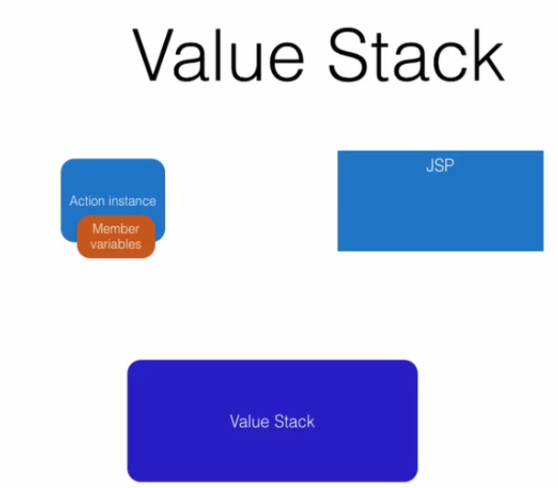
   5. 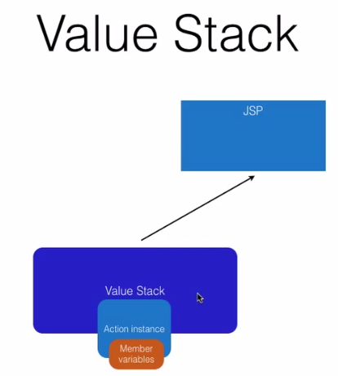
5. Accessing input parameter
   1. 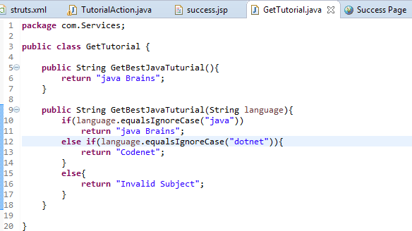
   2. 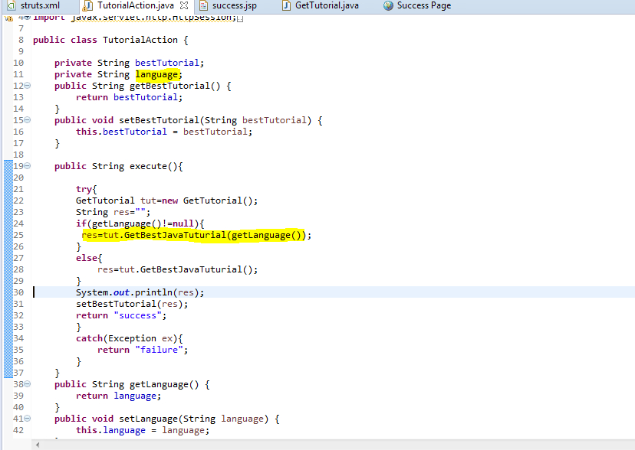
   3. 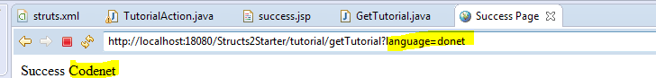
   4. Interceptors will automatically set the parameter to the value of matching variable in class and set the value to it
6. Post request to action
   1. 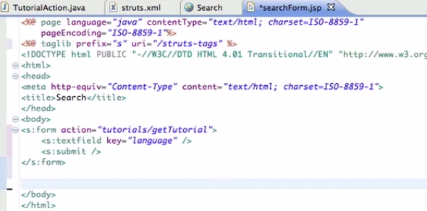
7. Login action and best Practices
   1. Sample login page and configuration**(TO BE DONE)**
   2. 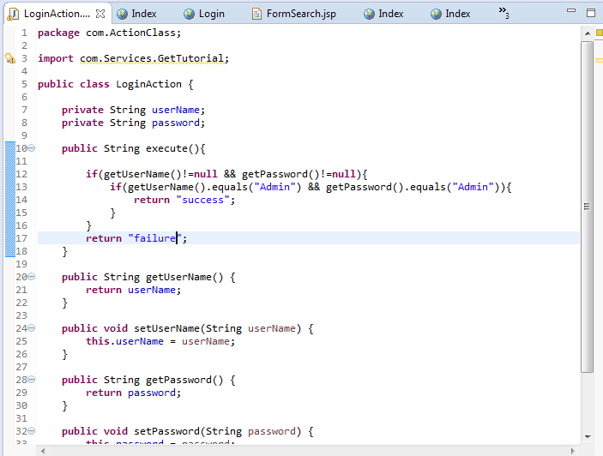
   3. 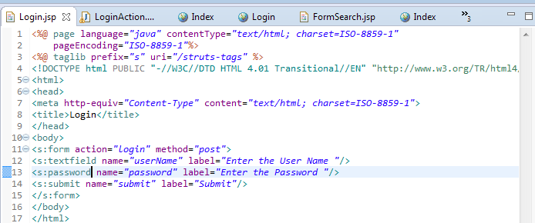
   4. 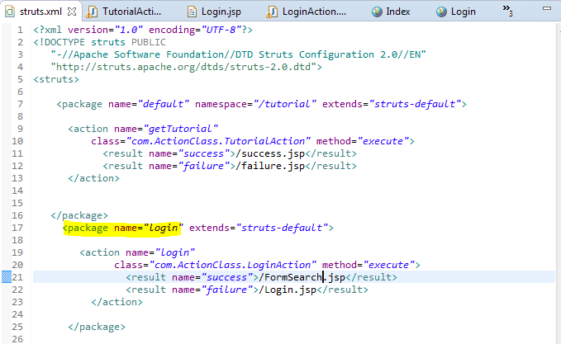
8. Login action and best Practices (Part 2)
   1. Implementing “Action” which contains key words for SUCCESS, NONE, ERROR, INPUT and LOGIN.
   2. 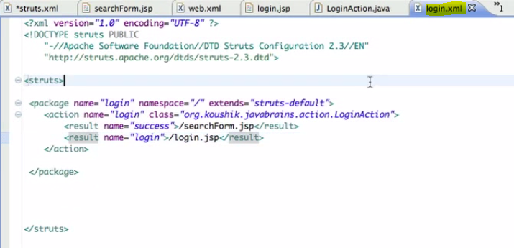
   3. 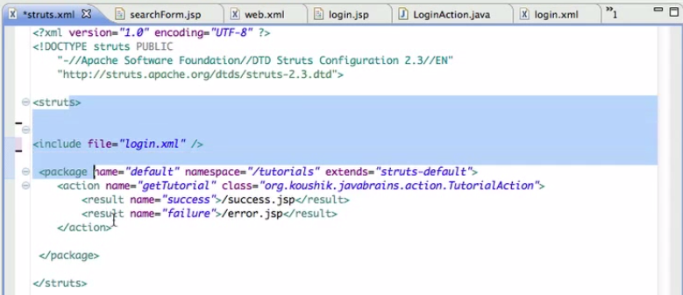
   4. We can configure the separate xml for the some action and add it in “struts.xml” using **“<include file=”Filename.xml”></include>** ”
   5. Use dummy action in struts.xml to redirect the action becz if any file change will not affect the URL and configuration in client’s system.
   6. 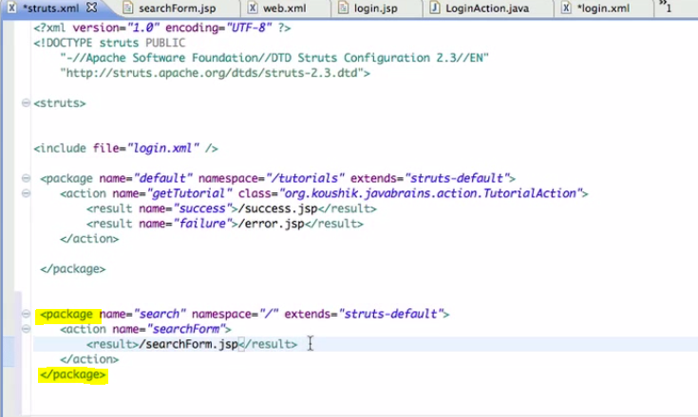
9. Wildcards
   1. 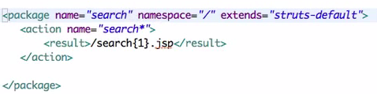
10. Action Support class.
    1. Struts 2 Actions
       1. Simple POGO Class
       2. Action Interface
       3. Action Support Interface
    2. Methods in action support method
       1. Validate()
       2. addFieldError(“FiledName”, “Message”)
    3. 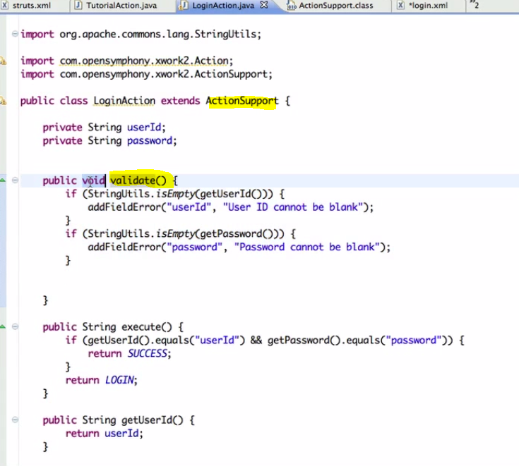
    4. 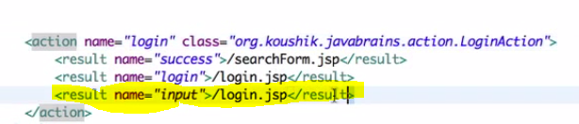
11. Configuring methods in Action mappings
    1. 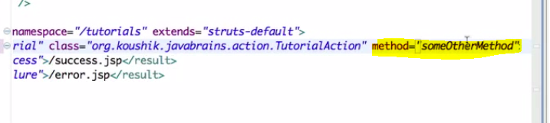
    2. 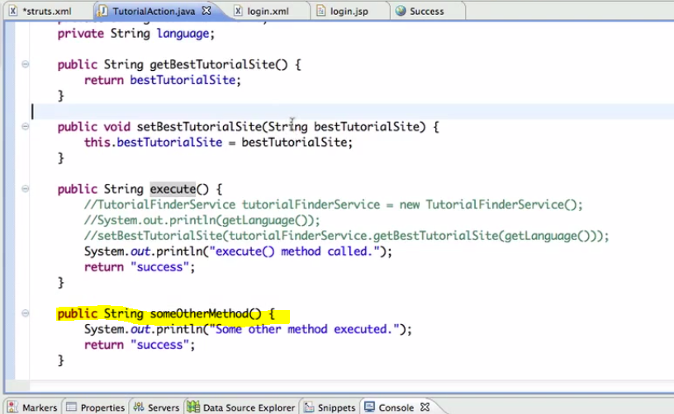
    3. 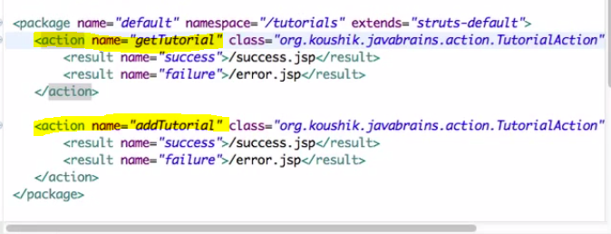
    4. 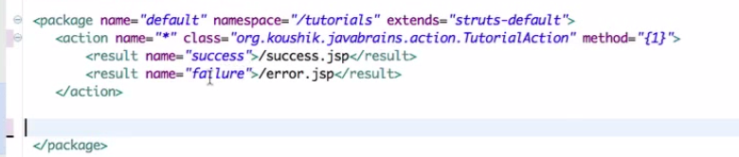
    5. Use “method” attribute in Action tag.
    6. We can also use wild cards
12. Model Objects
    1. 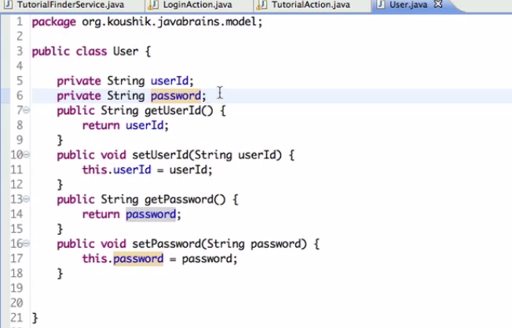
    2. 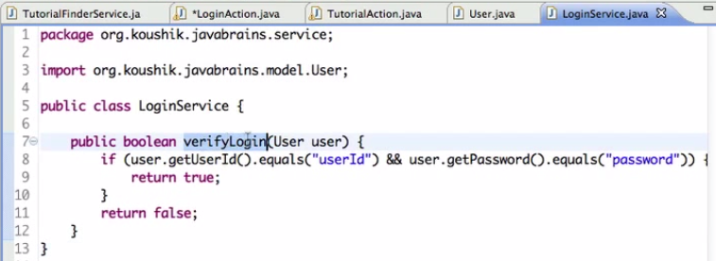
    3. 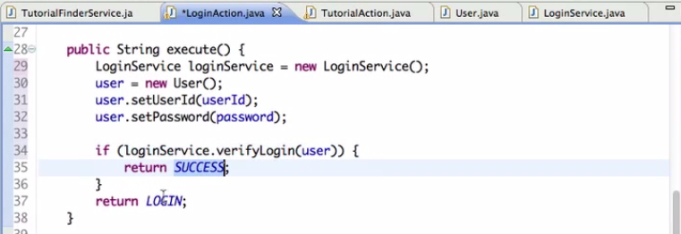
    4. 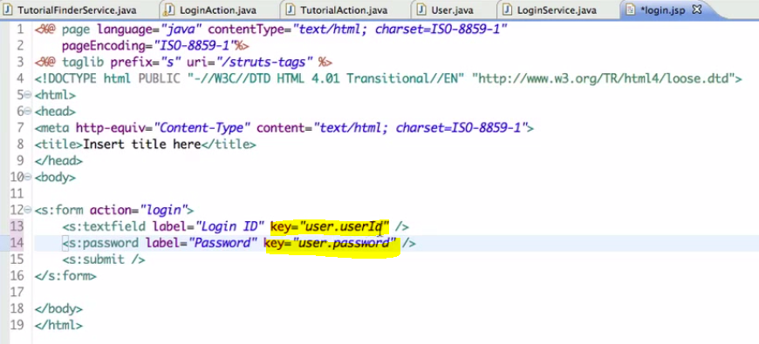
    5. 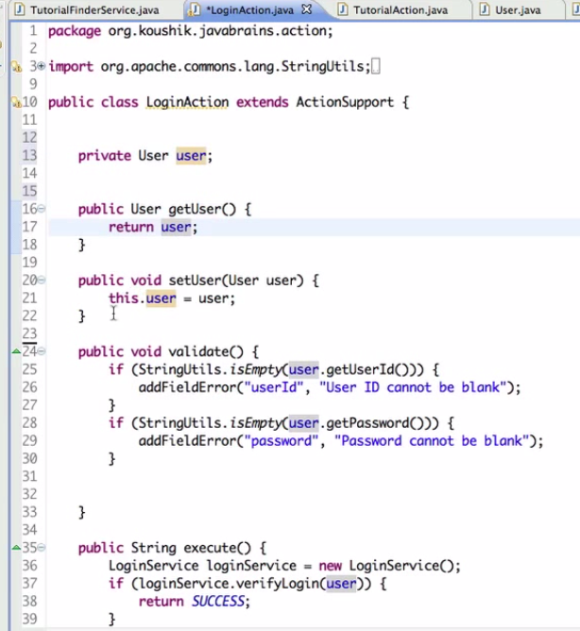
    6. Package of information that need to be send between different layers of Application
    7. We can directly map the member object to the Struts controls.
    8. Implementing Model drivenand return the model object in the getModel() Overridden method.
    9. 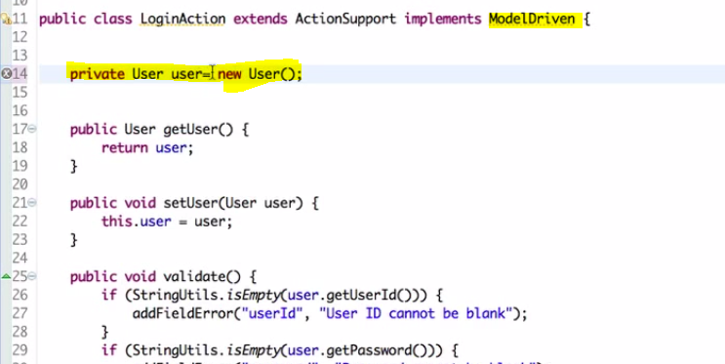
    10. 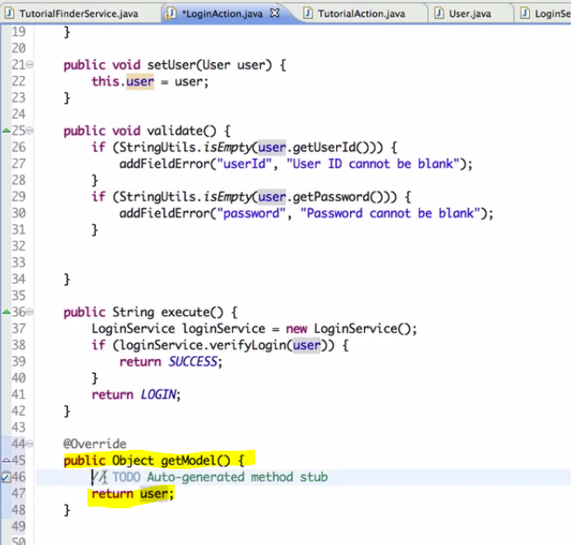
    11. Can also implements generics.
    12. 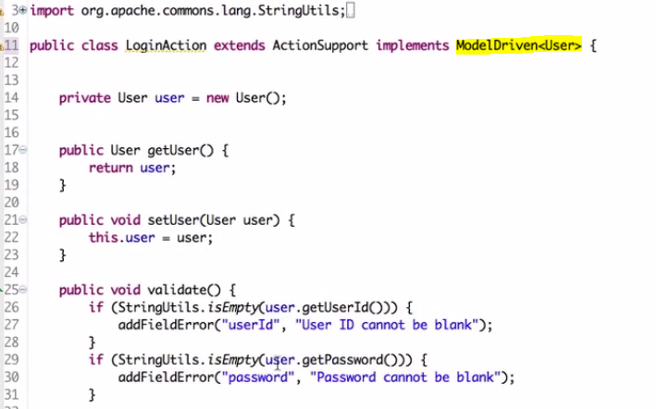
    13. 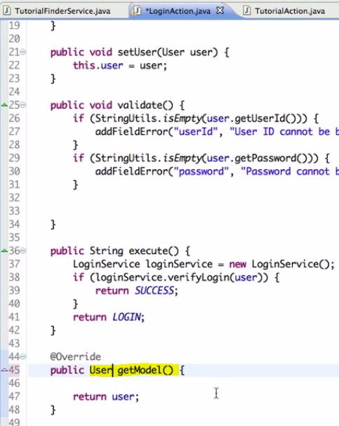
13. Interceptors
    1. Automatic Features of struts 2
       1. Param transfer
       2. Validation
    2. These automation are done by interceptors
    3. Struts-default
       1. It is a abstract class, so it can be only extended.
       2. It has result-types, interceptors and interceptors-stack elements in it.
    4. Three Concepts
       1. Cross cutting concerns
          1. 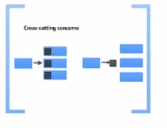
       2. Servlet Container
          1. 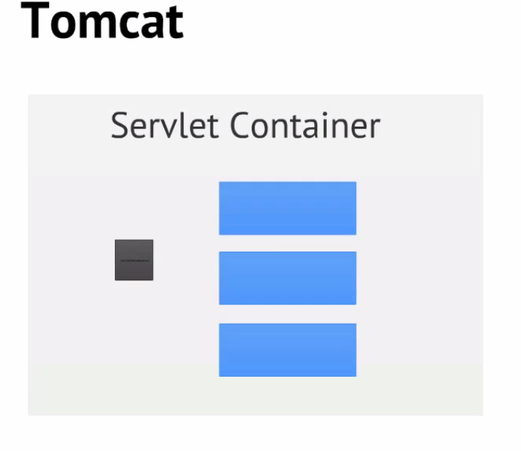
          2. Struts is a cross cutting concerns
       3. 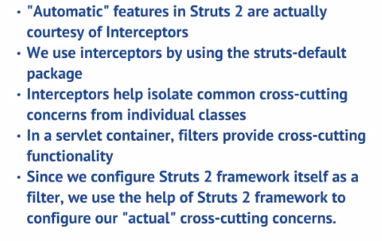
14. Configuring Interceptors (2)
    1. Nature of interceptor
       1. Configurable
       2. Java classes
       3. One or more interceptor
    2. 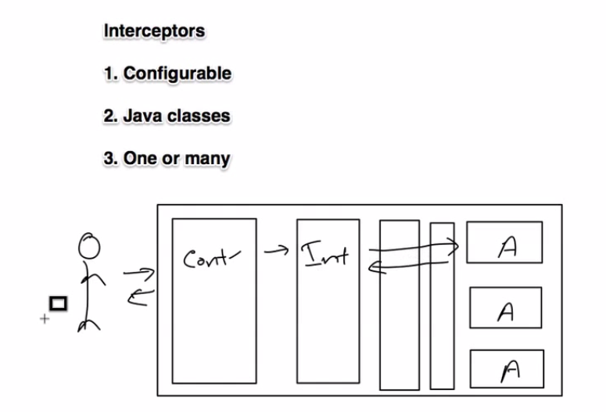
    3. Steps in creating an interceptor
       1. Declare an interceptor in struts.xml
       2. Declare the action
       3. Interceptor Stack
       4. We can specify a single interceptor or interceptor stack in action
       5. Refer struts-default.xml
       6. <Default-interceptor-ref name=”default-stack”> is used to specify the default stack.
15. Anatomy of interceptor
    1. 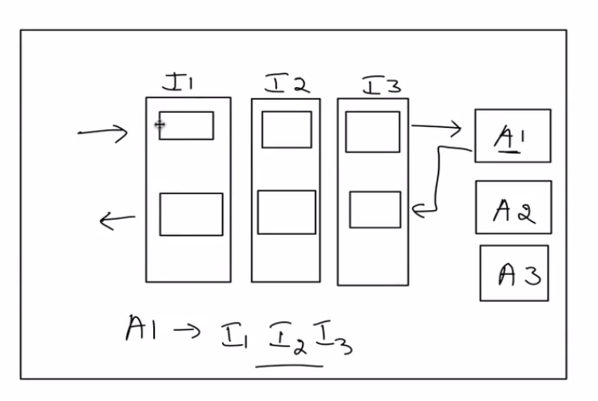
    2. 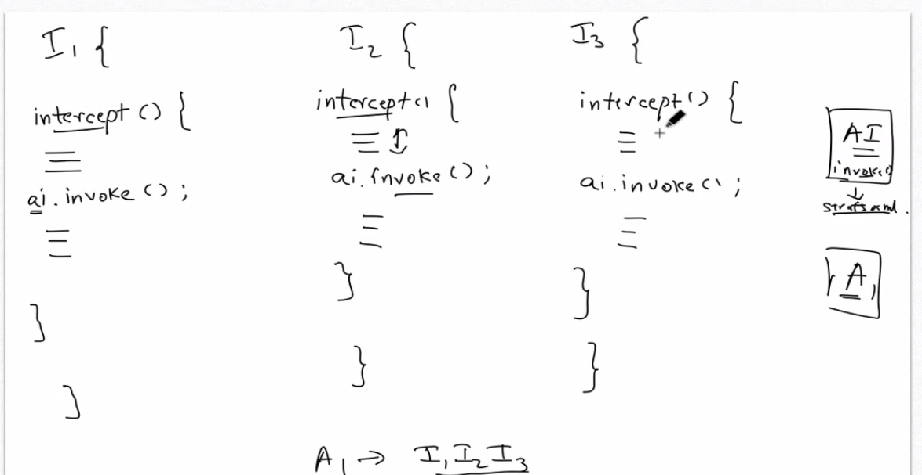
    3. Action Invocation
    4. Refer net for detailed interceptor

Notes:

Struts Framework consists of following classes:

* **Action Servlets:** used to control the response for each incoming request.
* **Action Class:** used to handle the request.
* **Action Form:** it is java bean, used to referred to forms and associated with action mapping
* **Action Mapping:** used for mapping between object and action.
* **Action Forward:** used to forward the result from controller to destination.

http://www.careerride.com/Interview-Questions-Java-Struts.aspx

Doubts

* Validation Framework consist of two XML configuration Files:  
  o Validator-Rules.xml file  
  o Validation.xml file

Exceptions are handled in struts by using any one of the following two ways:

* **Programmatically handling:** In this exception are handled by using try and catch block in program. Using this programmer can define how to handle the situation when exception arises.
* **Declarative handling:** In this exception handling is done by using the XML file. Programmer defines the exception handling logic in the XML file. There are two ways of defining the exception handling logic in the XML file:  
  -Global Action Specific Exception Handler Definition.  
  -Local Action Specific Exception Handler Definition.

The DispatchAction enable the programmer to combine together related function or class.

* Using Dispatch Action programmer can combine the user related action into a single UserAction. like add user, delete user and update user
* DispatchAction execute the action based on the parameter value it receives from the user.

1. Sturts 2 Tutorial 1 Installing and setup
2. Struts Tutorial 2 Sturts Action
   1. 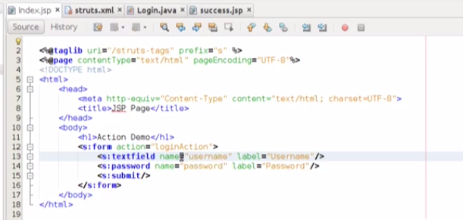
   2. 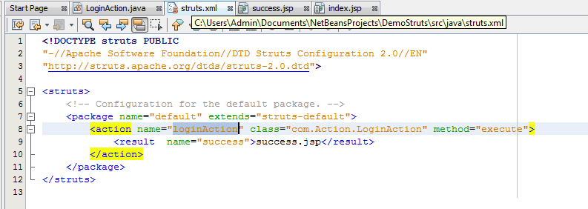
   3. 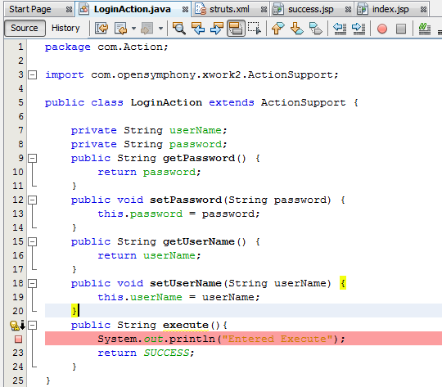
   4. 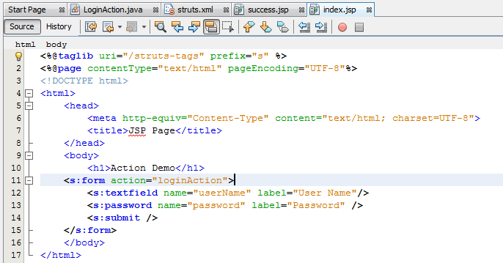

1. Struts Tutorial 3 Sturts Action Continue
   1. 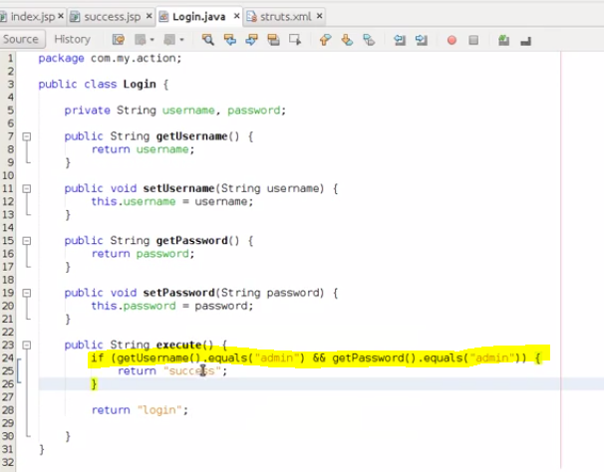
   2. 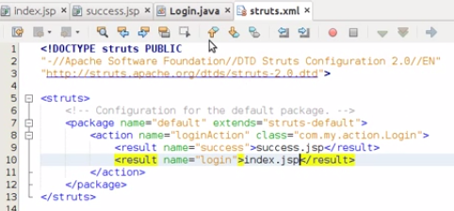
   3. 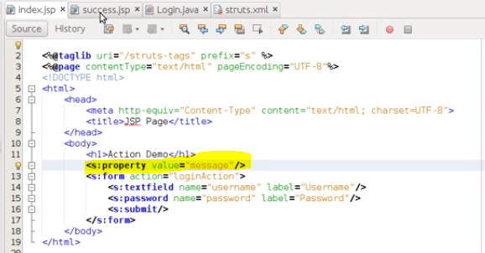
   4. 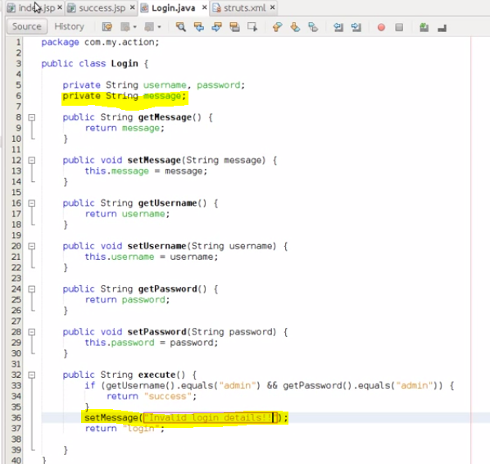
2. 04.Struts Tutorial 4 Sturts ActionSupport class
   1. 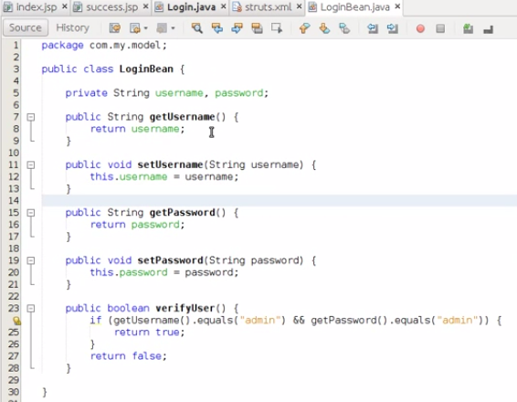
   2. 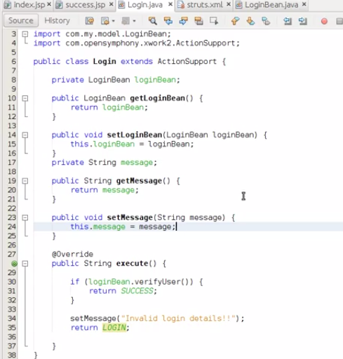
   3. 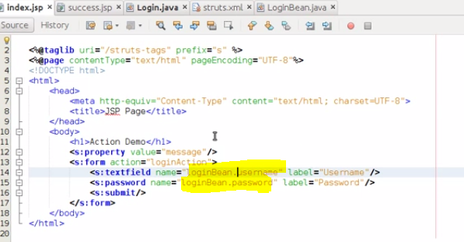
   4. 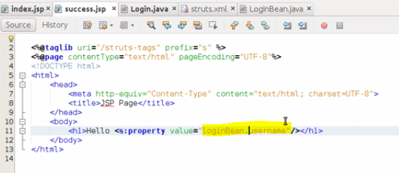
3. 05.Struts Tutorial 5 Validation in Struts2
   1. 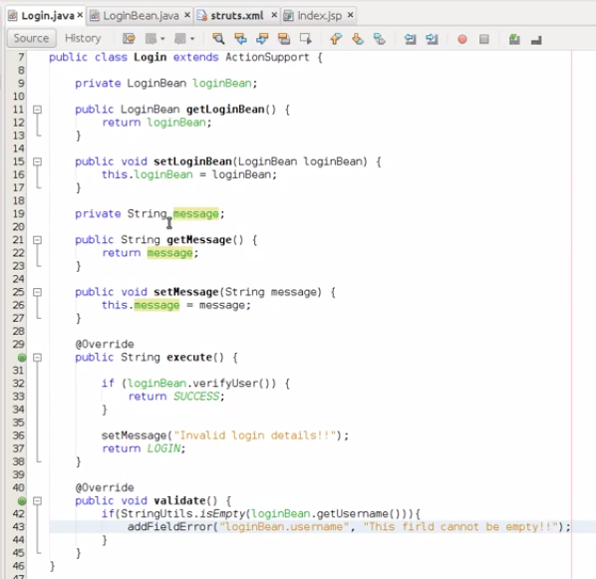
4. 06.Struts Tutorial 6 Session in Struts2
   1. Implementing SessionAware
   2. 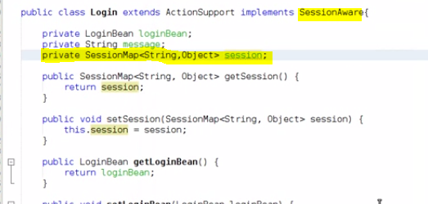
   3. 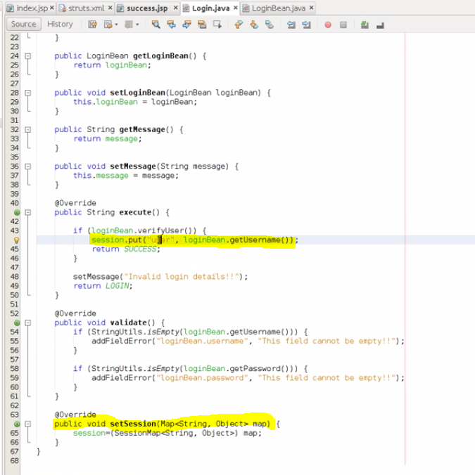
   4. 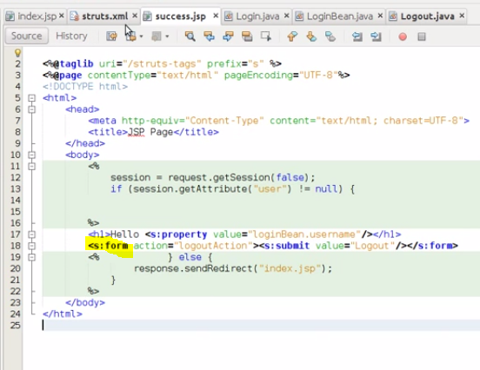
   5. 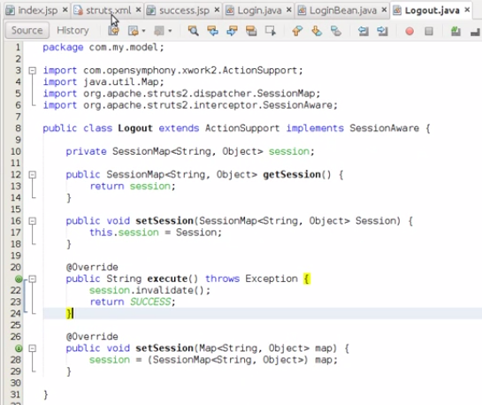
   6. 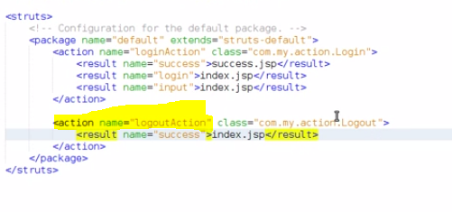
5. 1 - Introduction to Struts 2
6. 2 - Overview of its components and how it works
7. 3 - Setting up Struts 2 project and running HelloWorld application
8. 4 - Understanding Struts 2 configuration elements - part I
9. 5 - Understanding Struts 2 configuration elements - part II
   1. 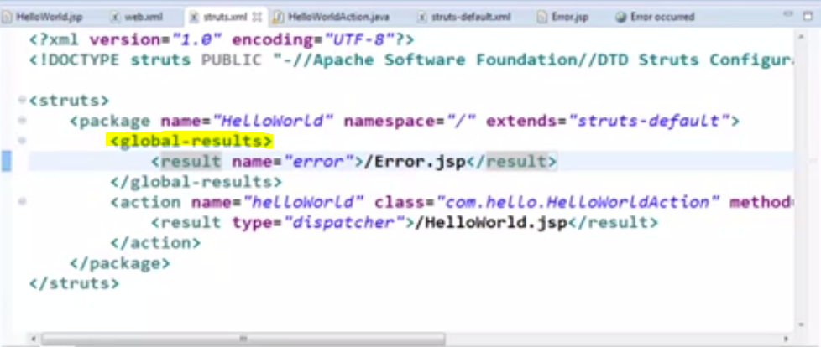
   2. 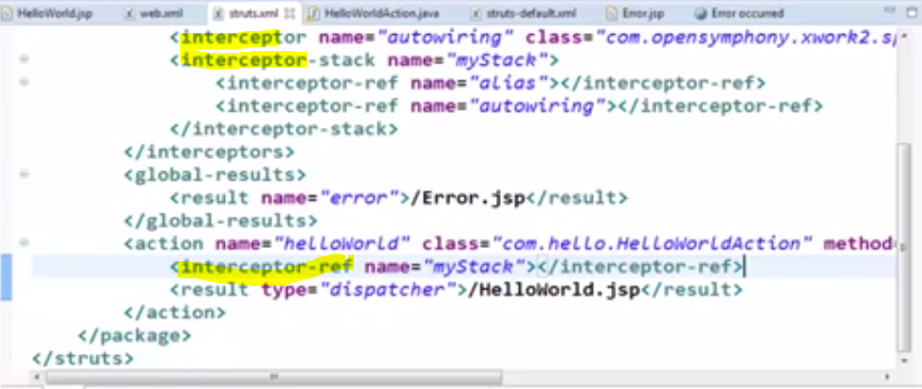
10. 6 - Different ways of writing Action class
11. 7 - Access HTTP resource objects from action class
    1. 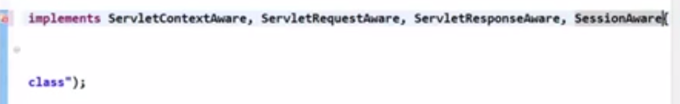
    2. 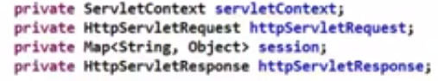
    3. 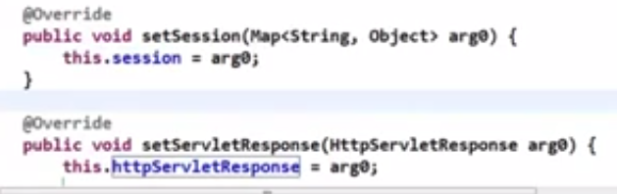
    4. 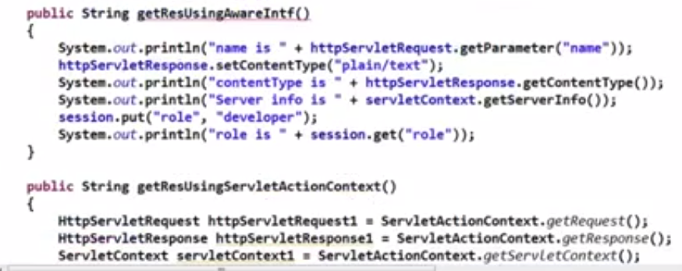
    5. 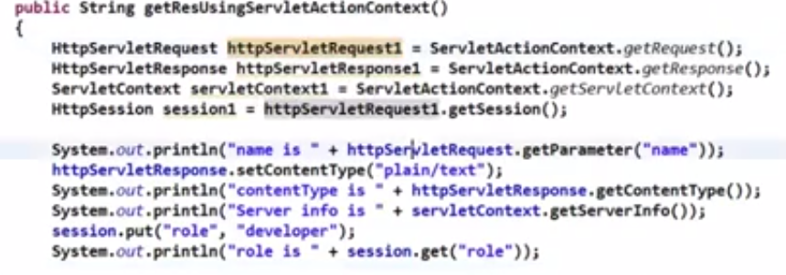
    6. 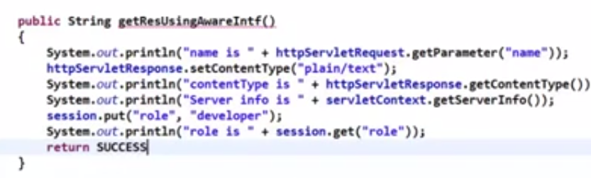
    7. 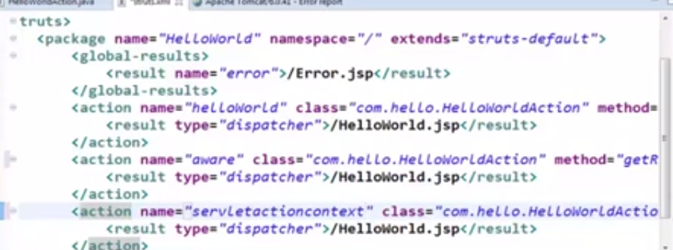
    8. 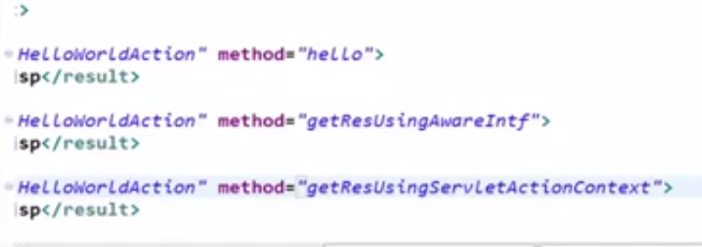
    9. 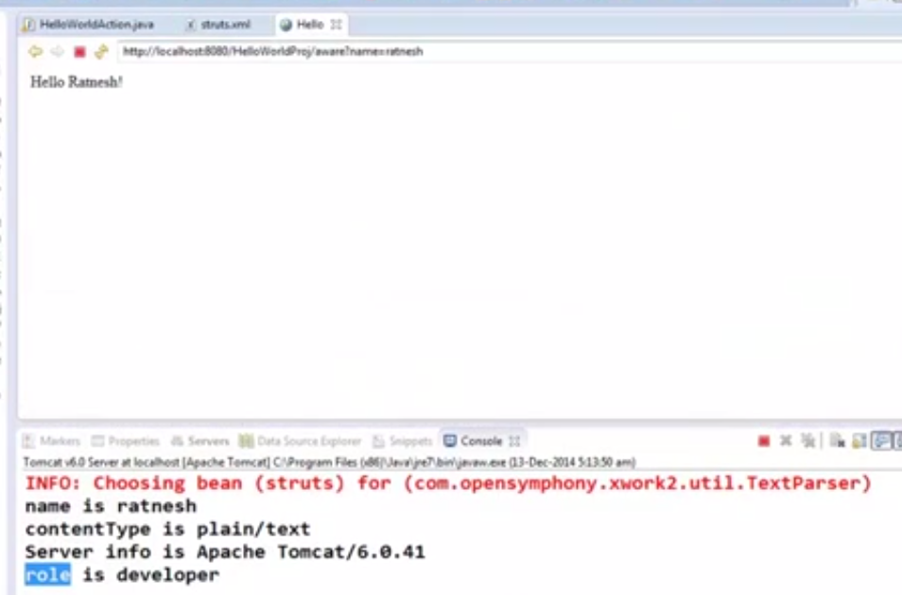
    10. 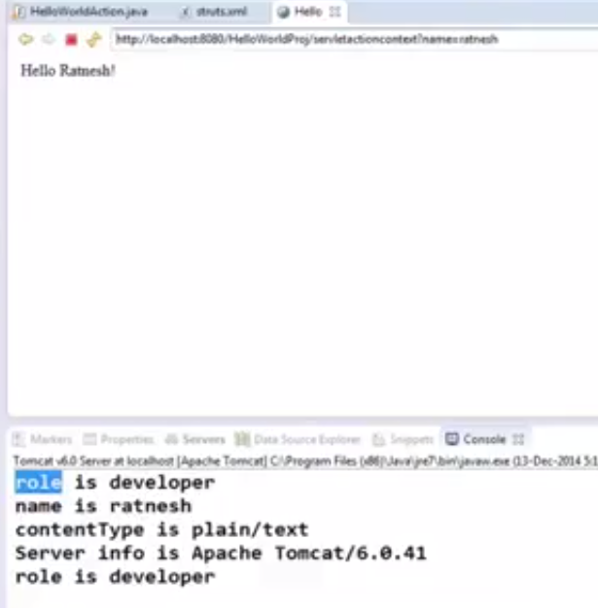
12. 8 - Wildcard mapping in actions
13. 9 - Overview of OGNL
    1. OGNL is the Object Graph Navigation Language
    2. 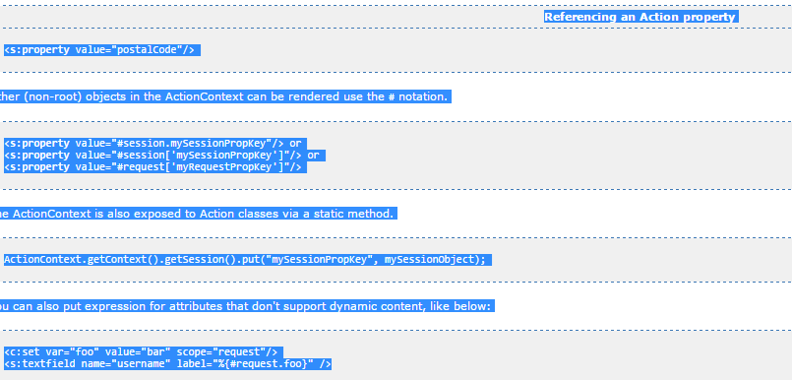
    3. 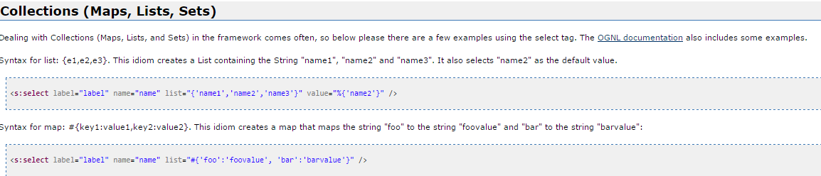
14. 10 - Struts 2 tags using a demo BookAuto web app - part I
    1. To make a default action when site loads
    2. 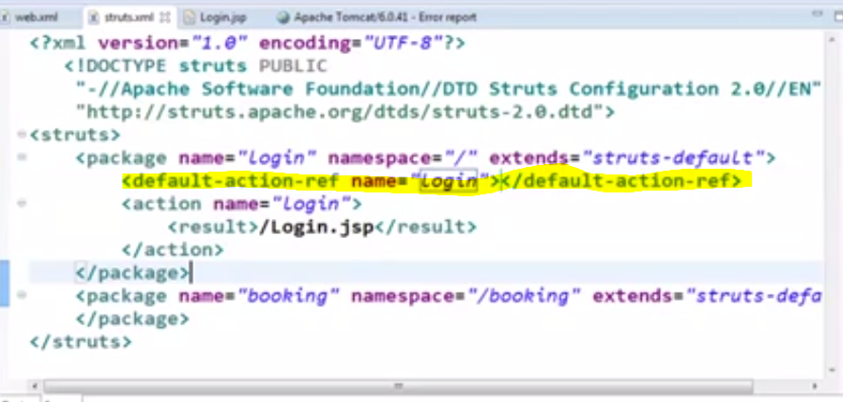
    3. 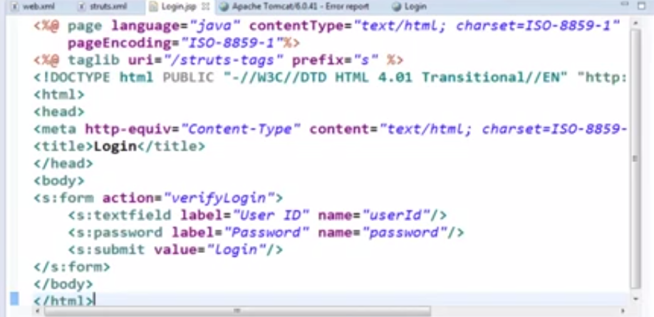
    4. 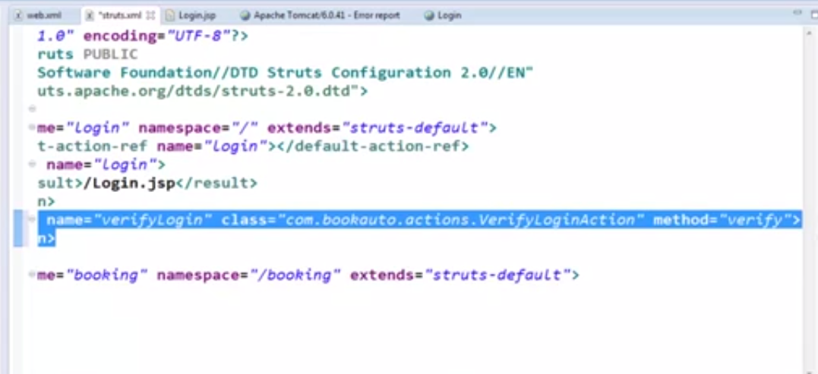
    5. 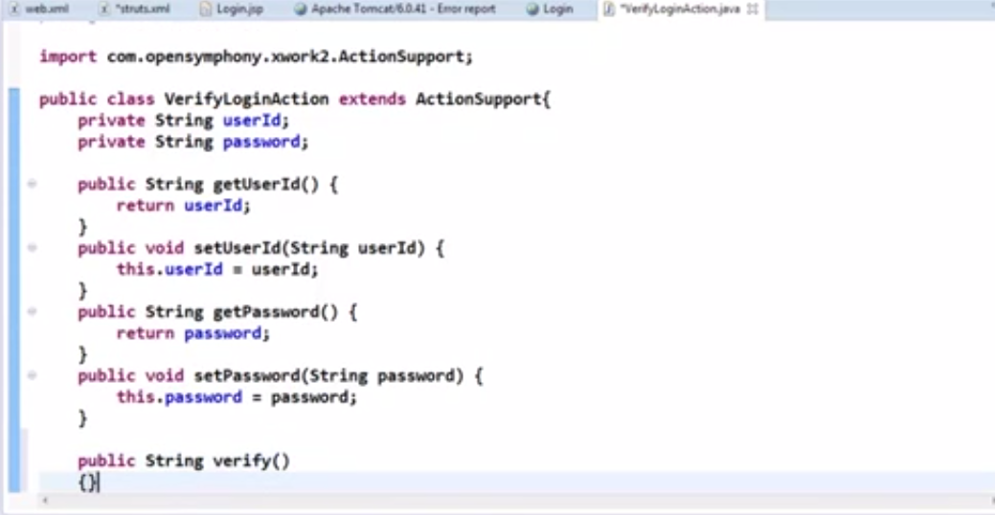
    6. 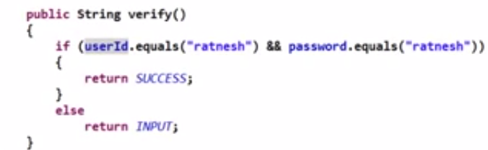
    7. 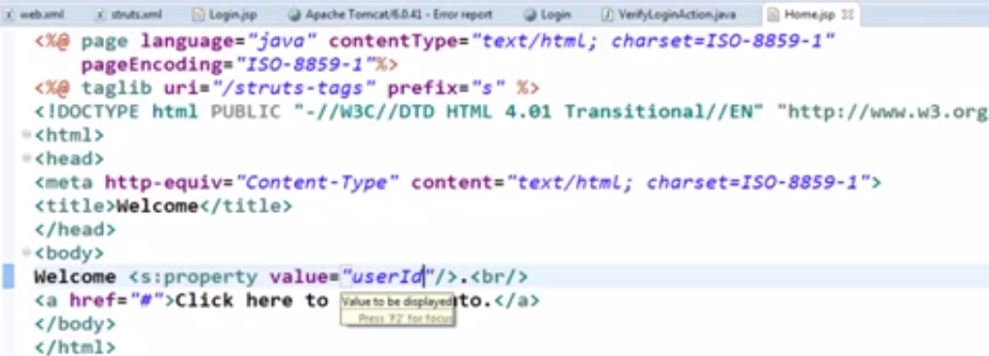
15. 11 - Struts 2 tags using a demo BookAuto web app - part II (1)
    1. 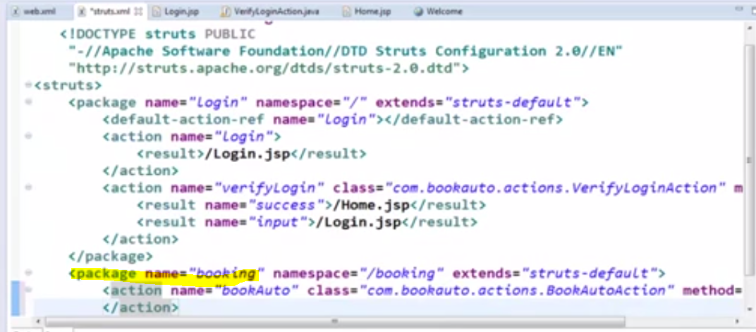
    2. 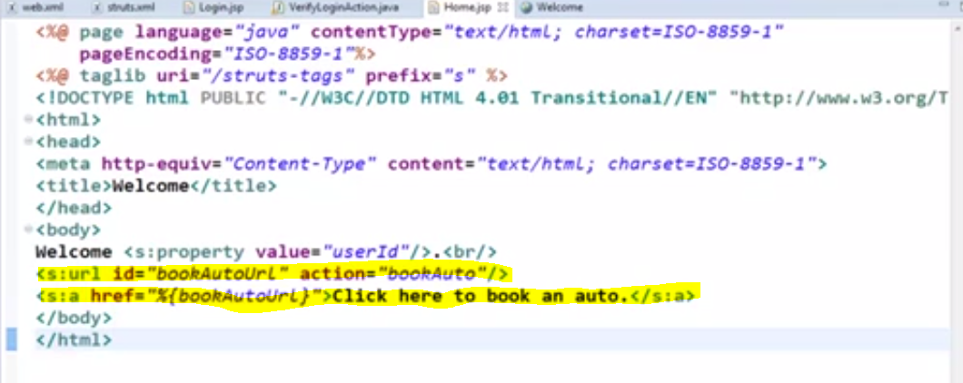
    3. 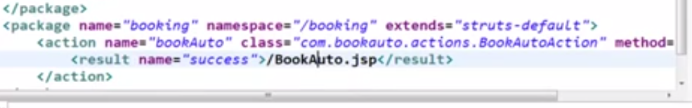
    4. 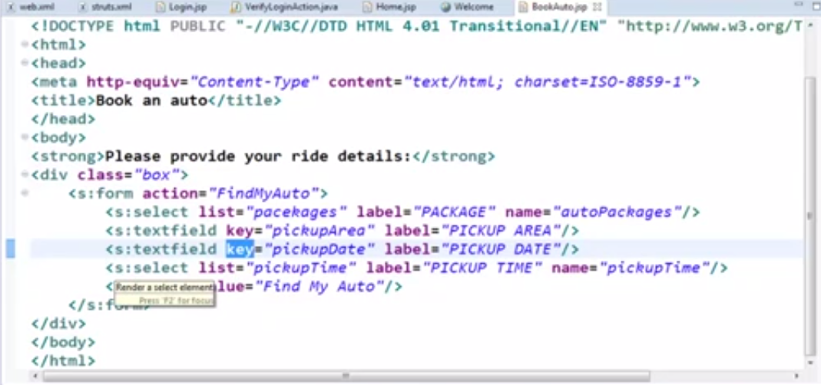
    5. 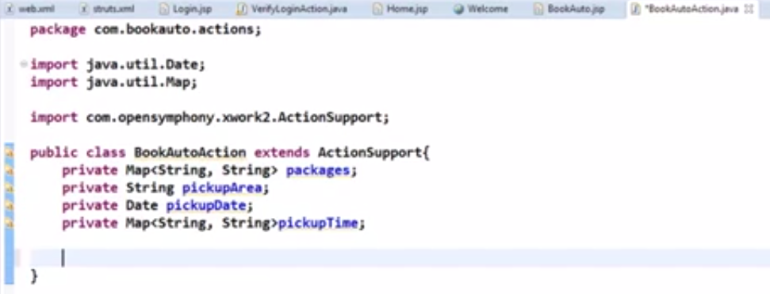
    6. 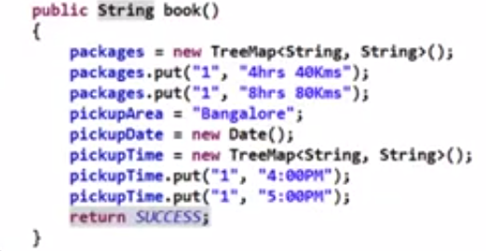
    7. 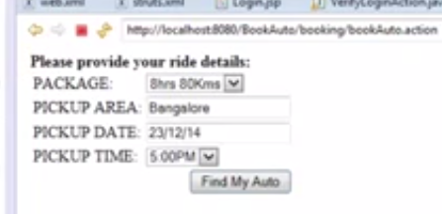
16. 12 - Struts 2 tags using a demo BookAuto web app - part III
    1. 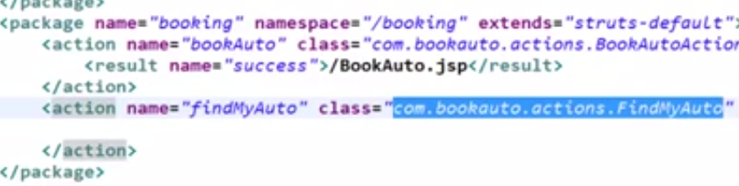
    2. 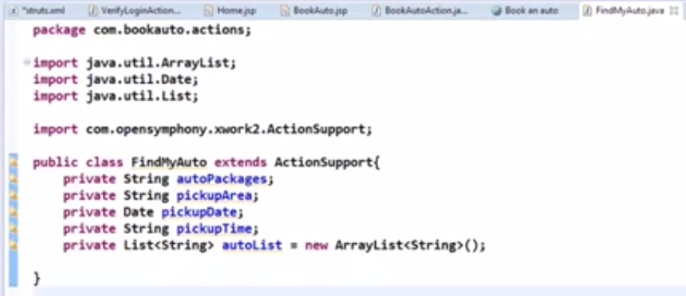
    3. 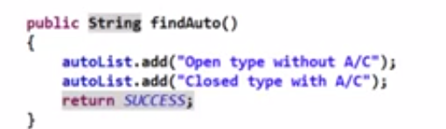
    4. 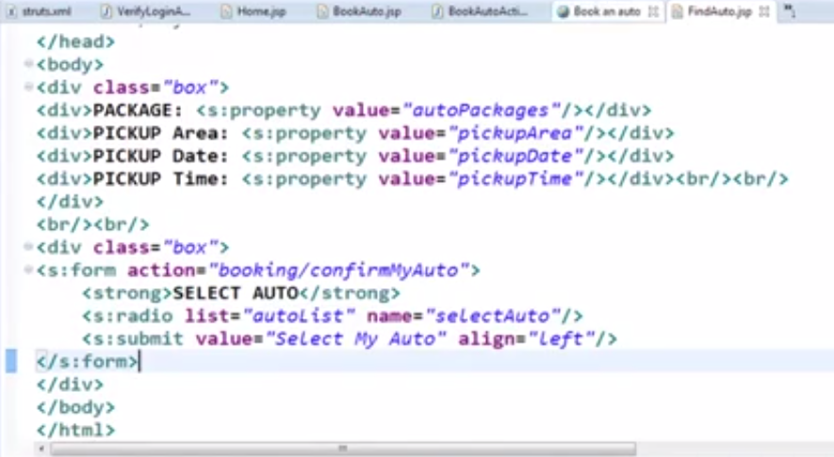
    5. 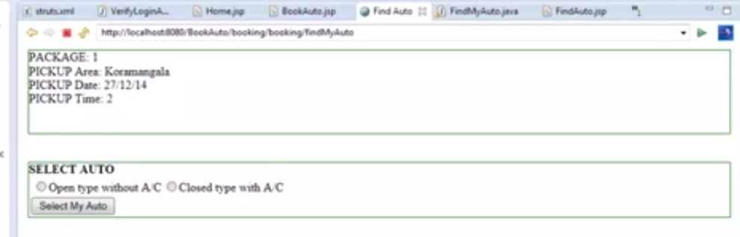
    6. 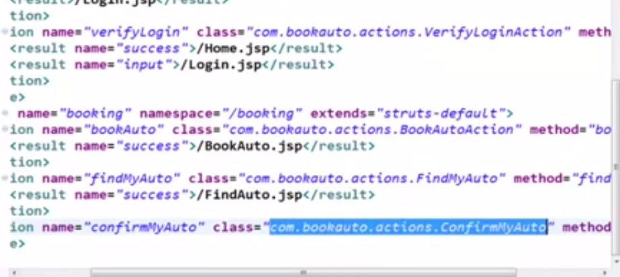
    7. 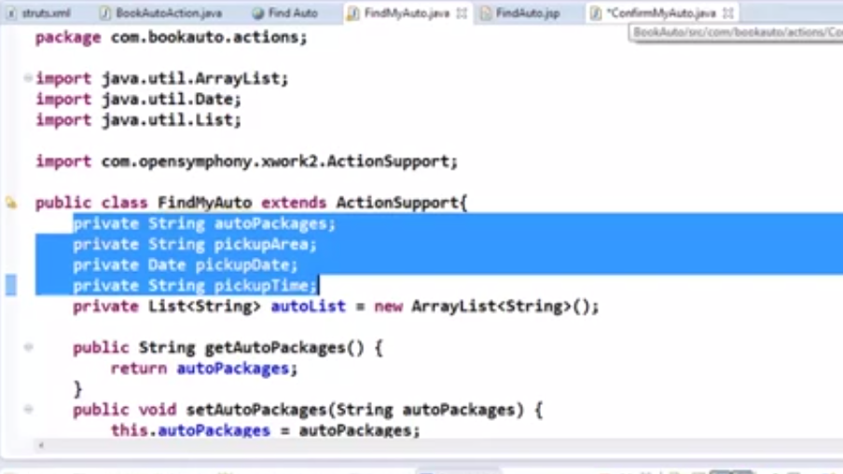
    8. 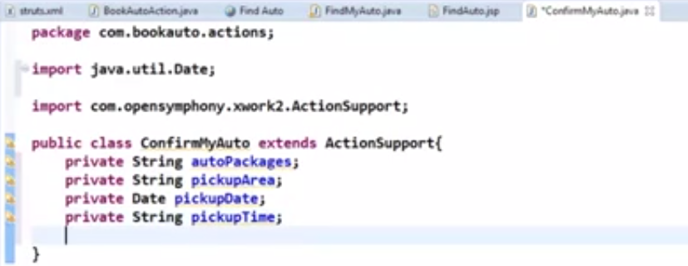
    9. 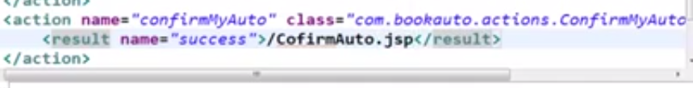
    10. 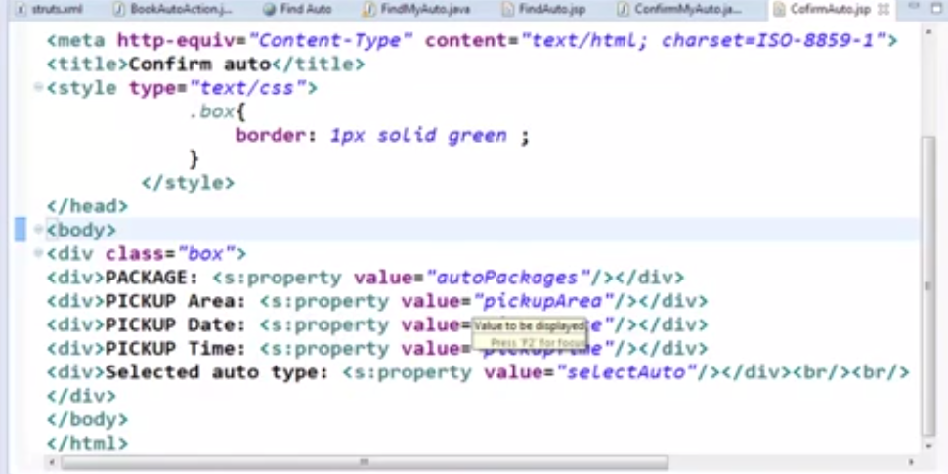
    11. 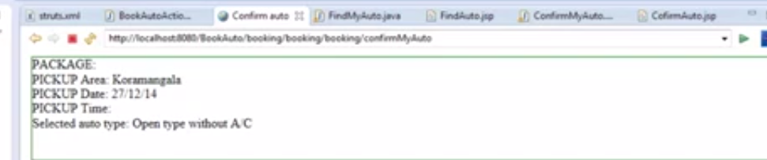
17. 13 - Input parameters validation techniques using requiredstring validator
    1. 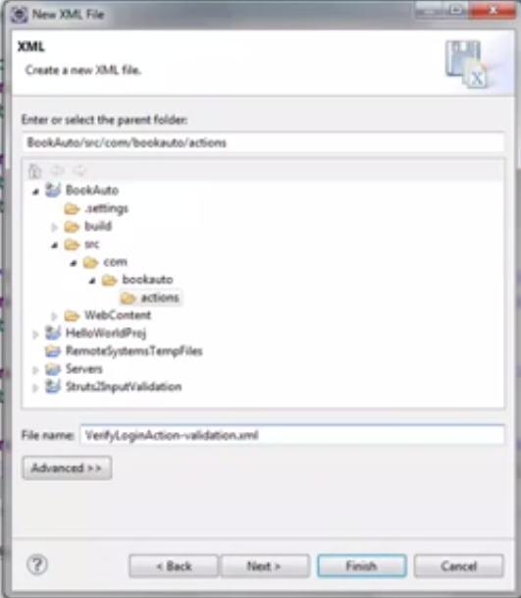
    2. 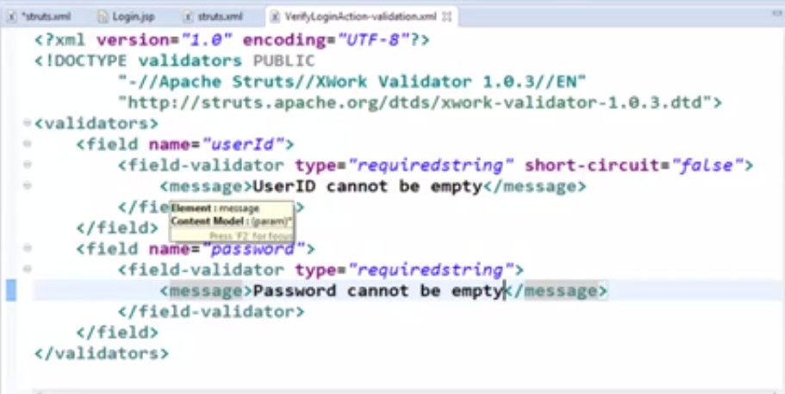
18. 14 - Input parameters validation using stringlength and email validators
    1. 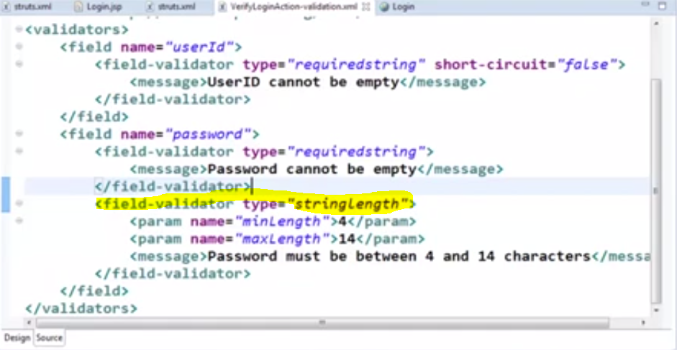
    2. 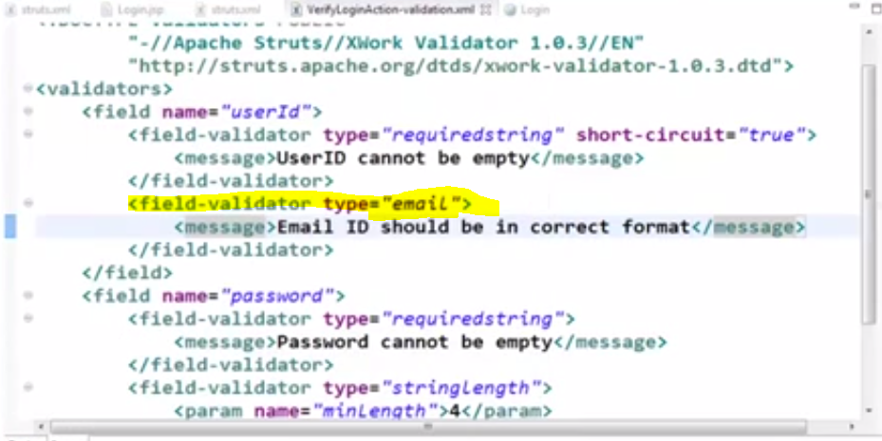
19. 15 - Input validation using visitor validator
    1. 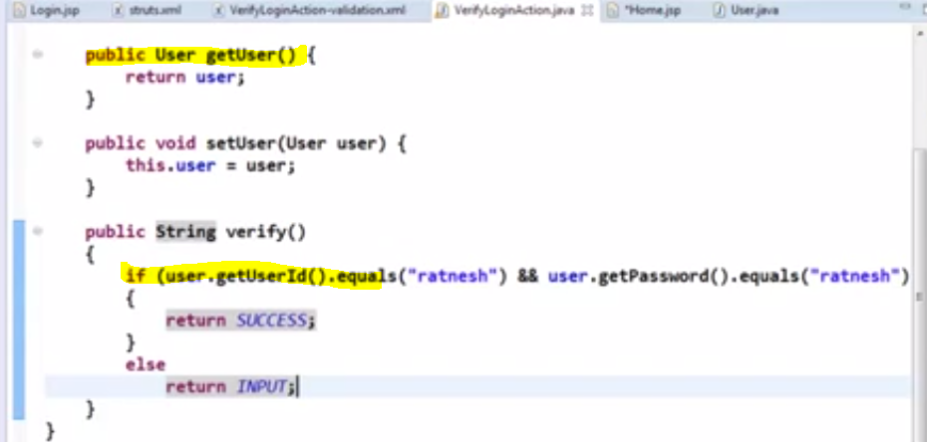
    2. 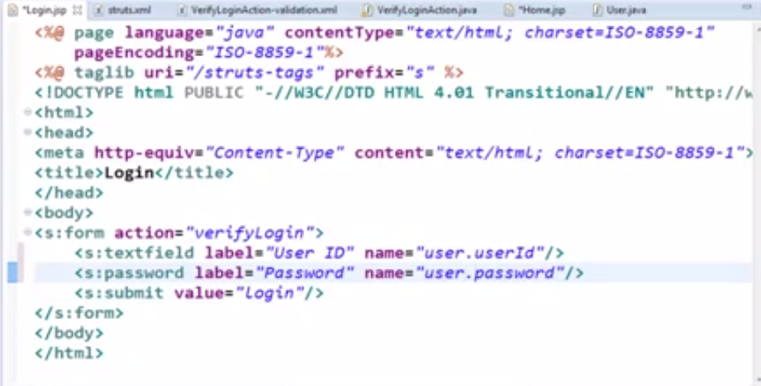
    3. 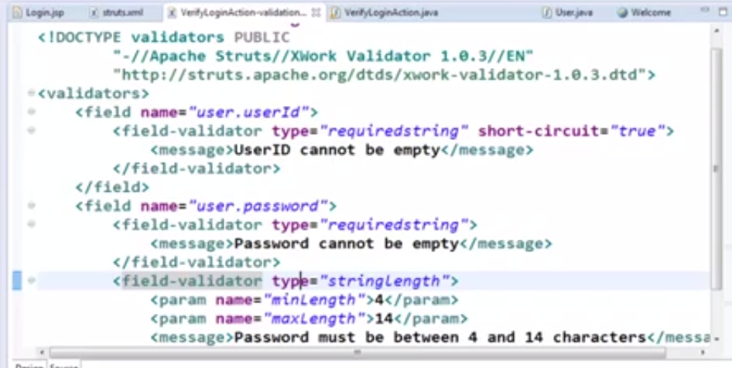
20. 16 - Writing our own custom validator
    1. 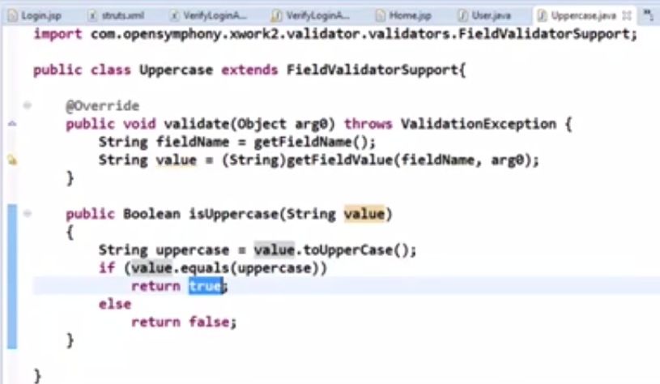
    2. 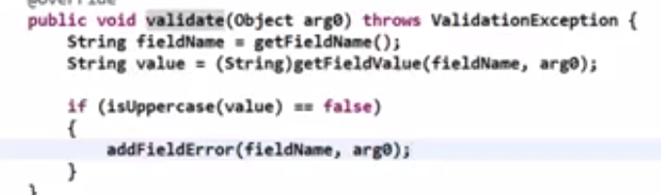
    3. 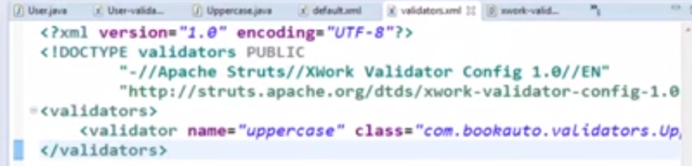
    4. 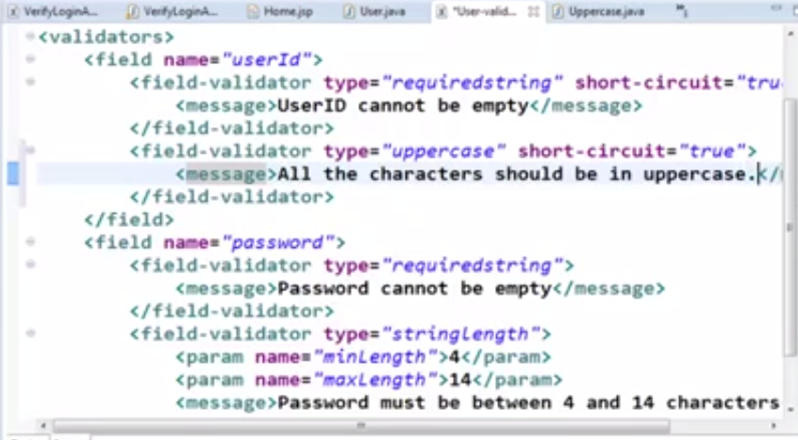
21. 17 - Programmatic validation
    1. 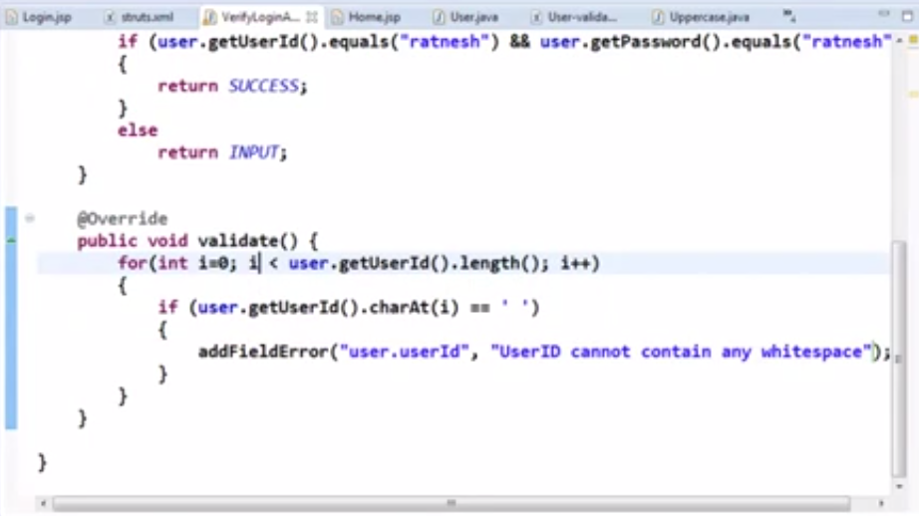
22. 18 - Type conversion
    1. 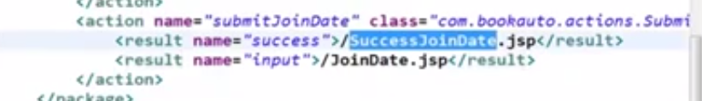
    2. 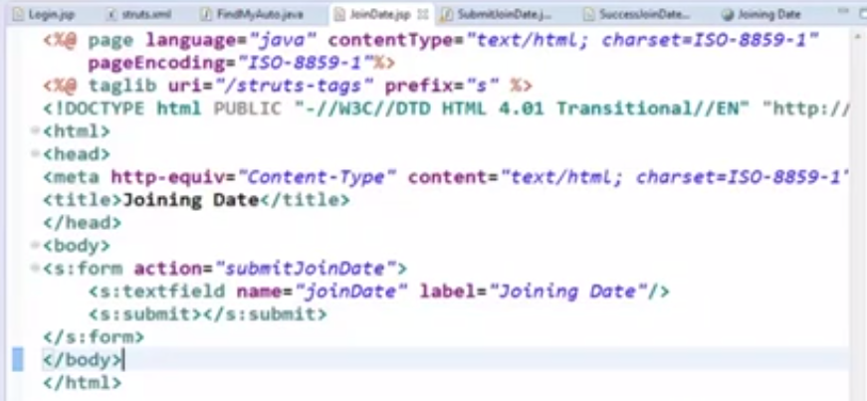
    3. 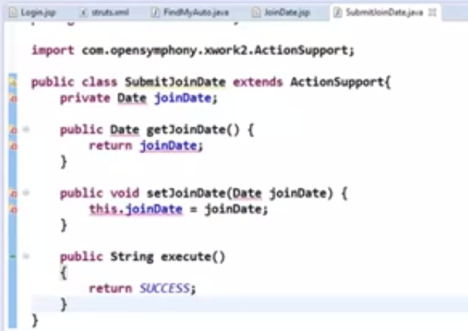
    4. 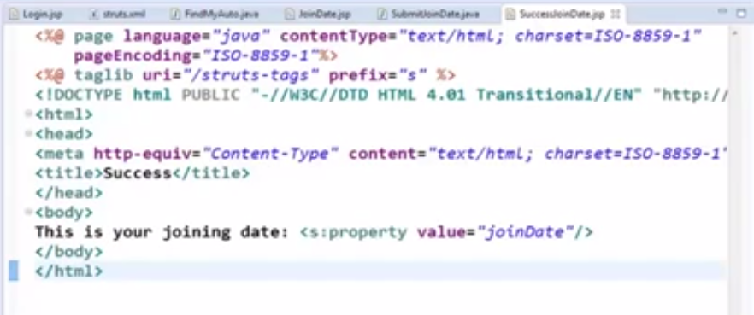
    5. 
    6. 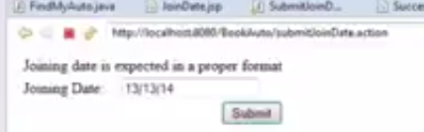
23. 19 - Writing our own Custom Type converter
    1. 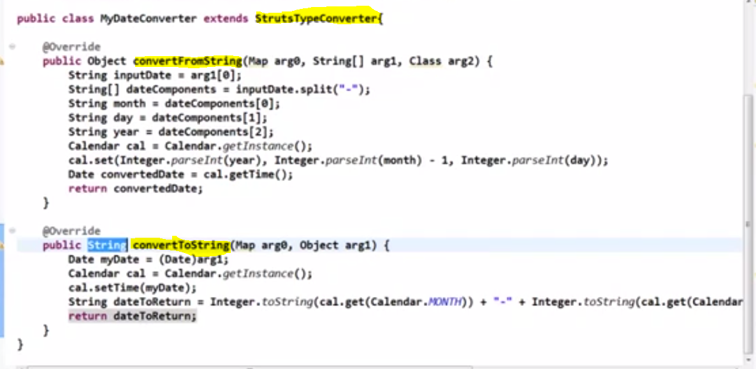
    2. 
24. 20 - Internationalization in Struts2 - part I
    1. 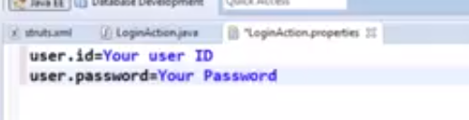
    2. 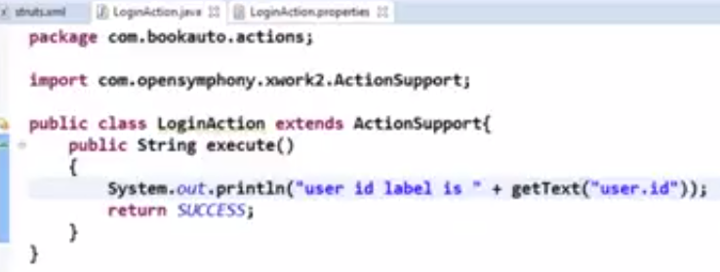
    3. 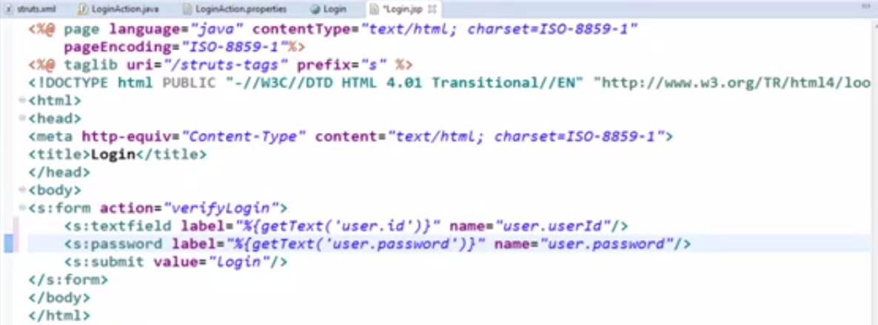
    4. 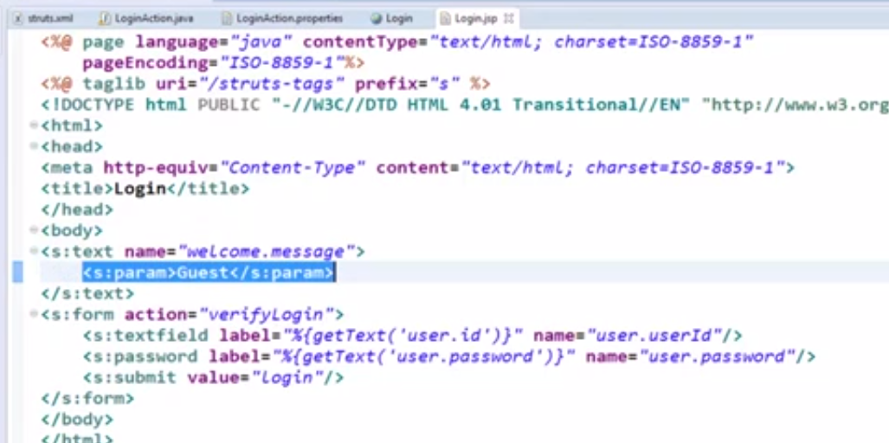
    5. 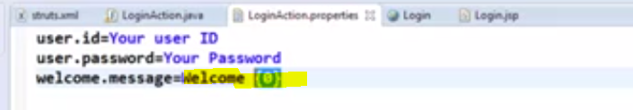
25. 21 - Internationalization in Struts 2 with example - part II
    1. 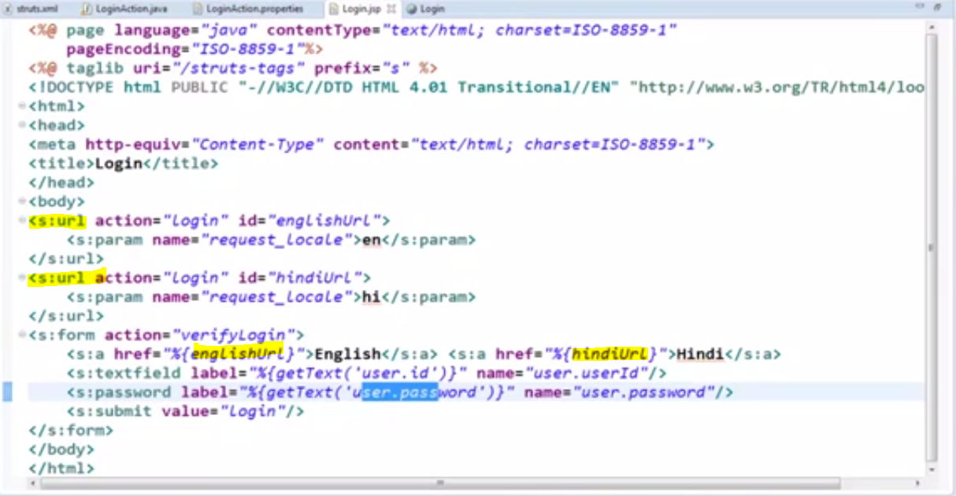
    2. 
    3. 
26. 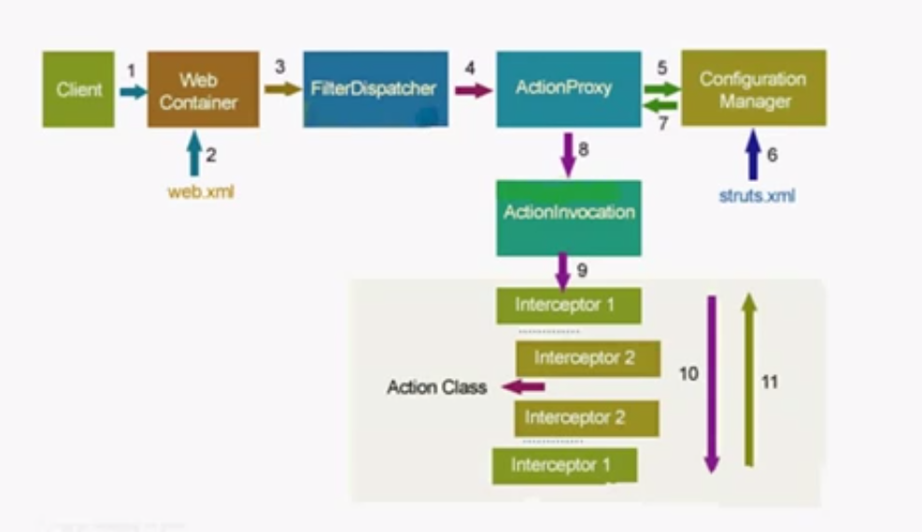
27. 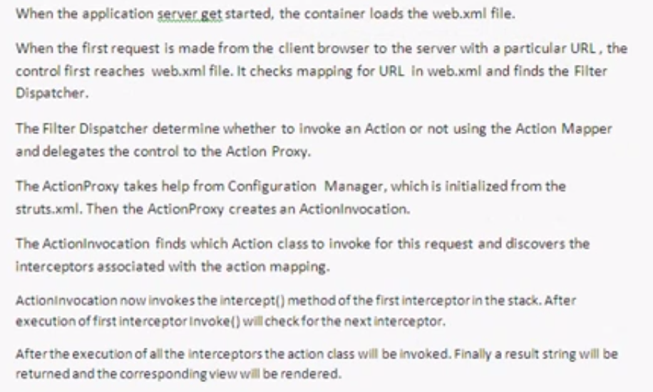
28. 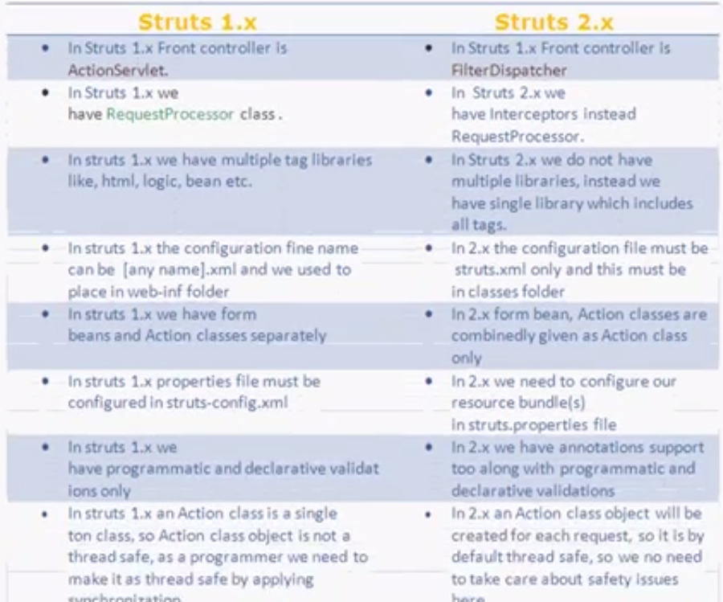
29. 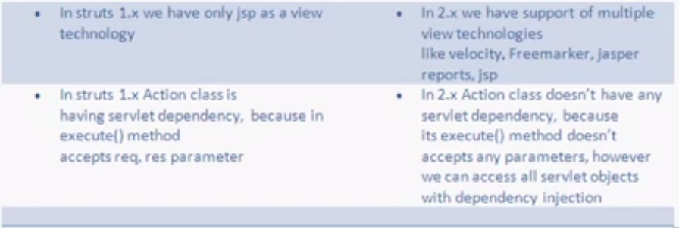
30. 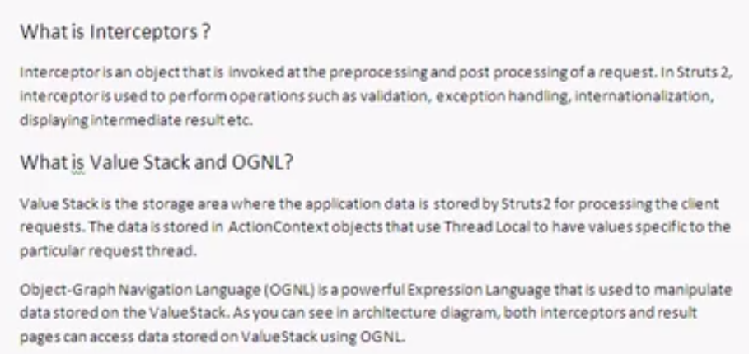
31. 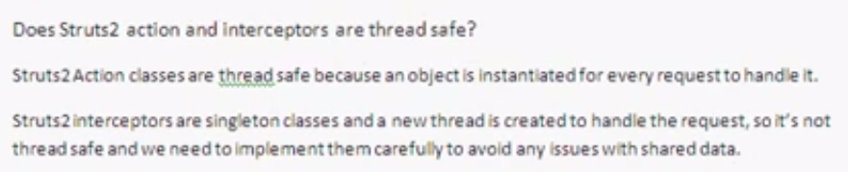
32. 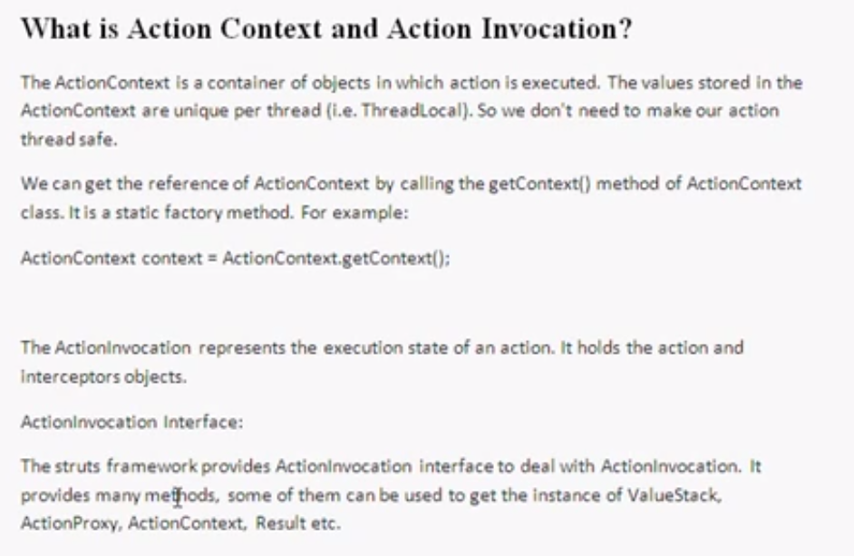

# Key Struts Interview questions

1. Can I have html form property without associated getter and setter formbean methods
   1. 
2. Can we handle exceptions in Struts programmatically
   1. 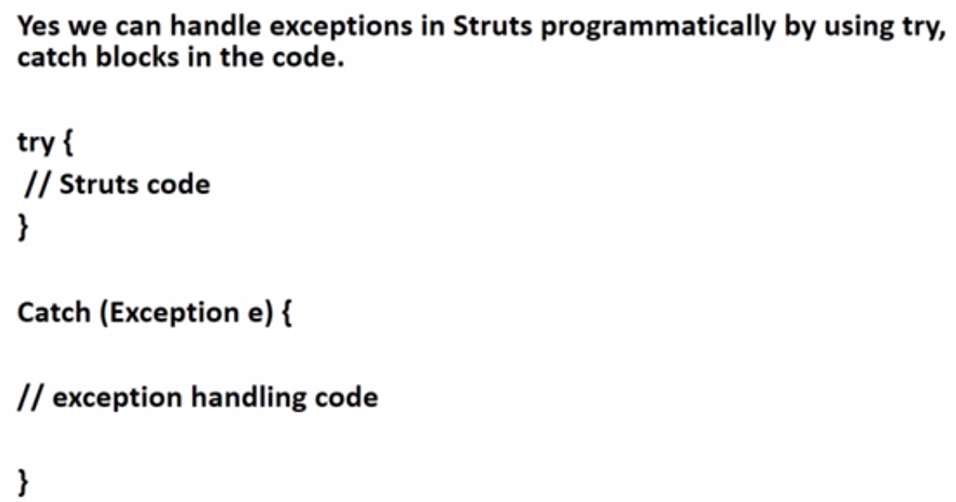
3. Can we have more than one struts config xml file for a single Struts application
   1. 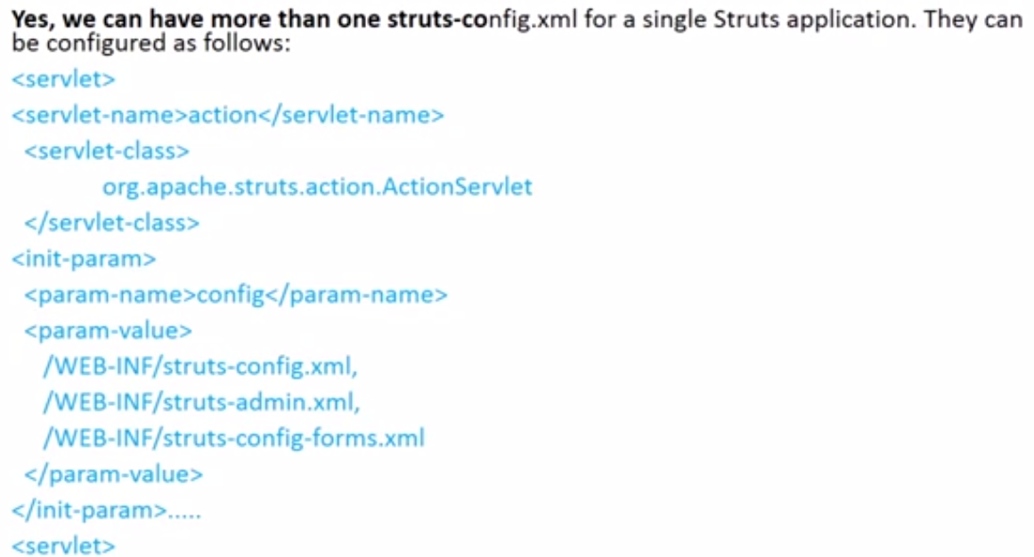
4. Difference between Html tags and Struts specific HTML Tags
   1. 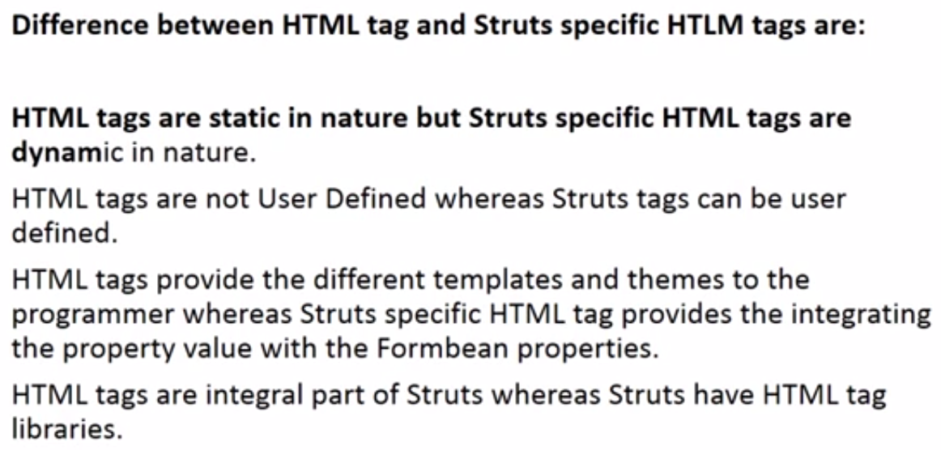
5. How action mapping tag is used for request forwarding in Struts configuration file
   1. 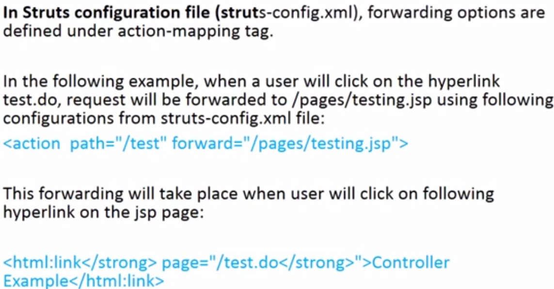
6. How can we display all validation errors to user on JSP page
   1. 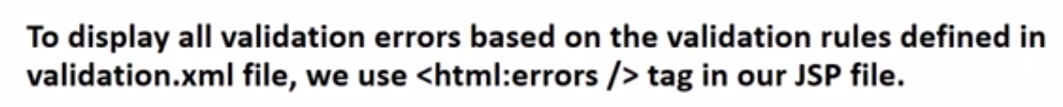
7. How can we group related actions in one group in Struts
   1. 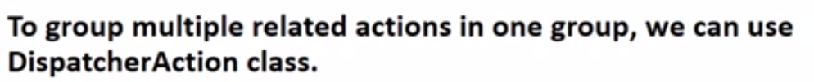
8. How duplicate form submission can be controlled in Struts
   1. 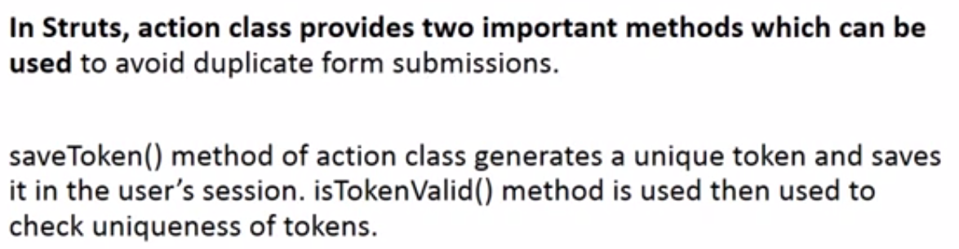
9. How exceptions are handled in java Struts application
   1. 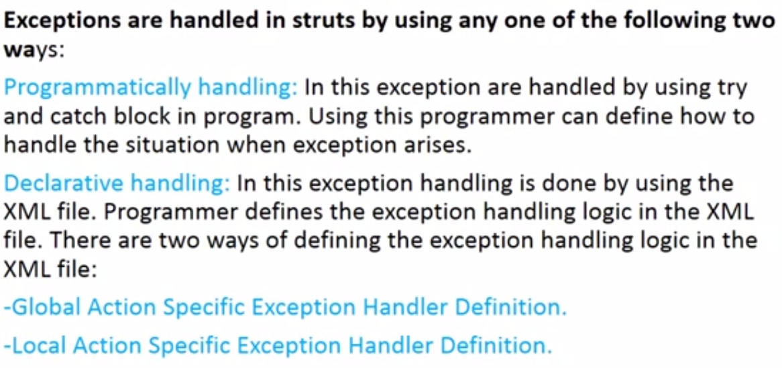
10. How is declarative handling of exceptions done in Struts
    1. 
11. How many instances of servlet usually run in a struts application
    1. One
12. How many servlet controllers are used in a Struts Application
    1. 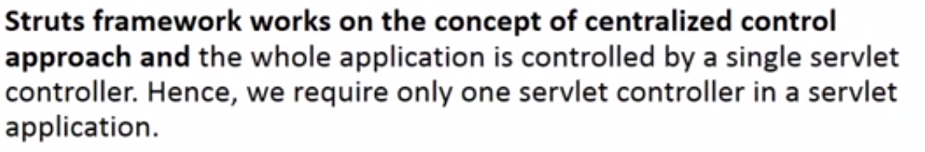
13. How nested beans can be used in Struts applications
    1. 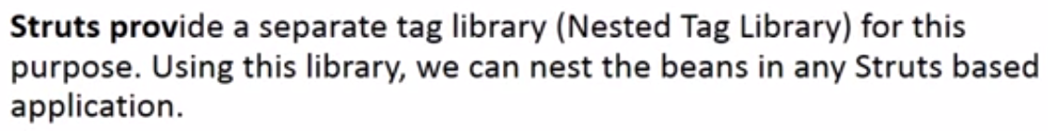
14. How to use forward action to restrict a strut application to MVC
    1. 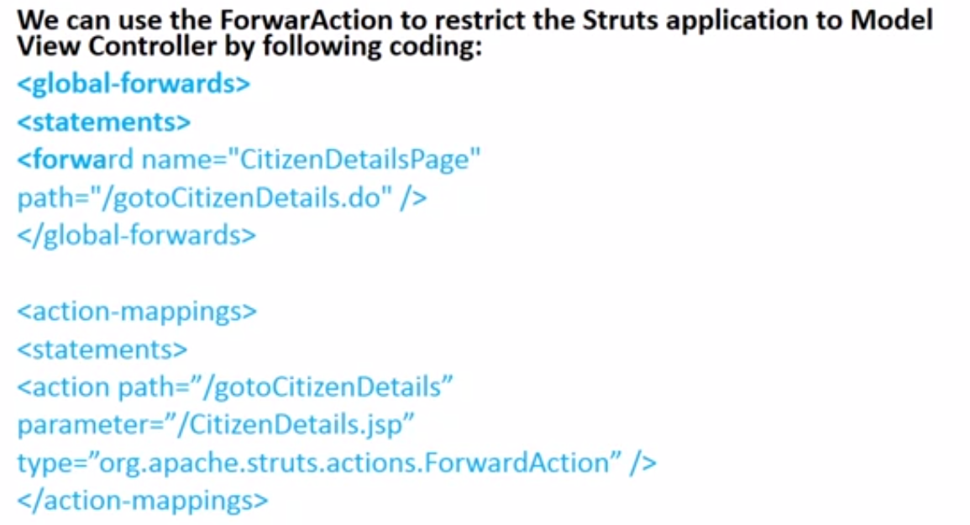
15. How you can retrieve the value which is set in the JSP Page in case of DynaActionForm
    1. 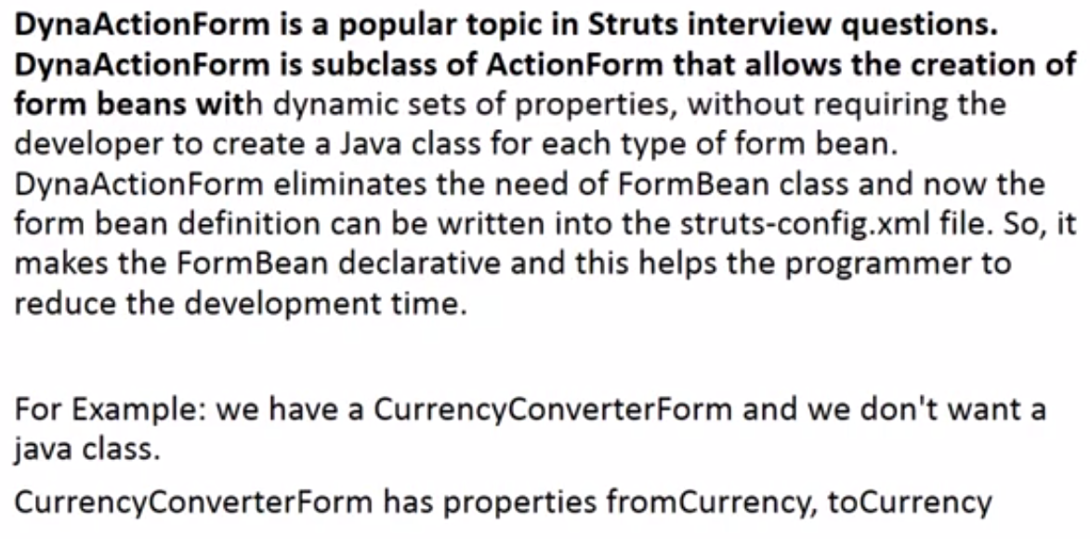
16. How you will make available any Message Resources Definitions file to the Struts Framework Environment
    1. 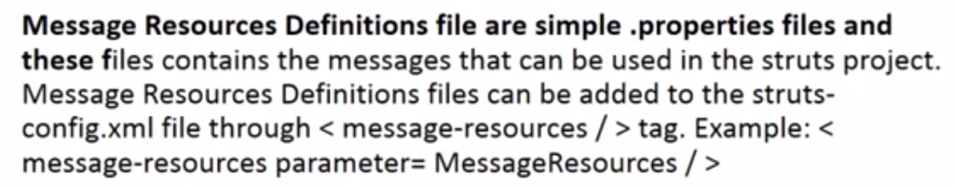
17. In how many ways duplicate form submission can occurs
    1. 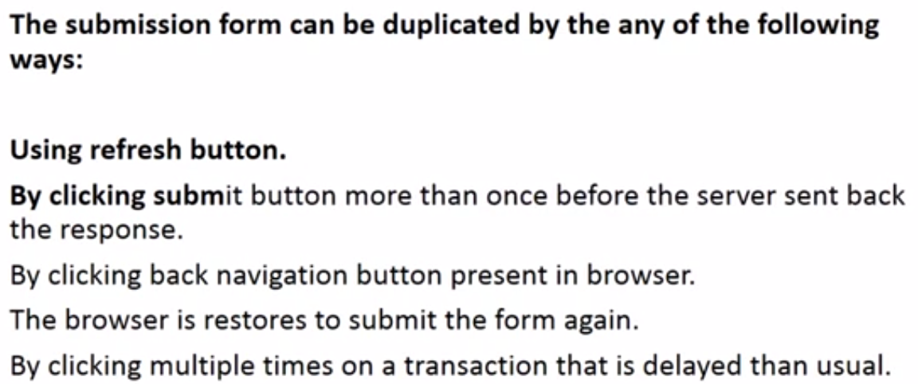
18. In Struts, how can we access Java beans and their properties
    1. 
19. In which method of Action class the business logic is executed
    1. 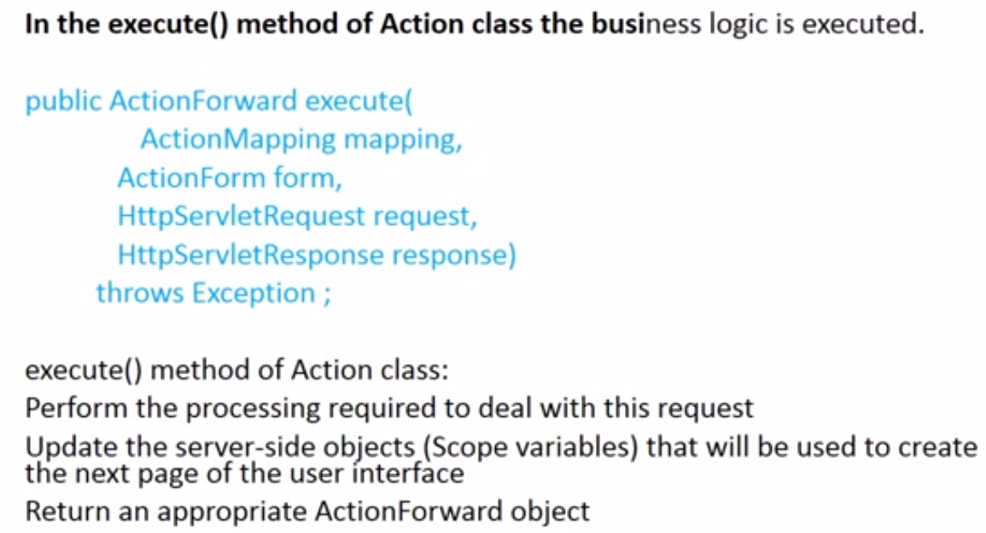
20. Java Struts interview questions - What are the steps used to setup dispatch action
    1. 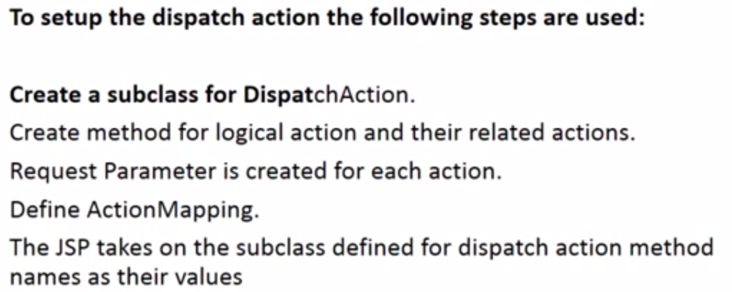
21. Java Struts interview questions and Answers - What are action errors
    1. 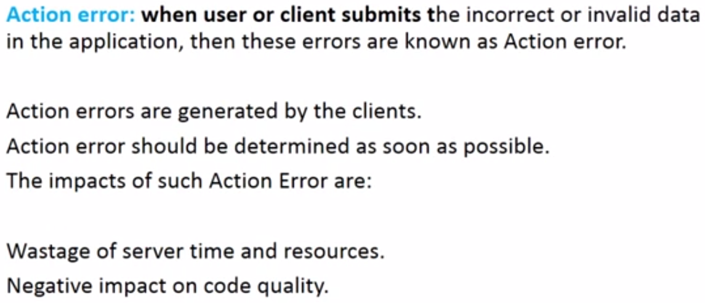
22. Java Struts interview questions and Answers - What are disadvantages of Struts
    1. 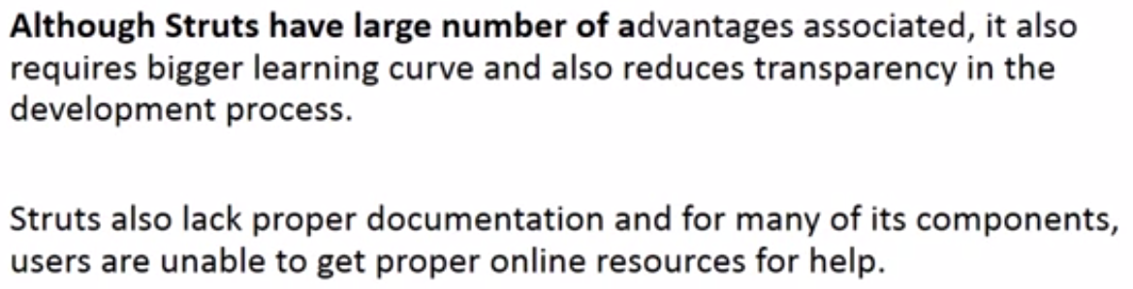
23. Java Struts interview questions and Answers - What are inner class and anonymous class
    1. 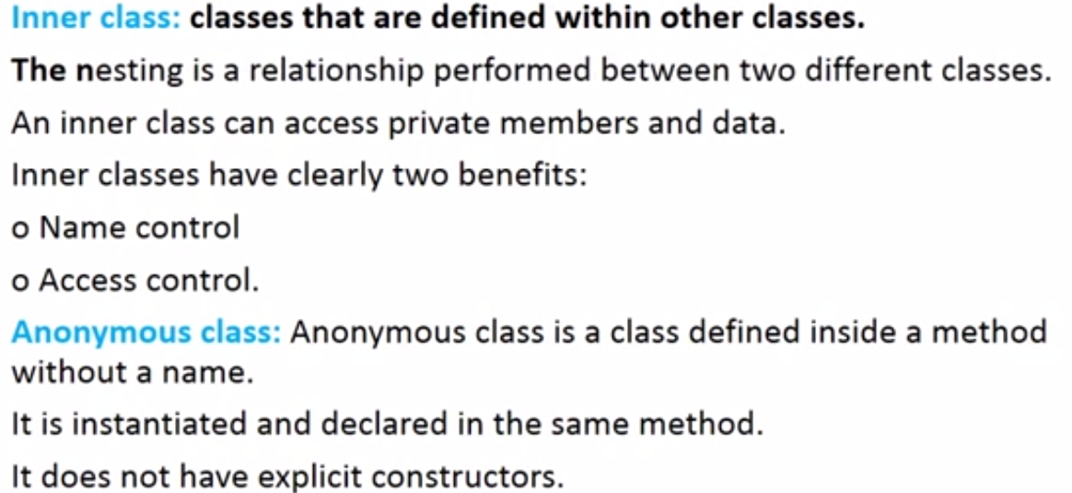
24. Java Struts interview questions and Answers - What are the benefits of Struts framework
    1. 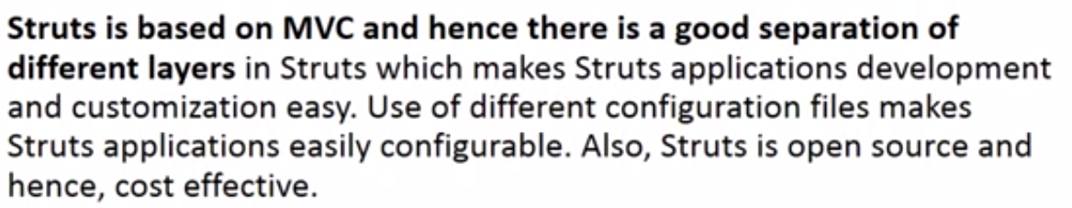
25. Java Struts interview questions and Answers - What are the classes used in Struts
    1. 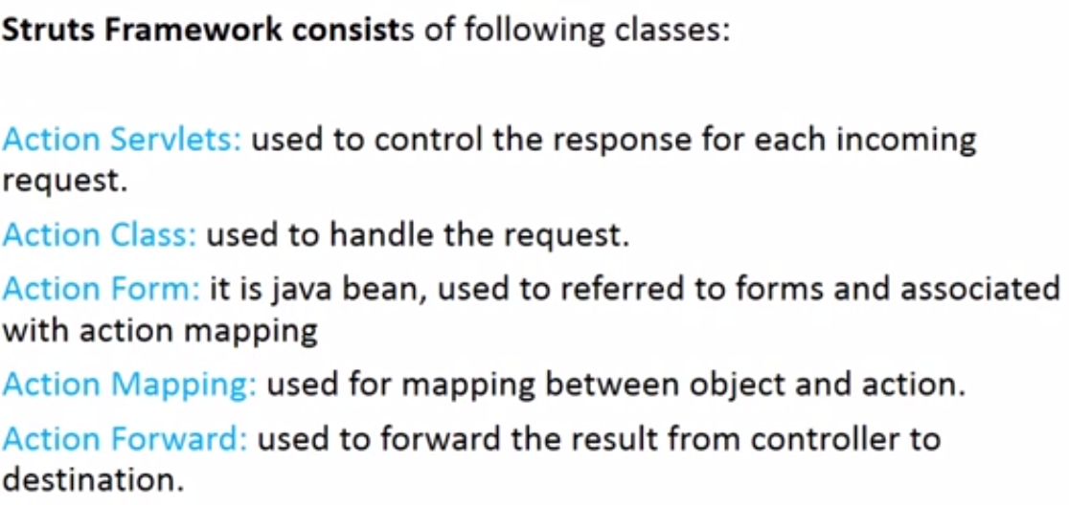
26. Java Struts interview questions and Answers - What are the components of Struts Framework
    1. 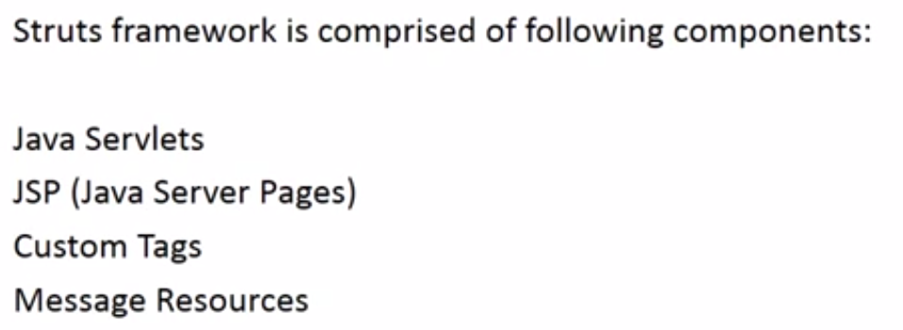
27. Java Struts interview questions and Answers - What are the Core classes of Struts Framework
    1. 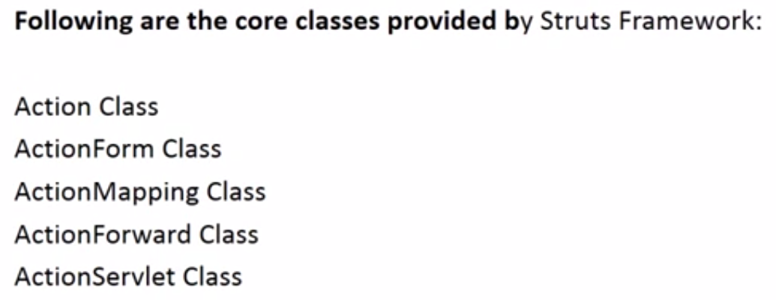
28. Java Struts interview questions and Answers - What are the Custom tags
    1. 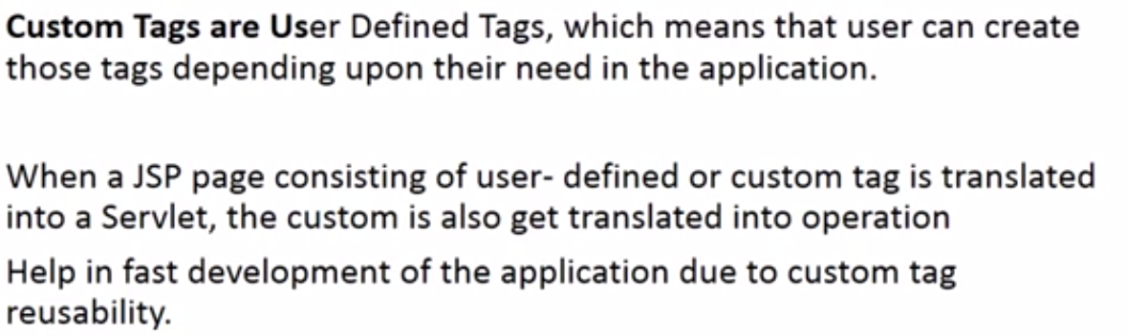
29. Java Struts interview questions and Answers - What are the loop holes of Struts
    1. 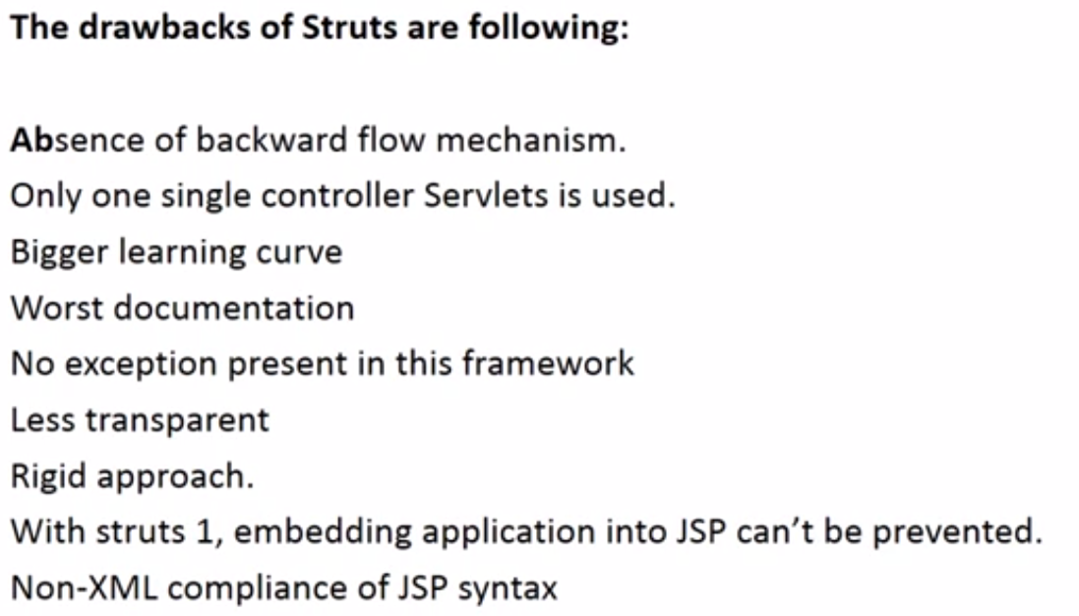
30. Java Struts interview questions and Answers - What are the steps of Struts Installation
    1. 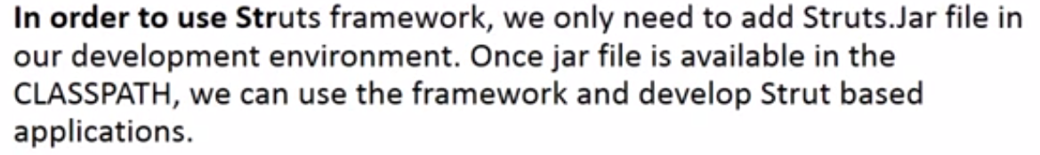

# Durga Soft

1. Demo on Struts Framework1
   1. MVC – Model, View and Controller
   2. MVC 2 – same as MVC with Model, View and controller. But model is divided into three: Business, DAO and Services.
   3. 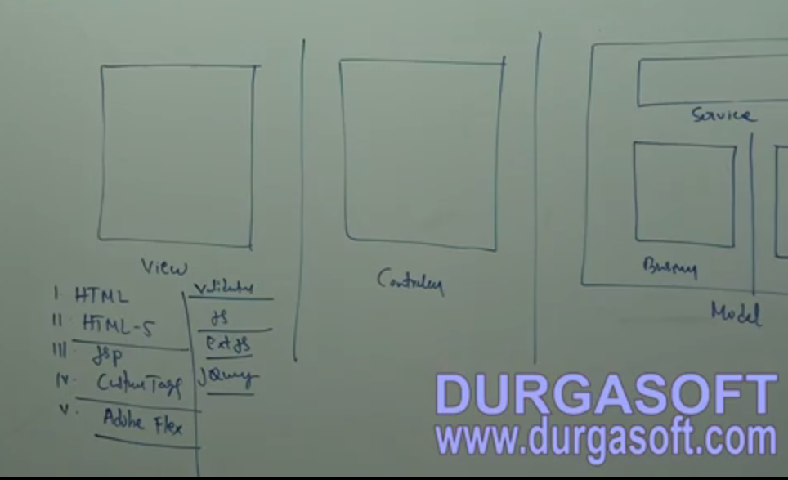
   4. 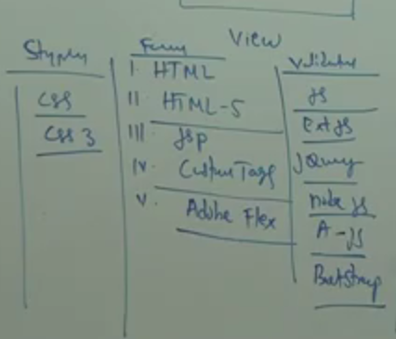
   5. 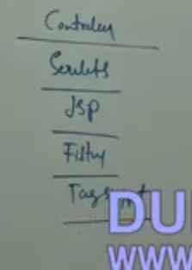
   6. 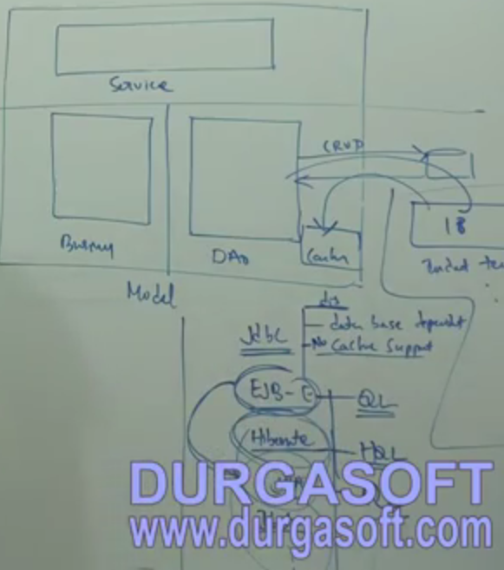
2. Demo on Struts Framework1
   1. 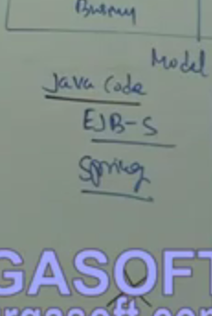
   2. Internationalisation support
   3. AJAX support
   4. Following features are available in struts 1X
      1. Form backup support
      2. Validation support
      3. I18N
      4. L10N
      5. Exception handling
      6. Modularisation
      7. Multi action
      8. Tiles
      9. Plugin support
3. Demo on Struts Framework3
   1. Following features are available in struts 2x along with 1X features
      1. AJAX
      2. Annotation to achive web services
      3. OGNL (Object draft notation lang) – for dynamic page
      4. Interceptors
      5. Pull MVC
4. Struts Frame work - (Part -1) by Naveen
   1. Struts is used in view and controllers only. not in Models
   2. View :
      1. Form tag support - Validation and Form back up
      2. ISBN support
      3. Logical tag support - Iteration Tags, conditional tags
      4. Tiles tag support - UI templates support
   3. Controllers
      1. Multi action controller
      2. multi button controller
      3. multi form controller
      4. Exception handler support
      5. Plug-in Support
      6. pre handling support (security/pre-logging)
      7. I18N
   4. Strut2 along with the above we have
      1. post handling support ( interceptor)
      2. AJAX tag support
      3. Strut2 framework is pull MVC
5. Struts Frame work - (Part - 2) by Naveen
6. Struts Frame work - (Part - 3) by Naveen
   1. 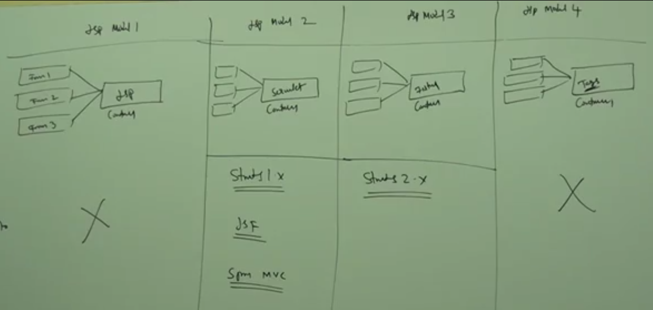
7. Struts Frame work - (Part - 4) by Naveen
   1. Required jars
   2. 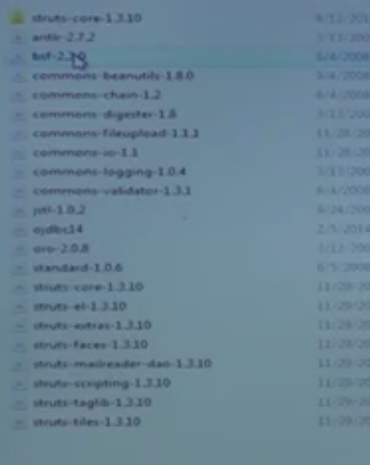
8. Struts Frame work - (Part - 5) by Naveen
   1. To configure struts in web.xml do the following
   2. 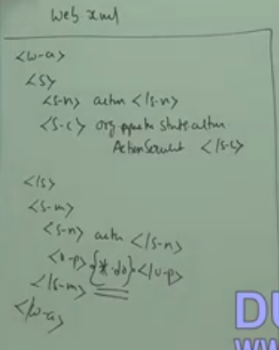
   3. 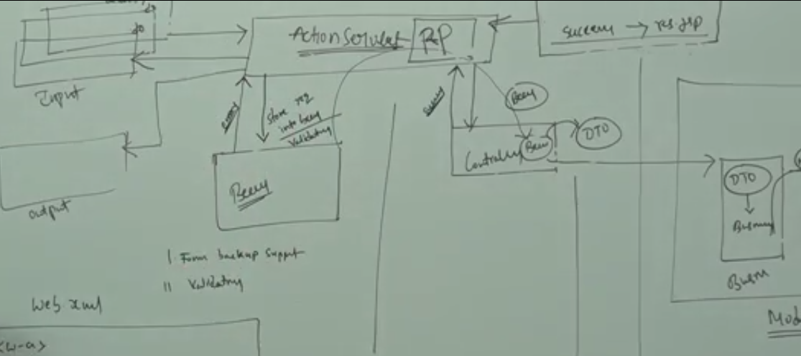
   4. The request from input pages will go to struts action servlet
   5. Request processor (RP) in Action servlet will read the struts configuration file and map the request to its corresponding bean and controller.
   6. from controller the request is passed to business and DAO.
9. Struts Frame work - (Part - 6) by Naveen
   1. Create a Emp reg form
      1. Pages: index.jsp, success.jsp
      2. Bean: Employee<- Action,
      3. Controller : RegistrtionController <- Action (it class can also be Action, DispatchAction, LookupDispatchAction, mappingDispatchAction, EventDispatchAction).
      4. Web.xml -> configure front controller (struts)
      5. struts-config.xml
   2. UI controls
10. Struts Frame work - (Part - 7) by Naveen
    * 1. 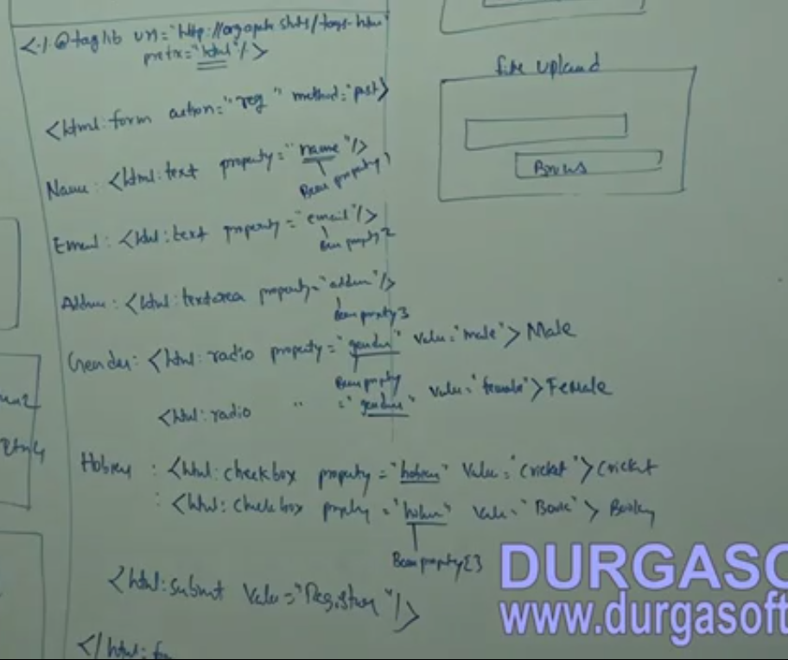
      2. 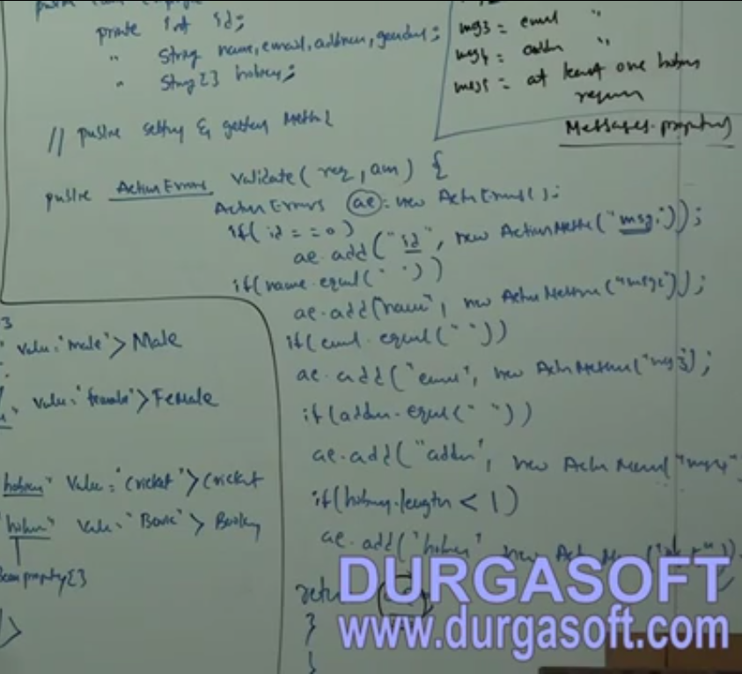
      3. 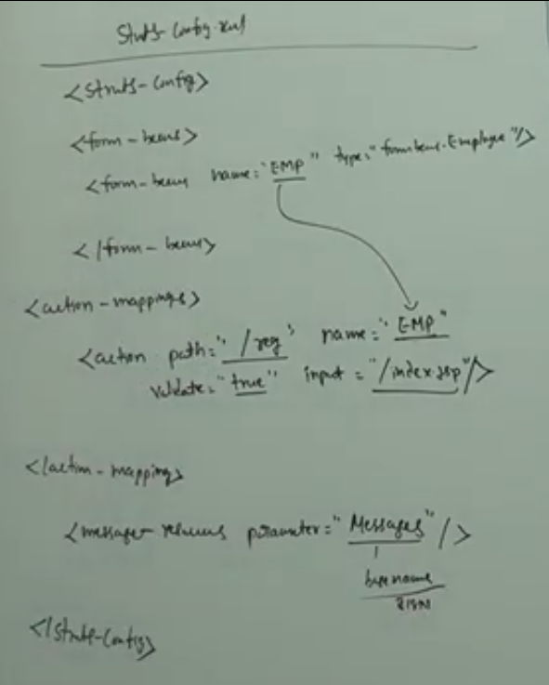
11. Struts Frame work - (Part - 8) by Naveen
    1. Emp reg sample project is done
12. Struts Frame work - (Part - 9) by Naveen
    1. 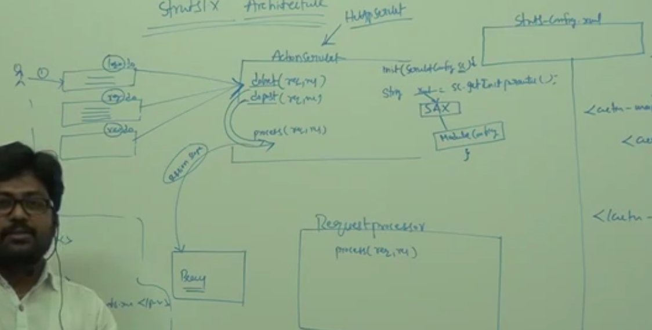
13. Struts Frame work - (Part - 10) by Naveen
14. Struts Frame work - (Part - 11) by Naveen
    1. Validations
       1. Programmatic - ActionForm , DynamicActionForm
       2. Declarative - Xml-> ValidatorForm(single form), DynaValidatorForm(single form), ValidatorActionForm(Multi form), DynaValidatorActionForm(Multi form).
    2. 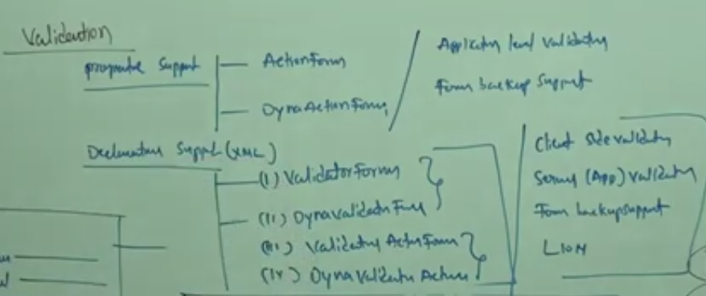
15. Struts Frame work - (Part - 12) by Naveen
    1. To remove the session data after controller method ends we need to wrie one more method in Action class named as RESET
    2. we can also use the scope to Request instead of session to achieve the above
16. Struts Frame work - (Part - 12) by Naveen
    1. Validation can be done thru the following
    2. 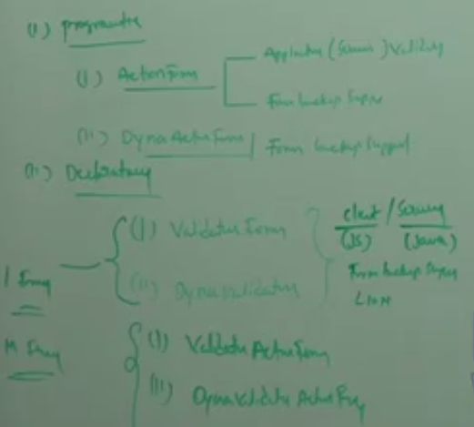
    3. Using validationForm the form is used only for bean backup
    4. The validation are done using separate validation plugin is explaind as below
    5. 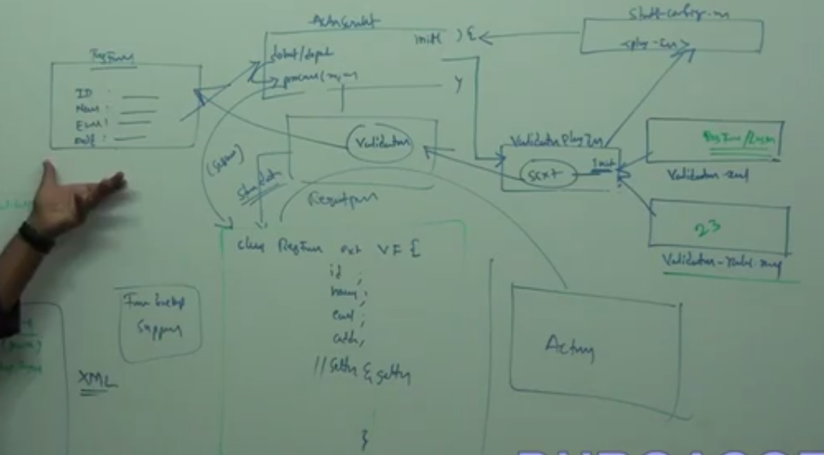
    6. An Example
    7. 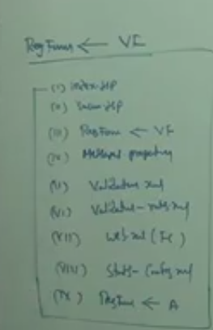
17. Struts Framework- (Part - 14) by Naveen
    1. Design the following
       1. Index.jsp
       2. regForm exts ValidationForm
       3. Validation.xml
       4. Validation-rules.xml
    2. 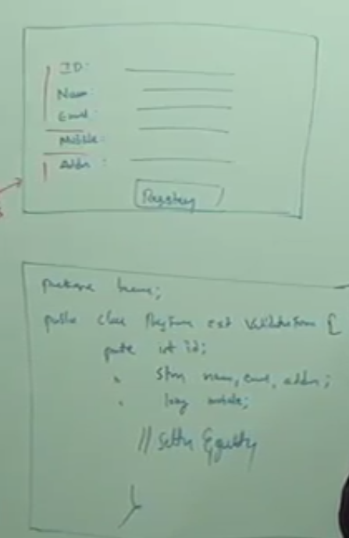
    3. For Min max validation
    4. 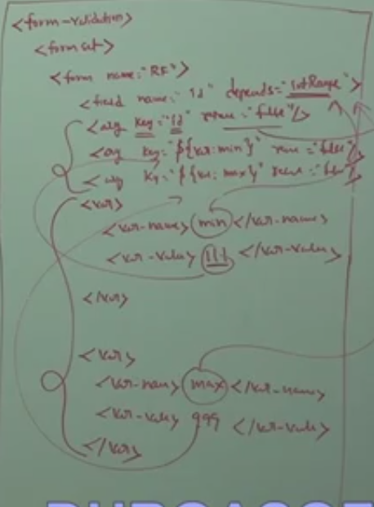
    5. For required
    6. 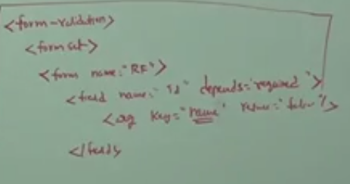
    7. Struts.xml
    8. 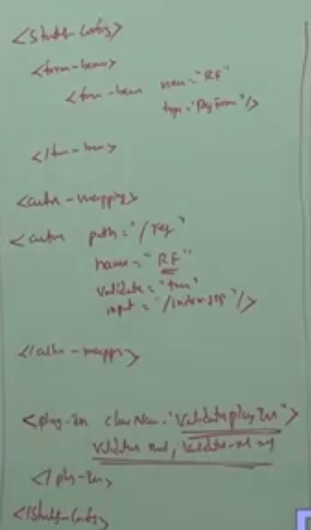
18. Struts Framework- (Part - 15) by Naveen
    1. 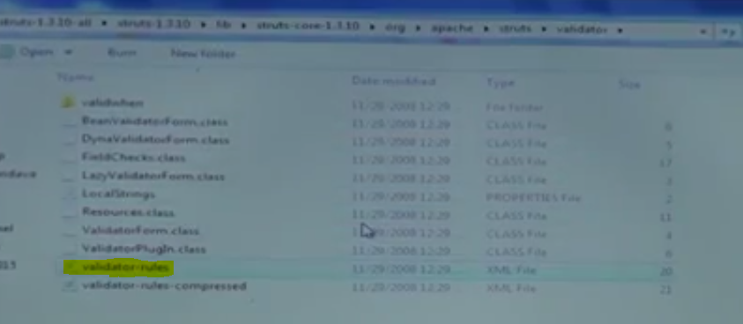
    2. 
19. Struts Framework- (Part - 16) by Naveen
    1. 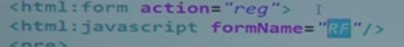
20. Struts Framework - I18N (Part 1) by Naveen
21. Struts Framework - I18N (Part 2) by Naveen
    1. 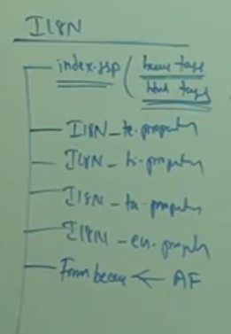
    2. 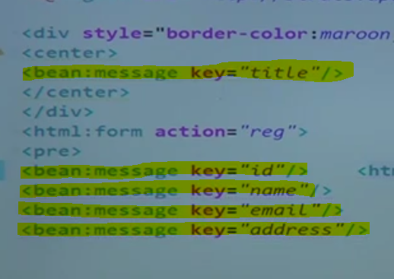
22. Struts Framework - I18N (Part - 3) by Naveen
    1. To use hyperlinks to change the lang
    2. 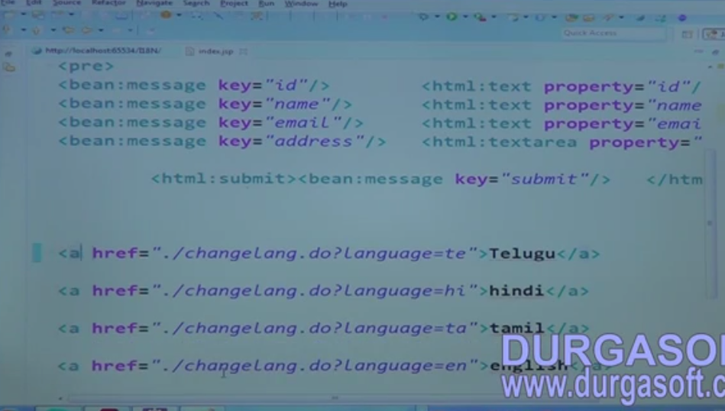
    3. 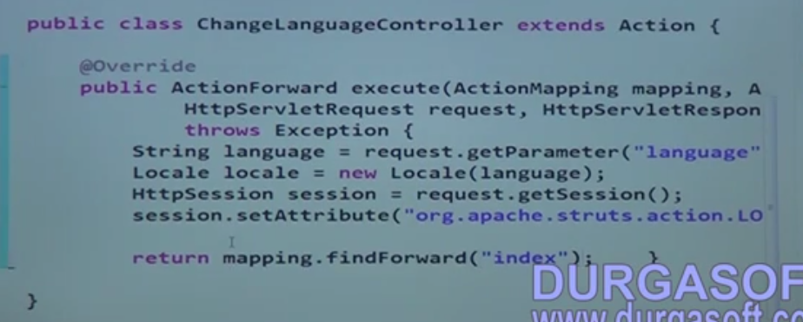
    4. 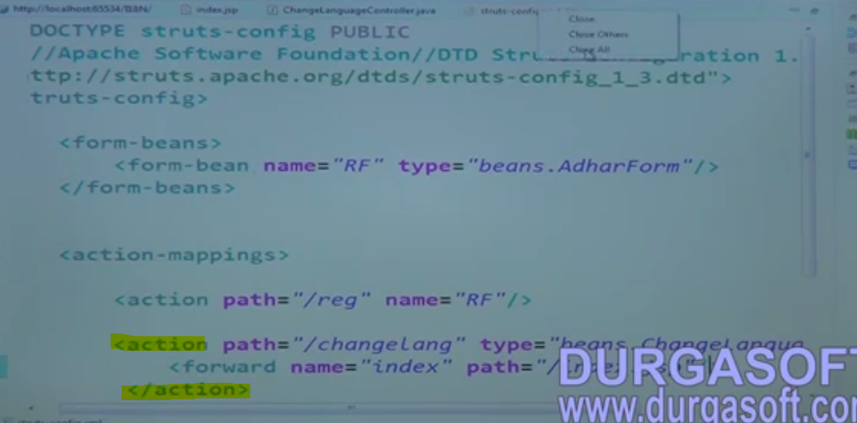
23. Struts Framework - I18N (Part - 4) by Naveen
    1. 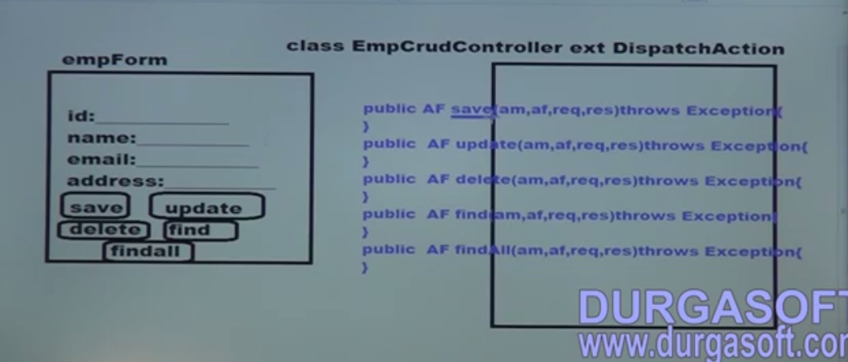
    2. 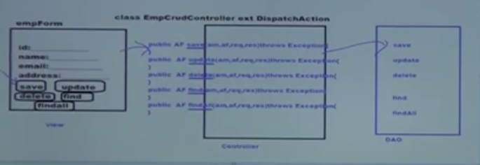
    3. 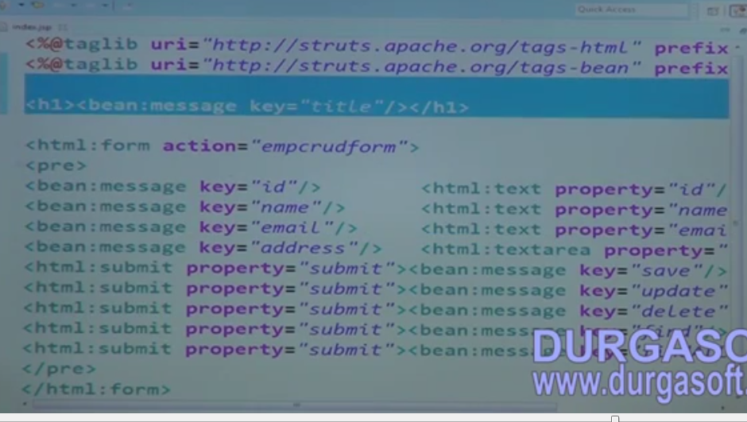
    4. 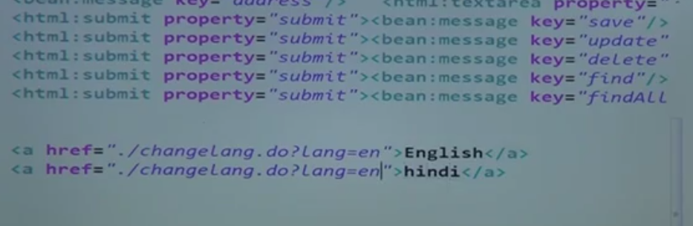
    5. 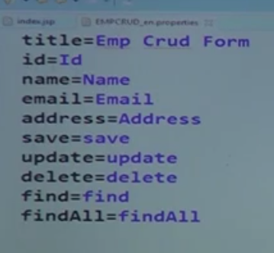
    6. 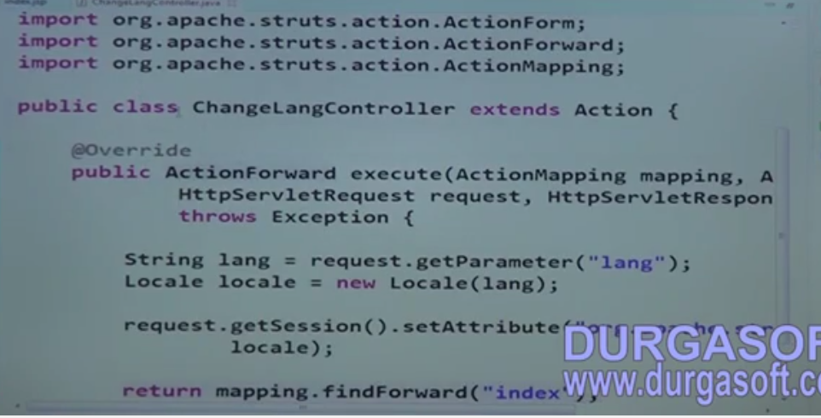
    7. 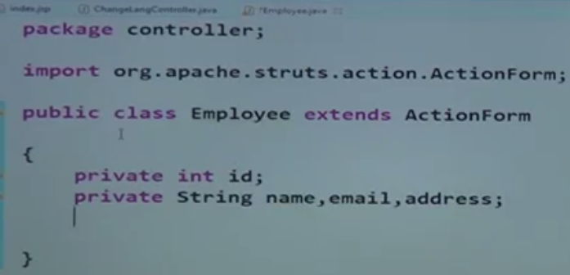
24. Struts Framework - I18N (Part - 5) by Naveen
    1. 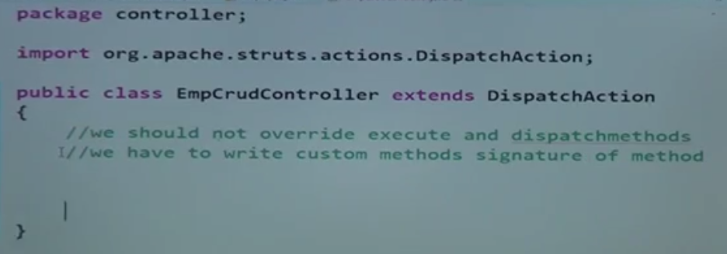
    2. 
    3. 
    4. 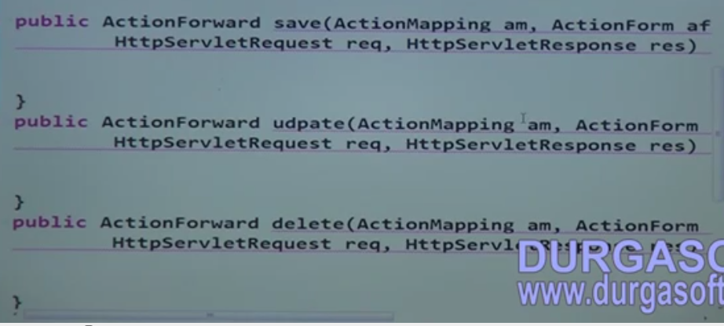
    5. Write a DAO class for CURD option
25. Struts Framework - I18N (Part - 6) by Naveen
    1. 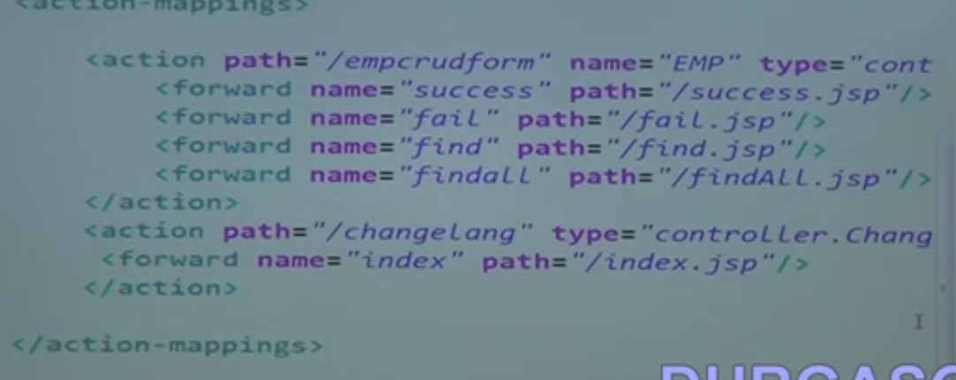
26. Struts Framework - I18N (Part - 7) by Naveen
    1. The problem with dispatch action is it will support multi button action but it will not support I18N support, if the button values are is languages other than english.
    2. if other languages it will search for the encoded language button value in the controller to execute and theat is not possible in java.
    3. So we go with LookupDispatcherAction or EventDispatchAction to achieve this.
27. Struts Framework - I18N (Part - 8) by Naveen
    1. 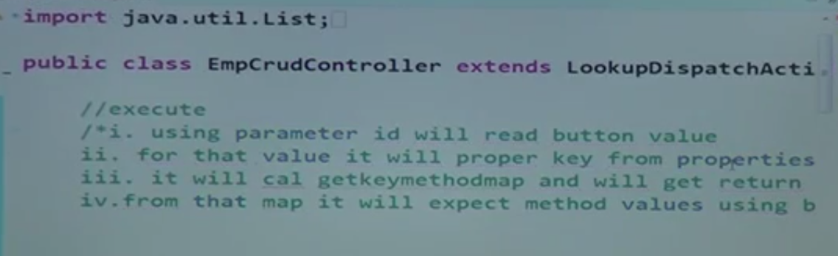
    2. 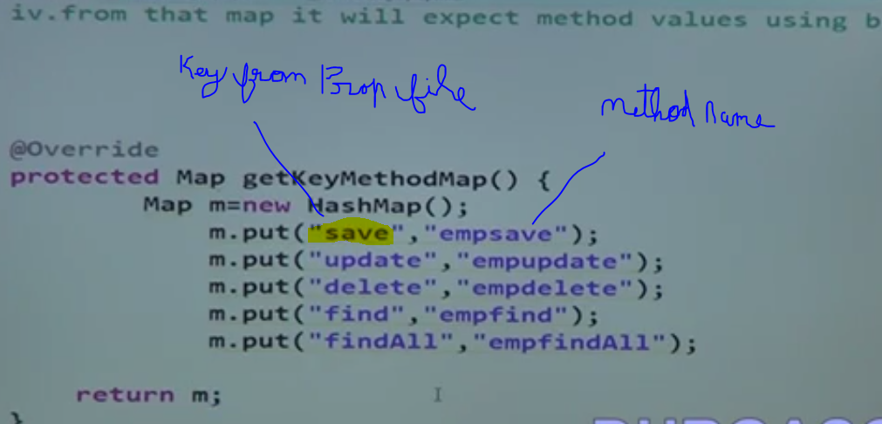
    3. Using EventmethodDispatchMethod
    4. 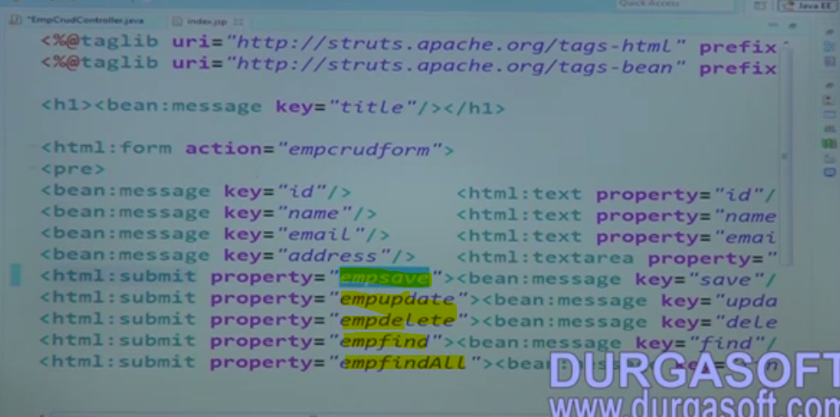
    5. Add these values as parameter in Struts config.xml under Action tag
    6. 
28. Struts Framework - I18N (Part - 9) by Naveen
    1. Map two forms to a single controller
    2. 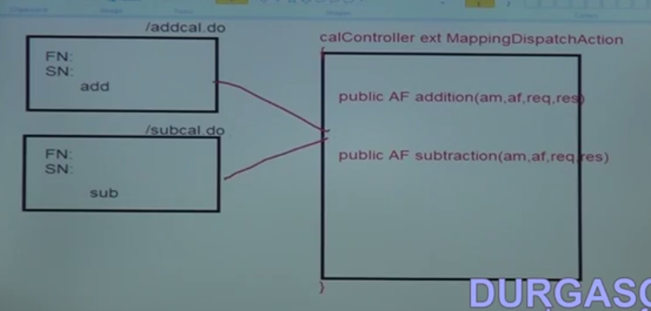
    3. 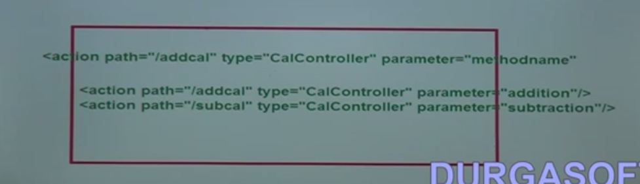
    4. Sample for add, update, delete and find and findAll form different pages using ame controller
    5. 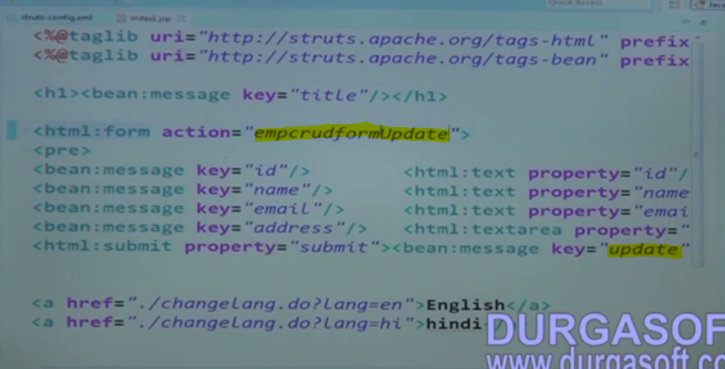
    6. 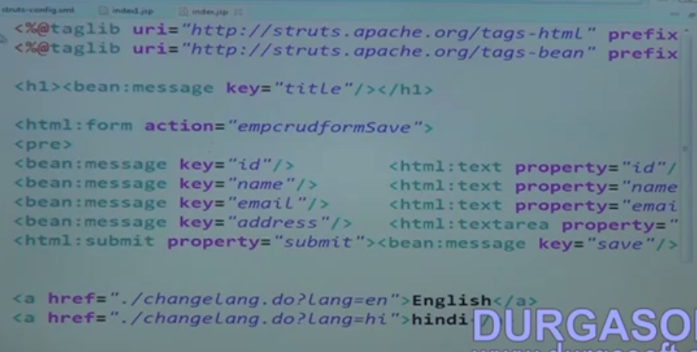
    7. 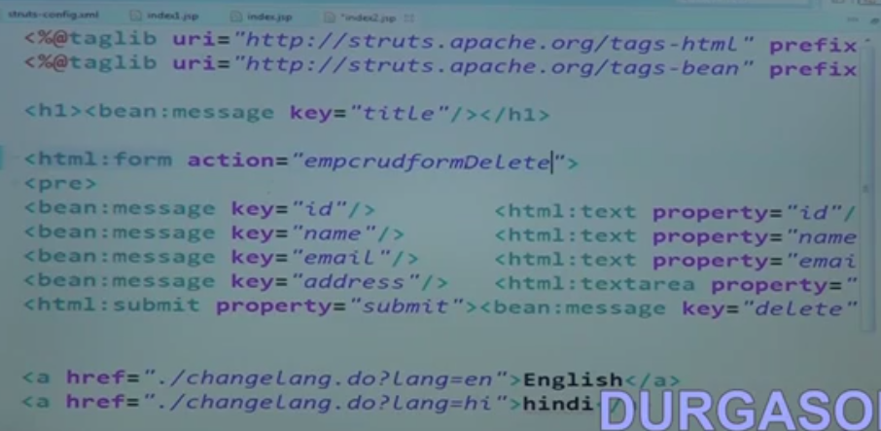
    8. 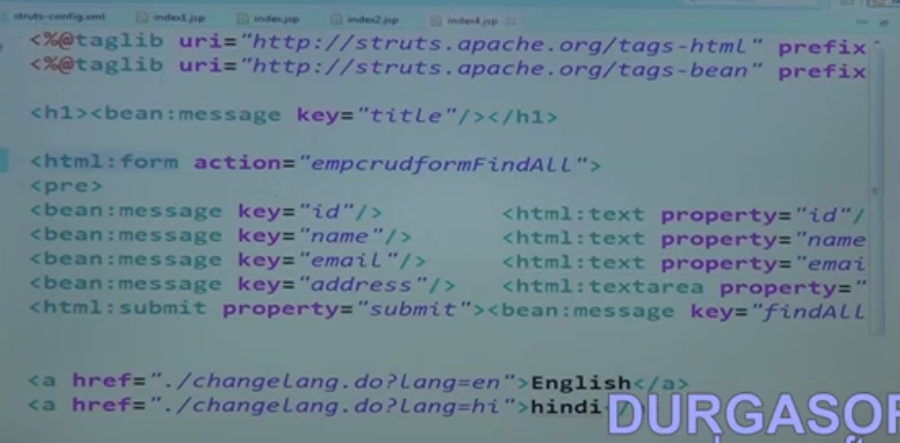
    9. 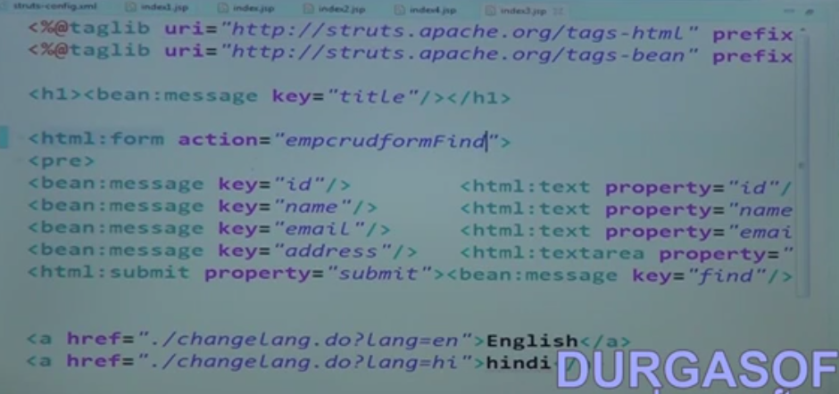
    10. 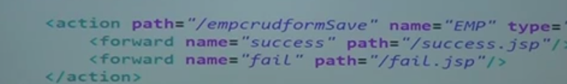
    11. 
    12. 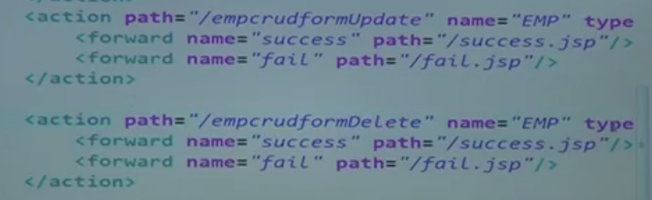
    13. 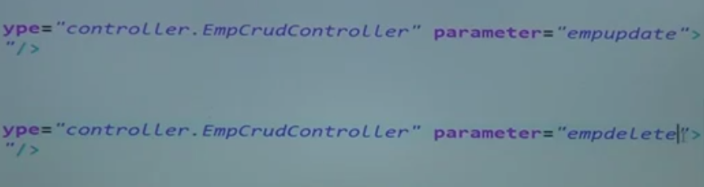
    14. 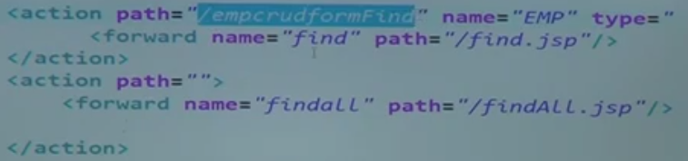
    15. 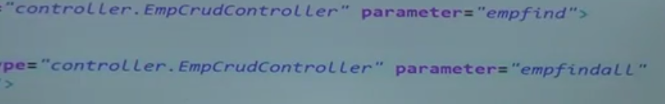
    16. 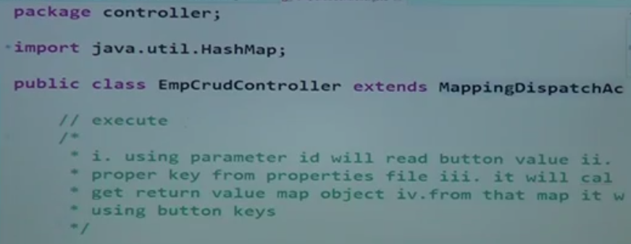
29. Struts Frameworks Controllers 1
    1. 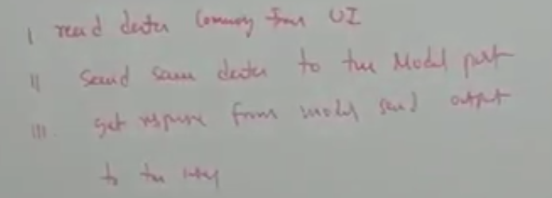
    2. Types:
       1. **Action** - Used for single button
       2. **Dispatch Action** - Multiple Submit button. But it won't support I18N support. Since Button name should be equal to method name in the controller, other language decoded value will throw exception
       3. **LookupDispatchAction** - Here Submit button key in message.properties are mapped to the method name. so it support both multi action and I18N support.
       4. **EventDispatchAction** - map the submit button id to methods in controller
       5. **MappingDispatchAction** - Multiple form action to a single controller.
30. Struts Frameworks Controllers 2
    1. Action Class example
    2. Create a Dynamic web project
    3. 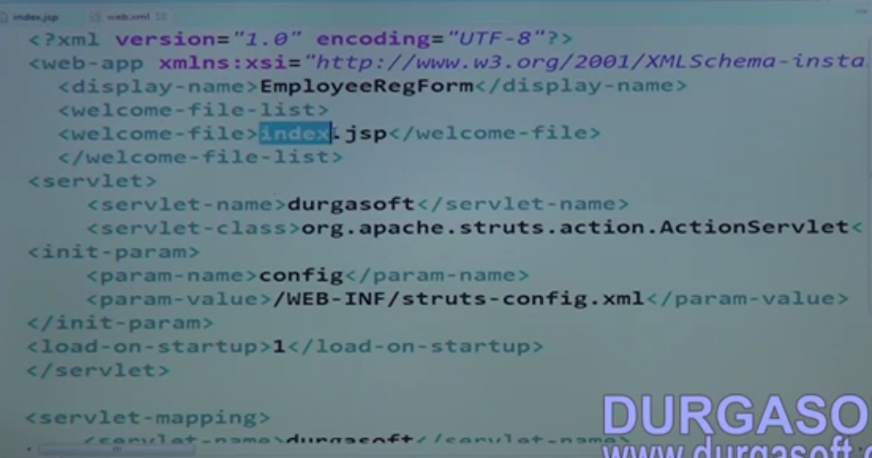
    4. 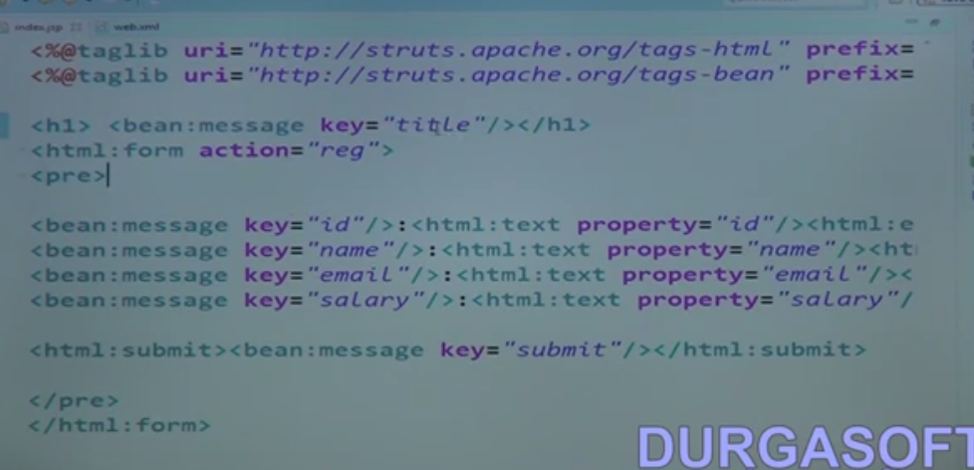
    5. 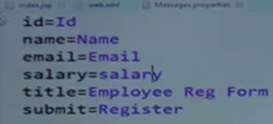
    6. Do the same for other lang
    7. 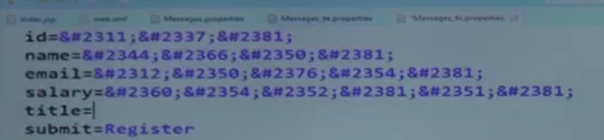
    8. Create a bean RegForm
    9. 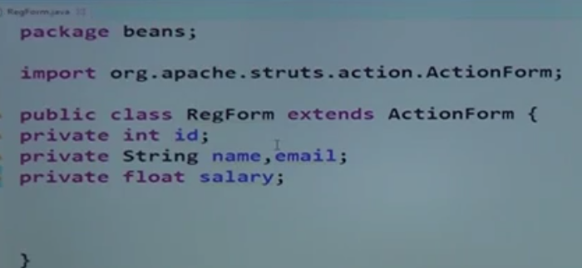
    10. 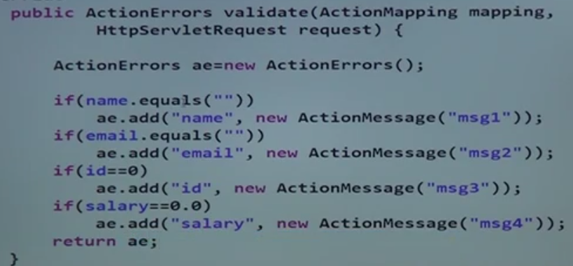
    11. Add the messages(msg1,msg2,msg3,msg4) in the properties files
    12. 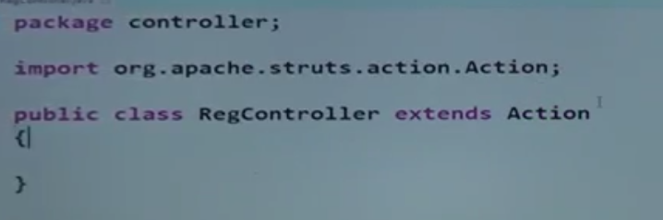
    13. create DAO for CURD operations
    14. 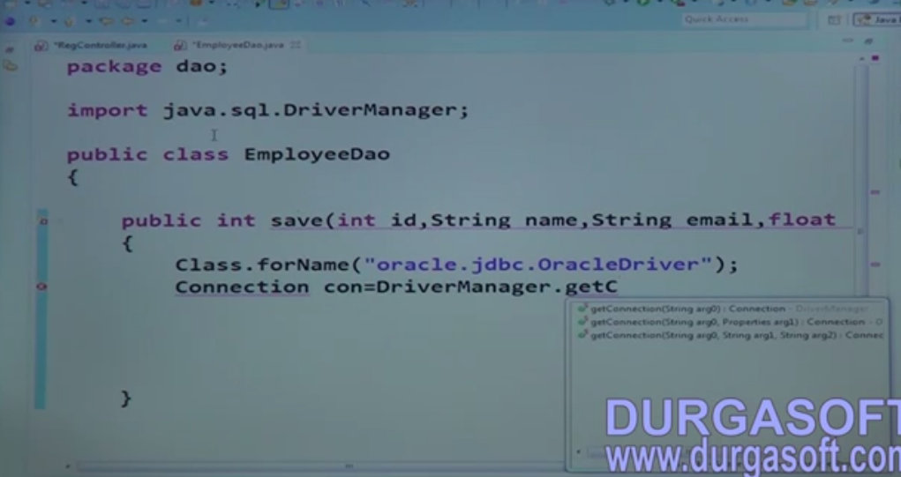
    15. 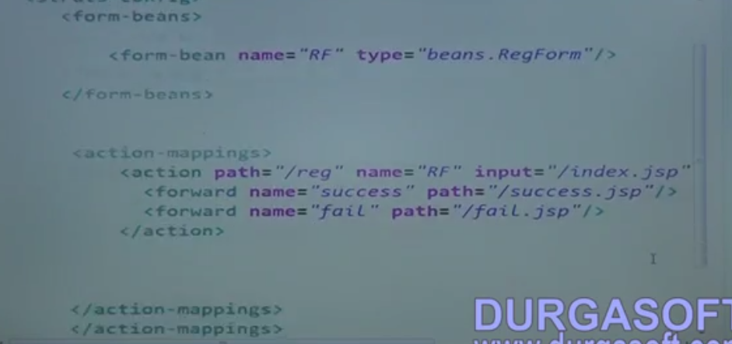
    16. 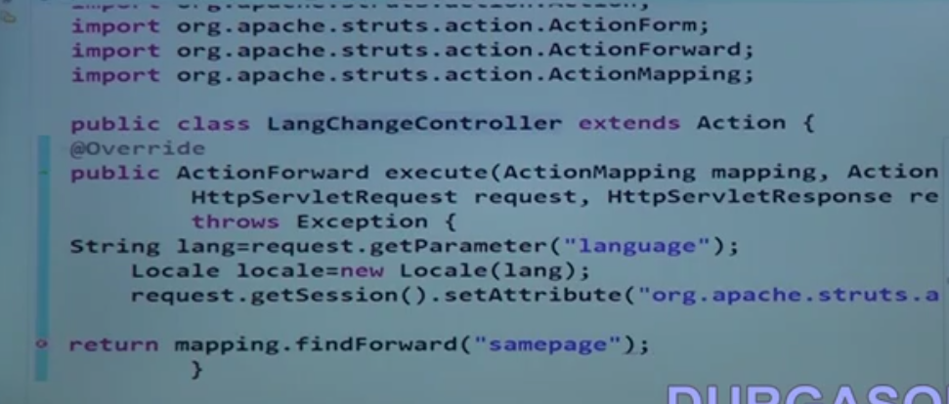
    17. 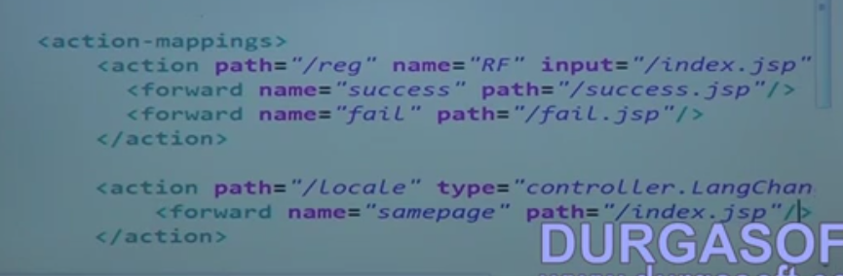
31. Struts Frameworks Controllers 3
    1. To do multiple action in same form with out I18N support we can extend our form from DispatchAction
    2. 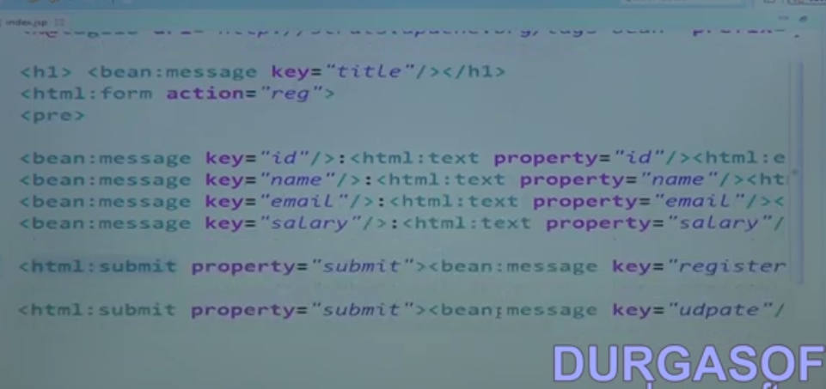
    3. 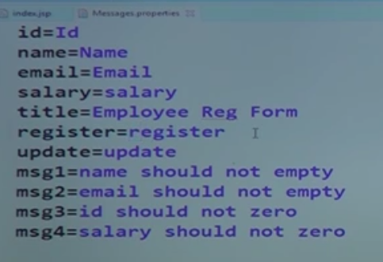
    4. Do the same in other properties file too
    5. 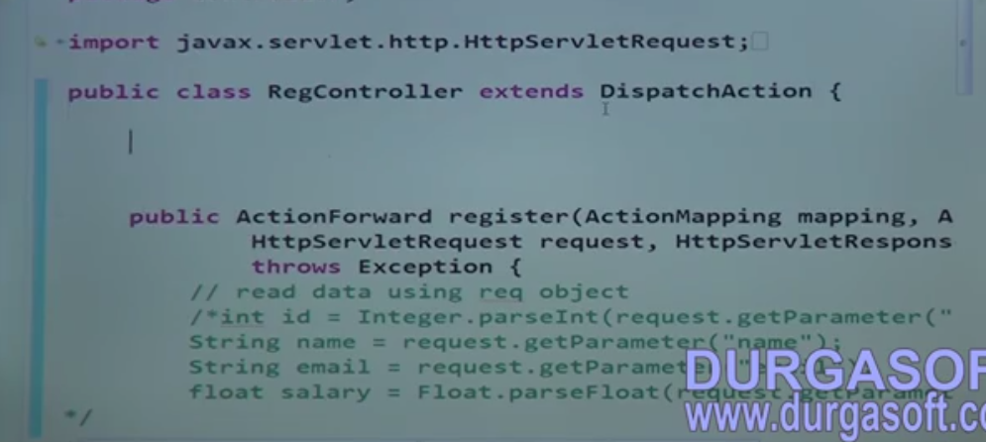
    6. Add two methods register and update in this controller and call the corresponding DAO.
    7. If we use other languages we will get "NoSuchMethodException".
    8. So with I18N support along with multi button action we need to extend our controller from **LookupDispatchAction.**
32. Struts Frameworks Controllers 4
    1. 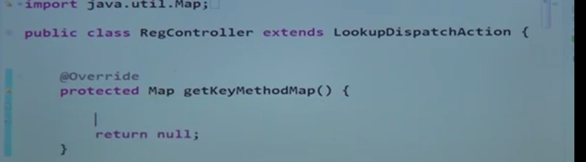
    2. 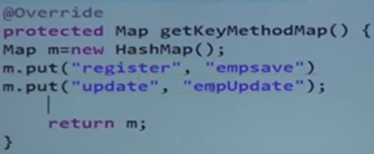
    3. Using the above change we can achieve I18N support along with multi action.
    4. We can also do the same using "**EventDispatchAction**". Here we will use the button Id to map the method in Controller.
    5. 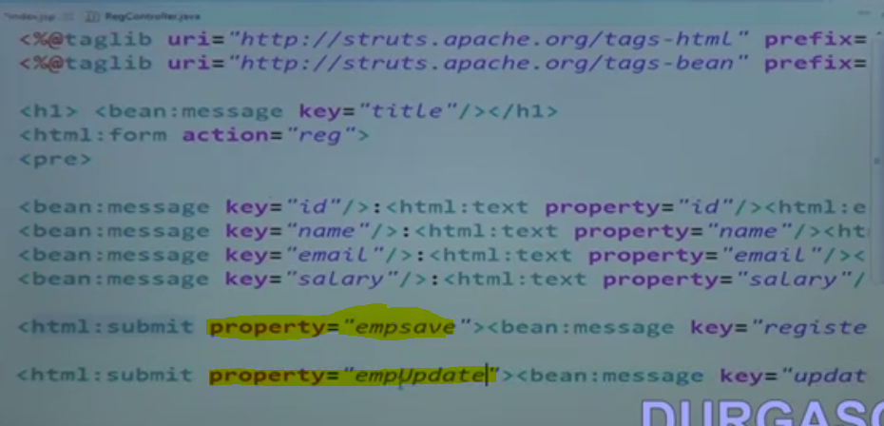
    6. 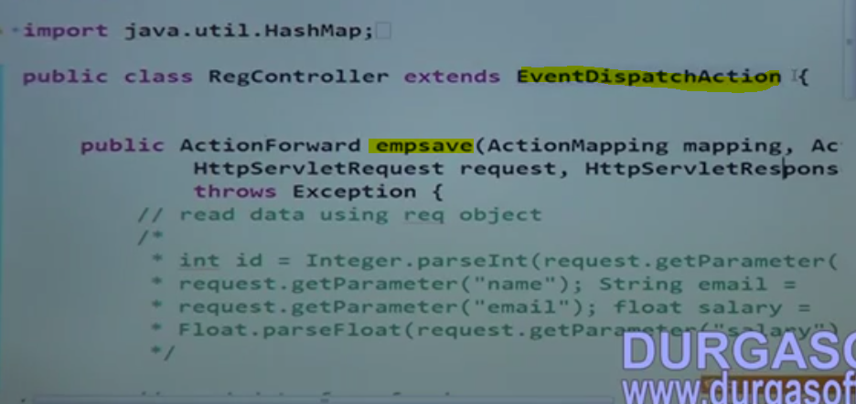
    7. 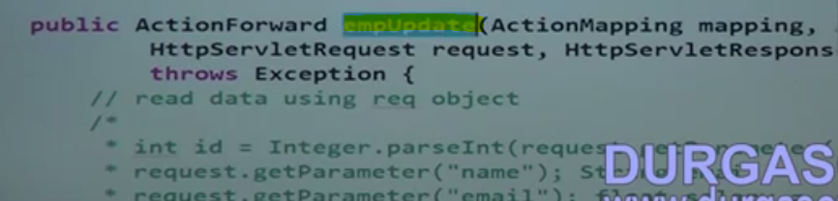
    8. 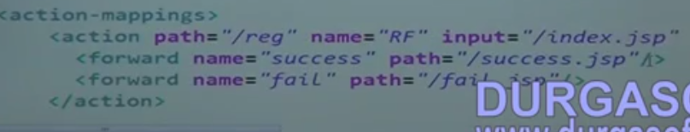
    9. 
33. Struts Frameworks Controllers 5
    1. 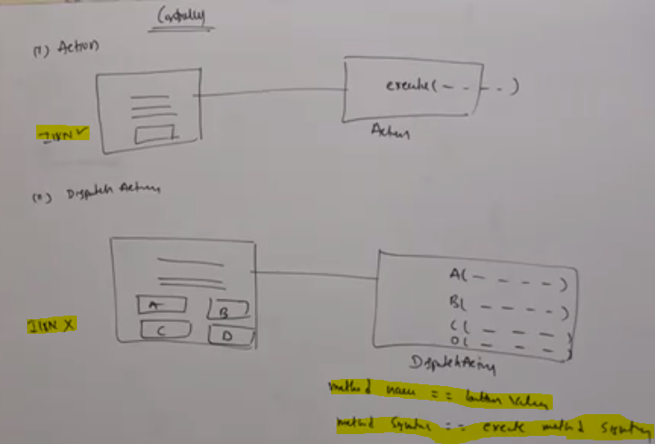
    2. 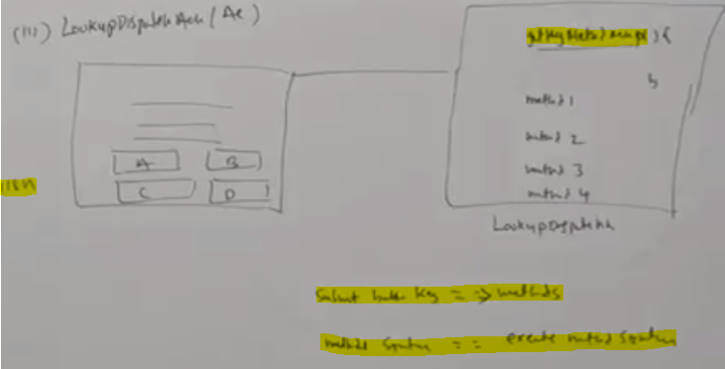
    3. 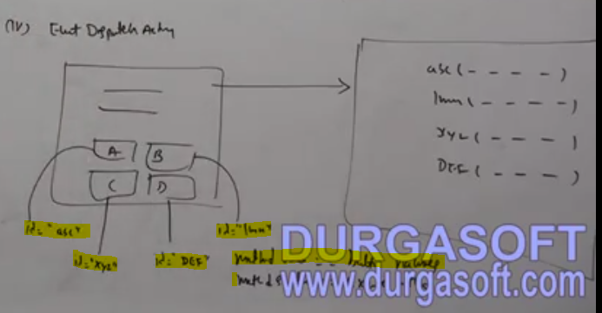
       1. Method names should be equal to Button ID
       2. Method sign should be equal to execute method
    4. The final is mapping dispatch action
       1. 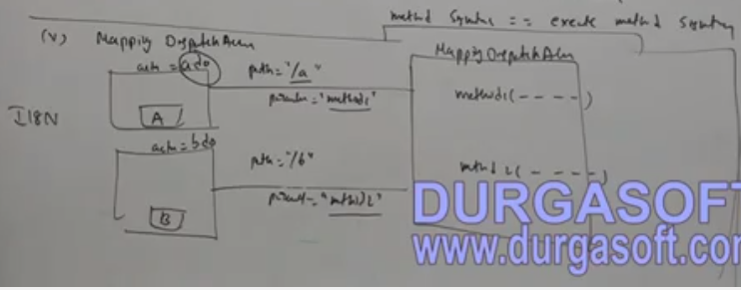
       2. 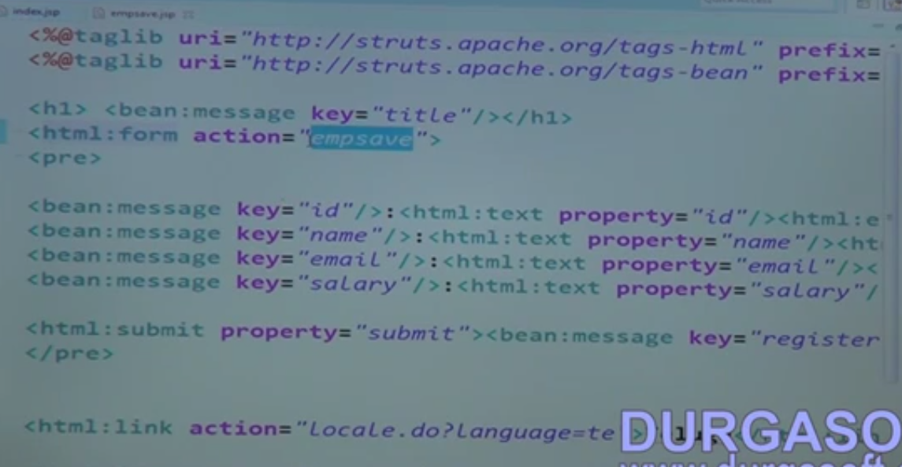
       3. 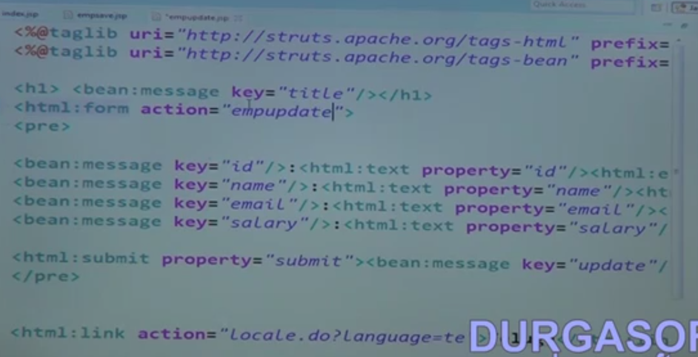
       4. 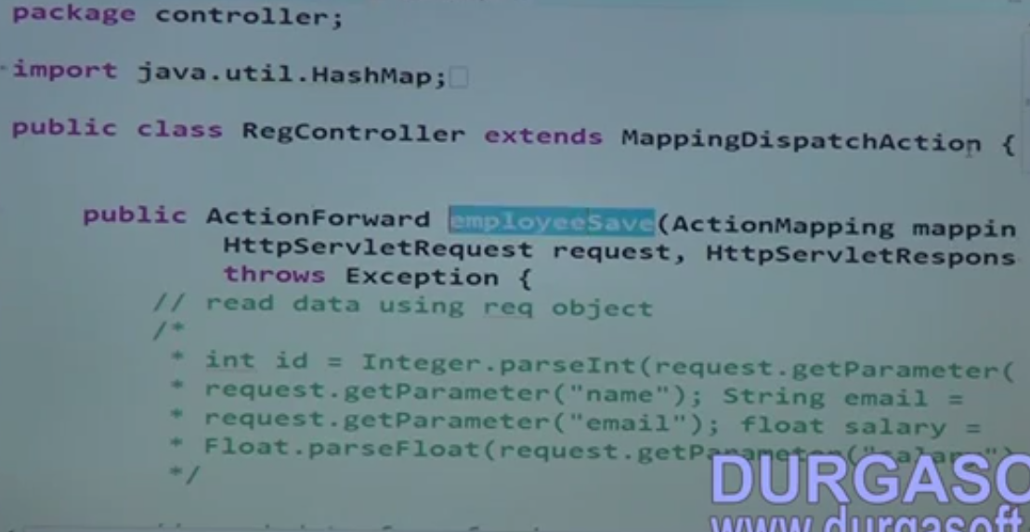
       5. 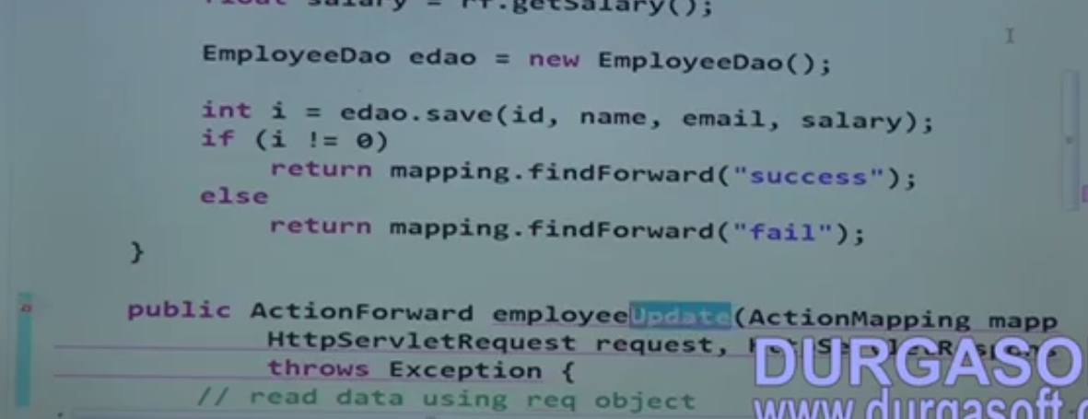
       6. 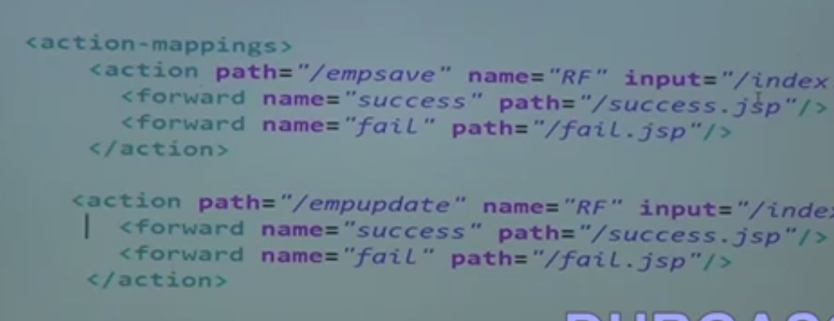
       7. 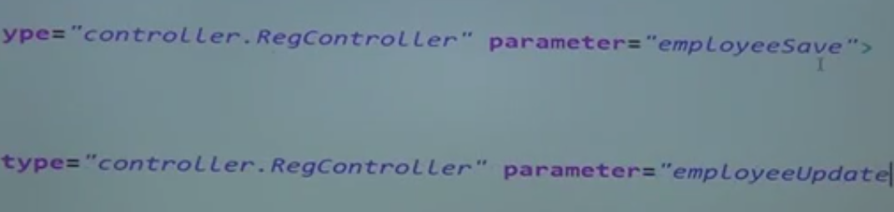
       8. We can configure in global forwards as below to general forward actions as shown below
       9. 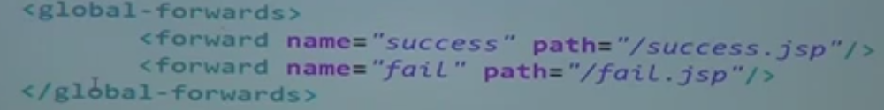
34. Struts Frameworks Built in Actions 1
    1. Following are the types of build in Actions
       1. Forward action
       2. Include action
       3. Switch action
       4. Locale Action
       5. Download Action
       6. Exception Handler
35. Struts Frameworks Built in Actions 2
    1. Forward and Include action Example
    2. 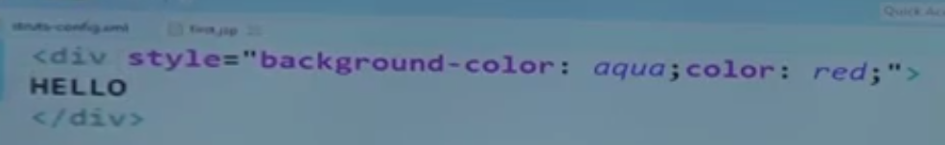
    3. 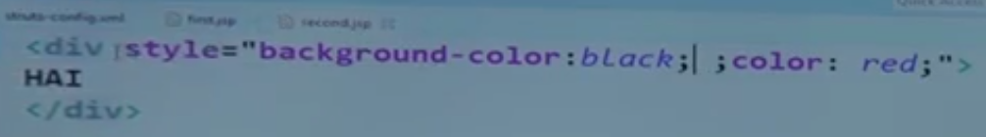
    4. Forward from first.jsp to second.jsp
    5. 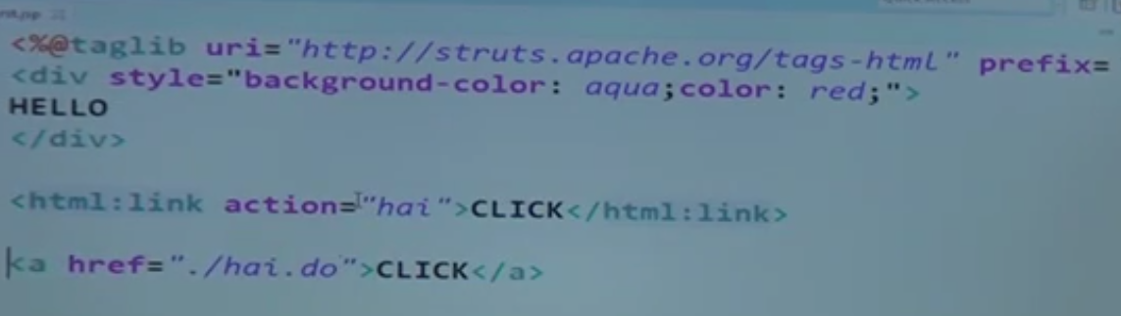
    6. 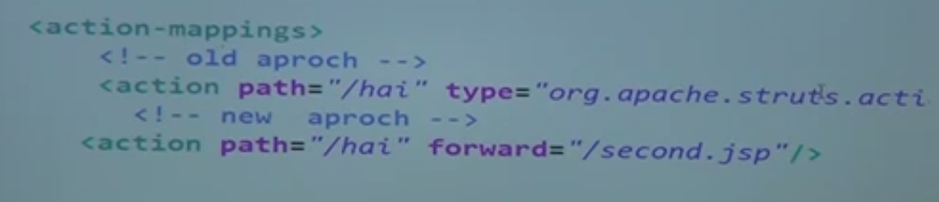
    7. 
    8. For Include action
    9. 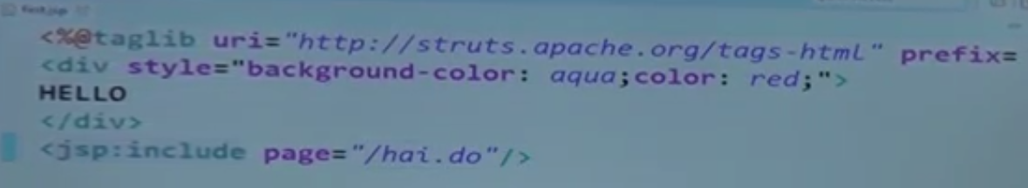
36. Struts Frameworks Built in Actions 3
    1. Switch Action
37. Struts Frameworks Built in Actions 4
    1. 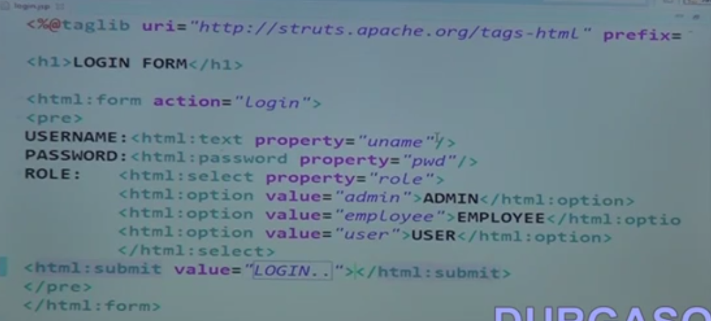
    2. Use action class as controller
    3. 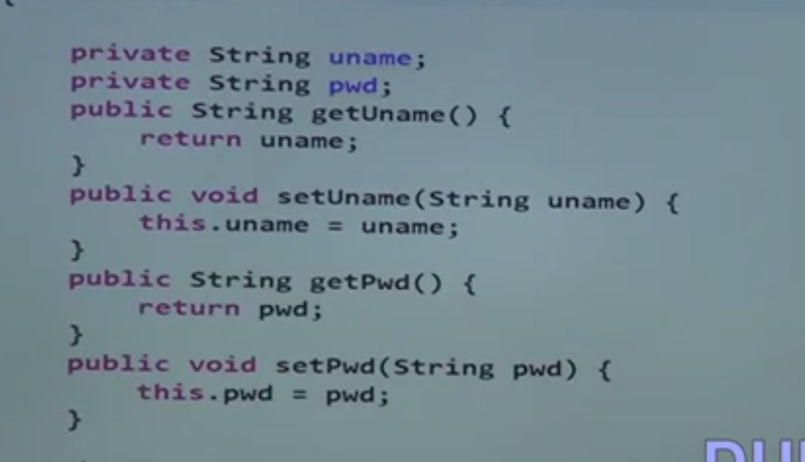
    4. 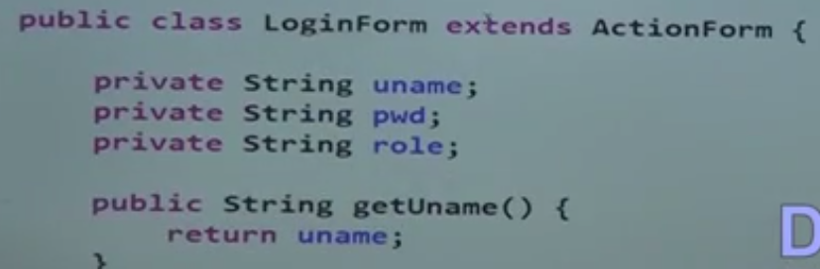
    5. Create one more Actionform extends Action class
    6. 
    7. 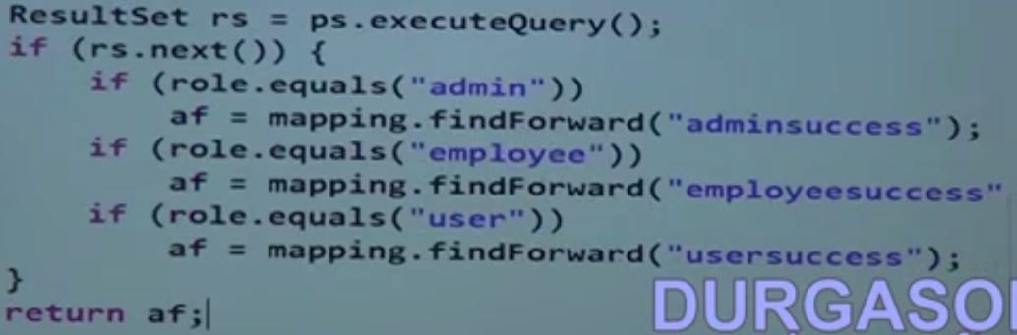
38. Struts Frameworks Built in Actions 5
    1. 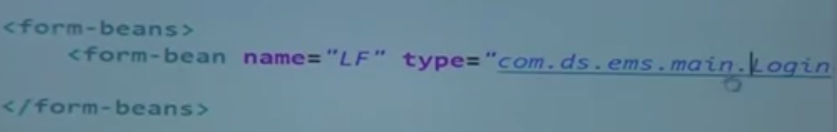
    2. 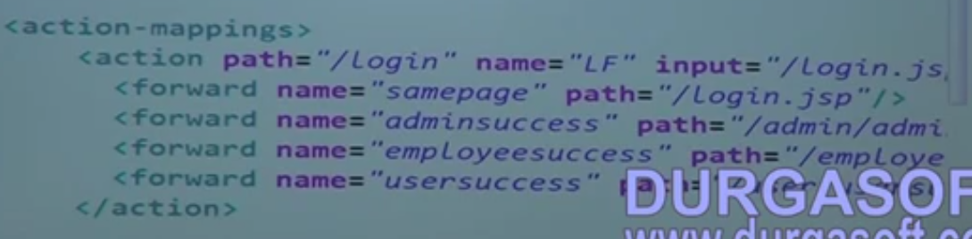
    3. If the Adminsuccess page has some form, then do the following
    4. 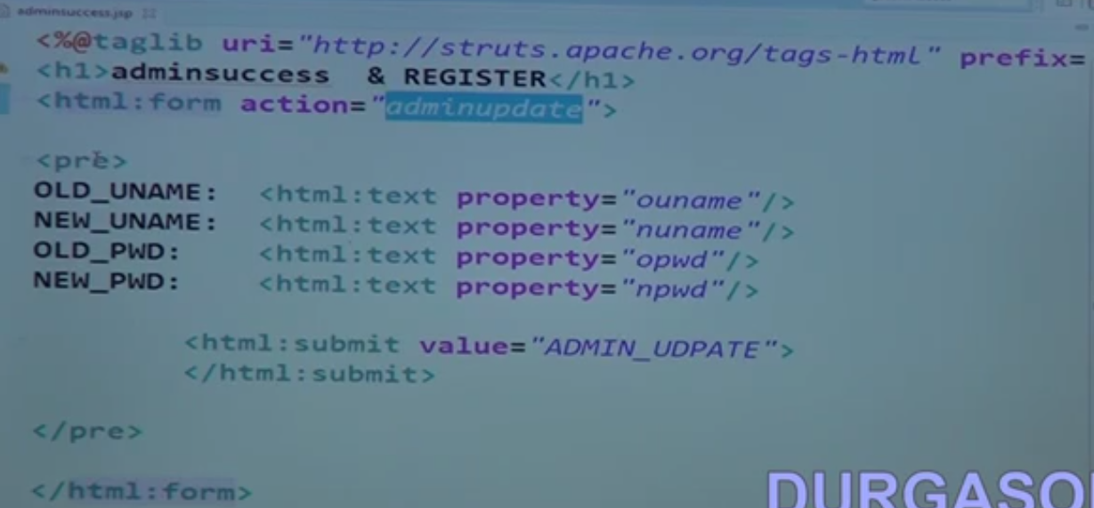
    5. 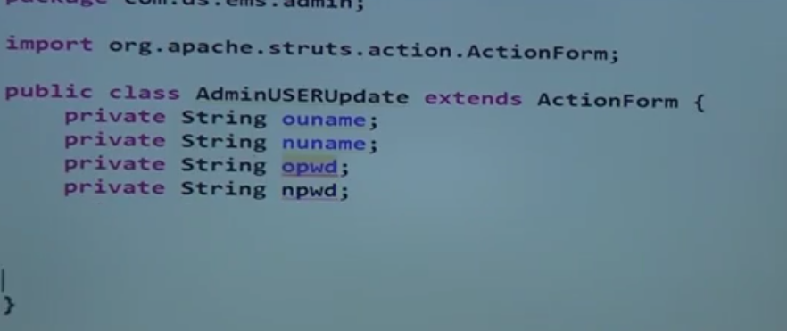
    6. 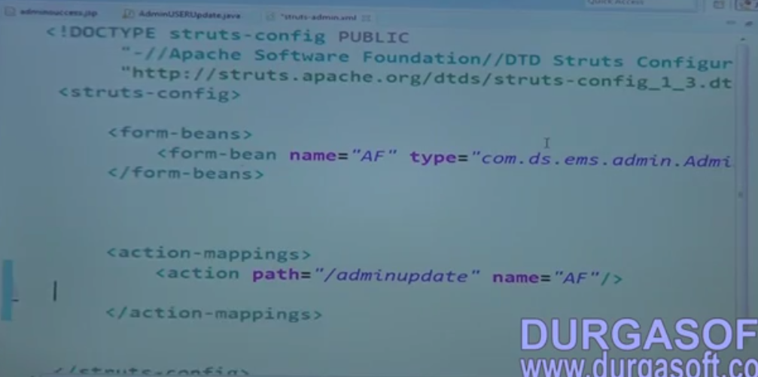
    7. 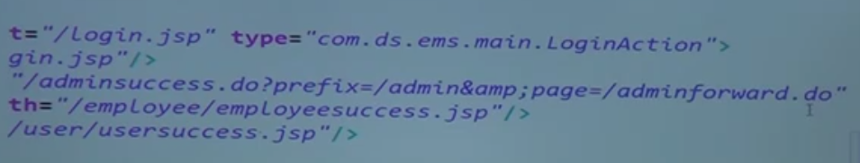
    8. 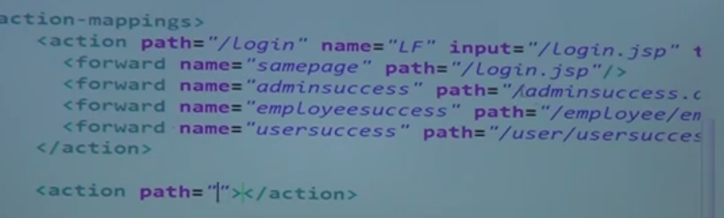
    9. 
    10. 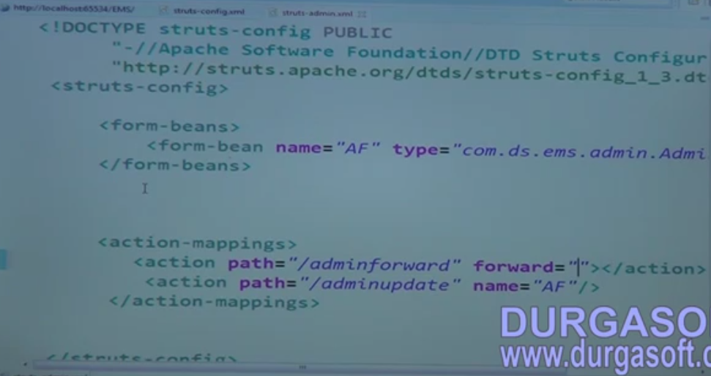
    11. Using simple Hyperlink
    12. 
39. Struts Frameworks Built in Actions 6
    1. Download Action
    2. 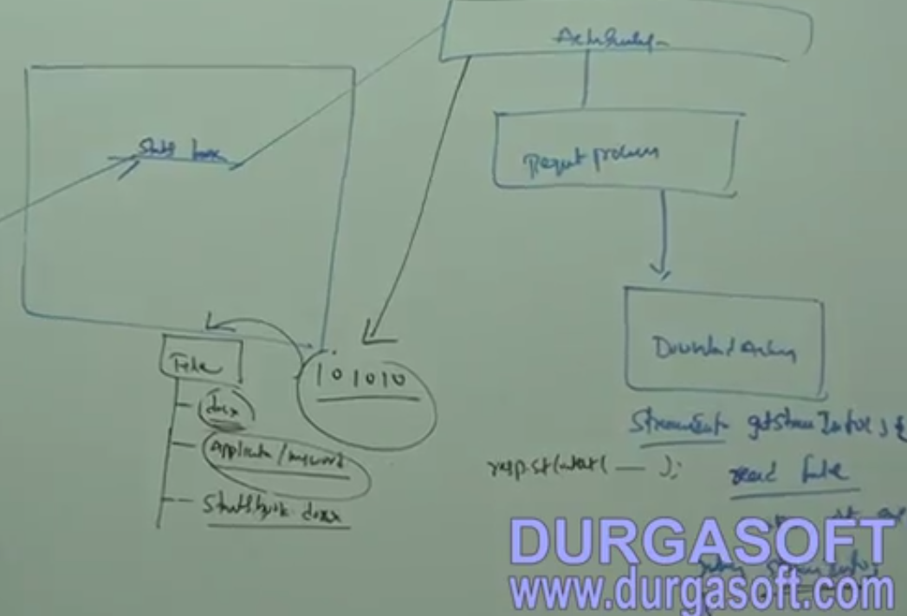
    3. Create a new Dynamic web project
    4. 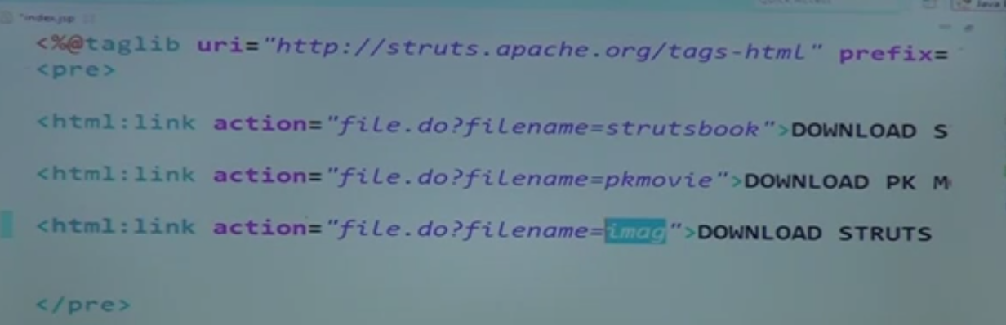
    5. Create a controller
    6. 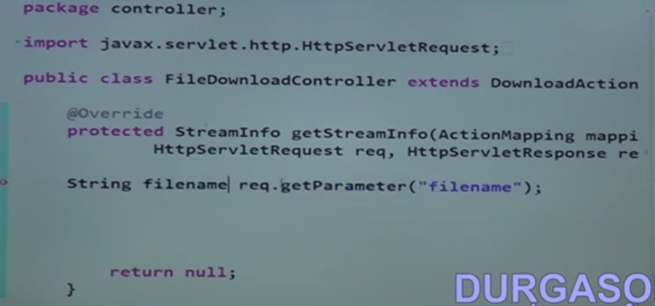
40. Struts Frameworks Built in Actions 7
    1. 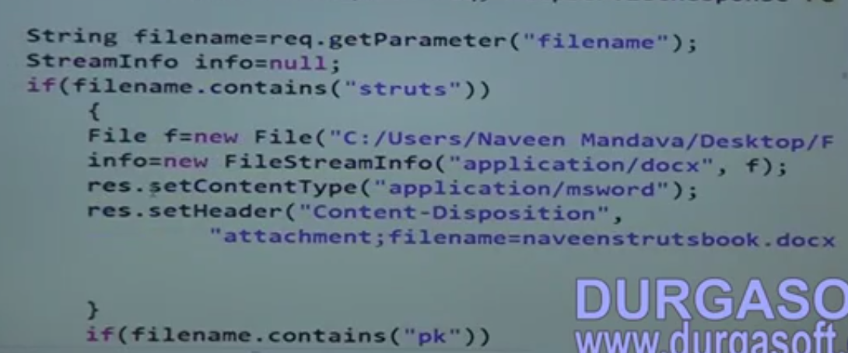
    2. 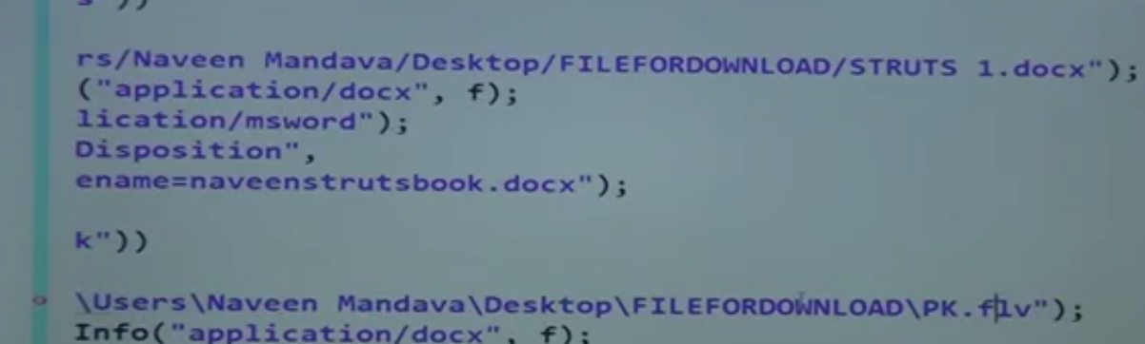
    3. 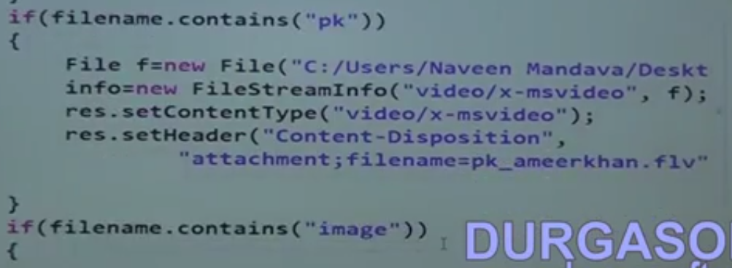
    4. 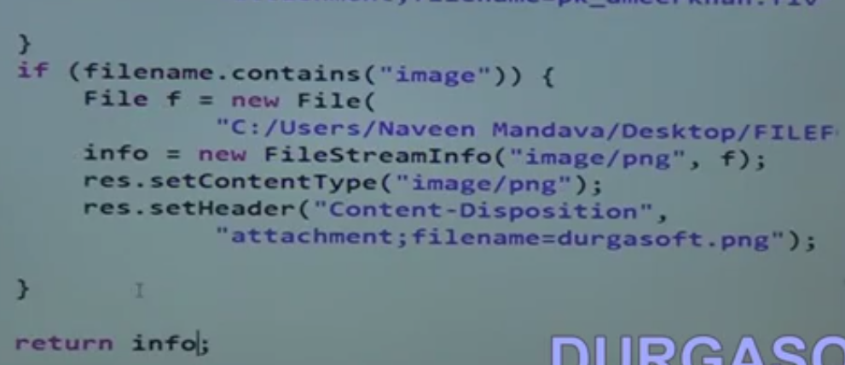
    5. 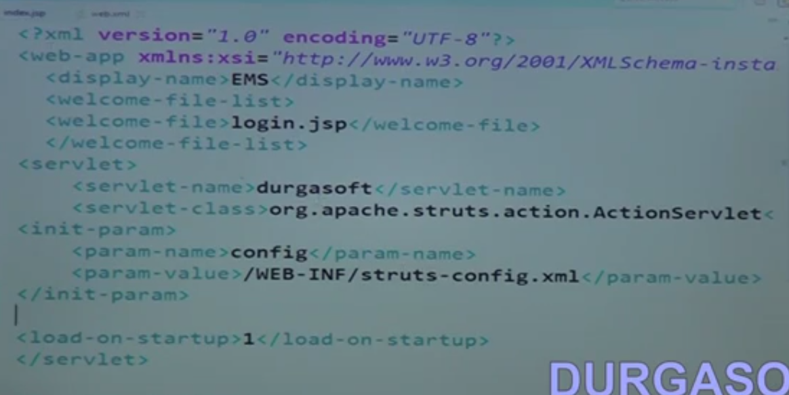
    6. 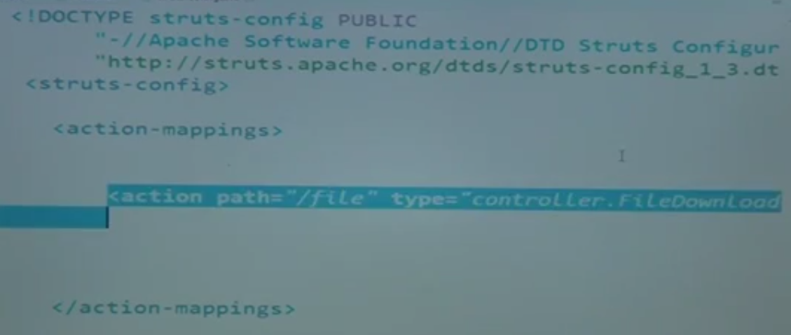
    7. Locale Action - to change browser language
41. Struts Frameworks Built in Actions 8
    1. Create a new dynamic web project
    2. Create a page whose language change when browser language changes
    3. 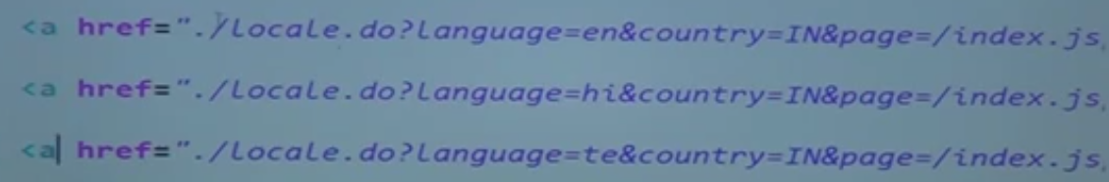
    4. 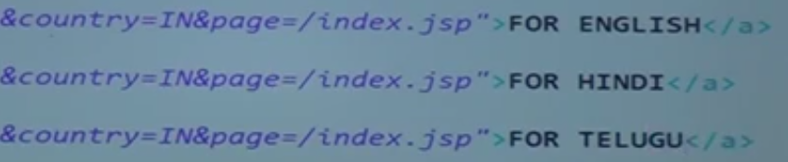
    5. 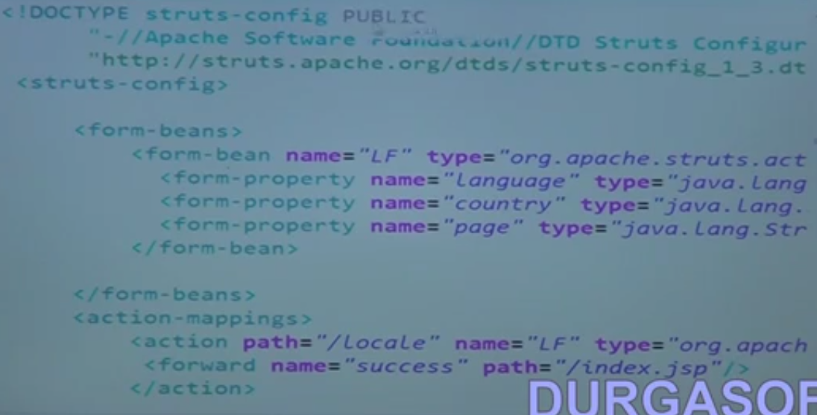
    6. 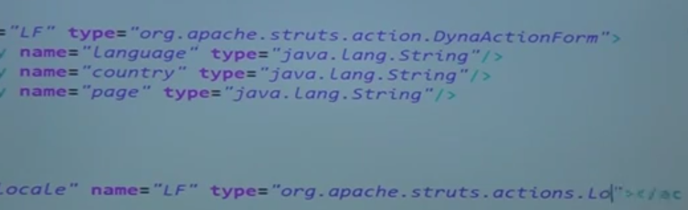
    7. 
    8. Exception handler
42. Struts Frameworks Built in Actions 9
    1. Create a sample dynamic web project
    2. 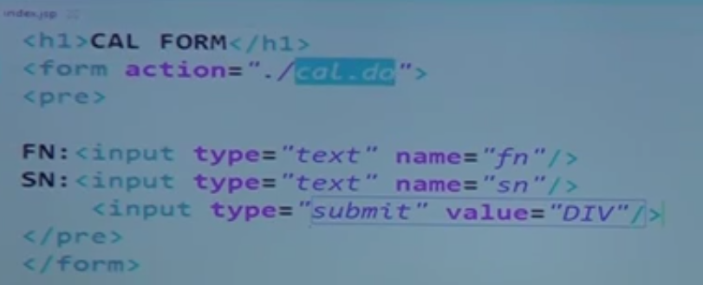
    3. Write a controller extends action
    4. 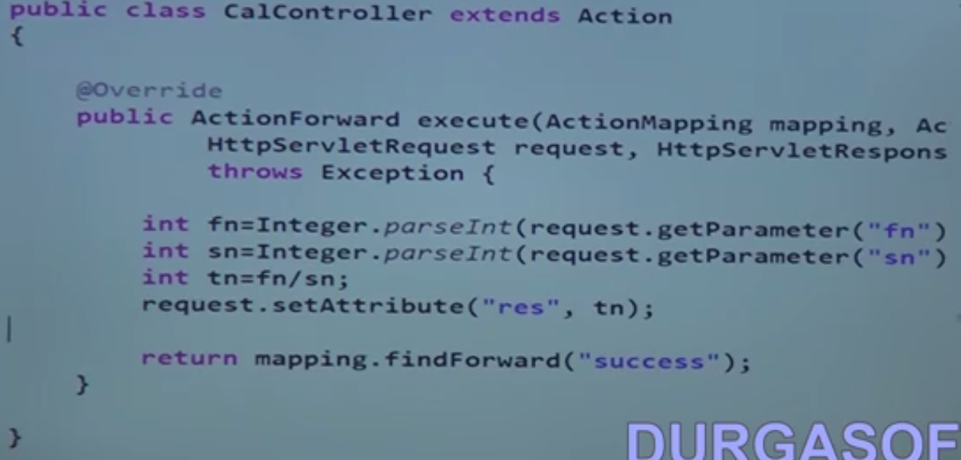
    5. 
    6. 
    7. 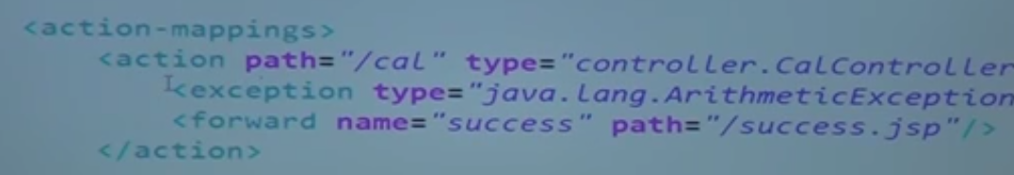
    8. 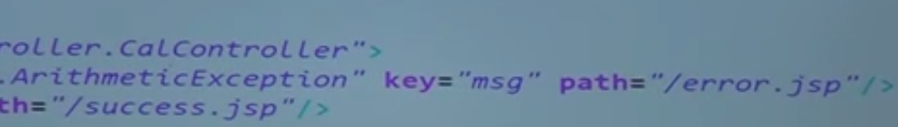
    9. 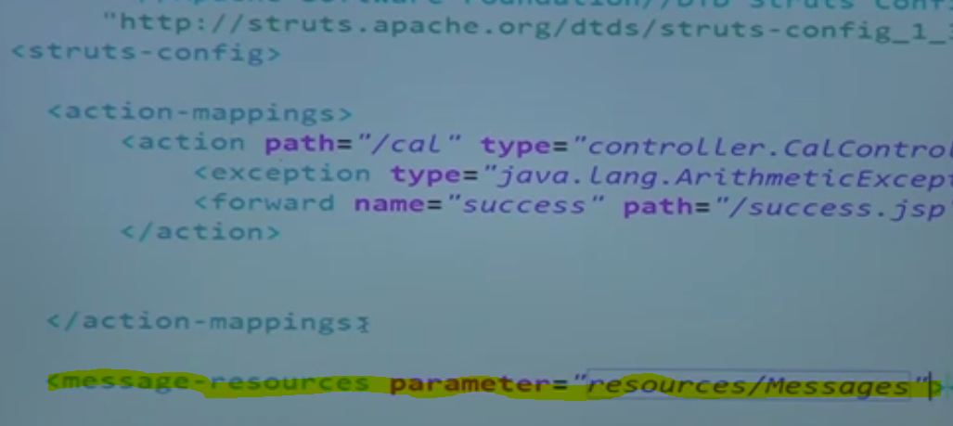
    10. To do user defined exception
    11. 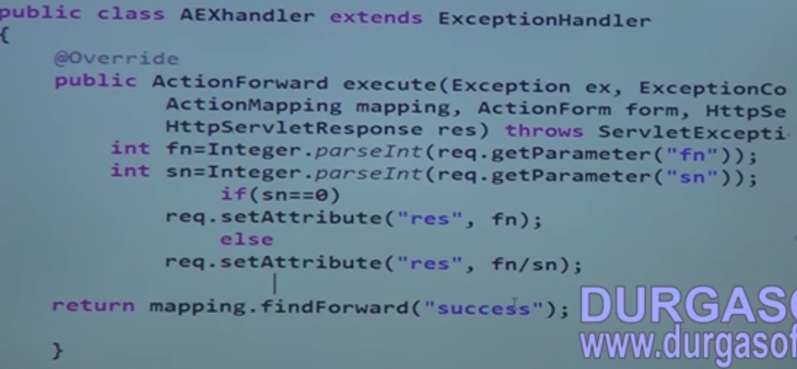
    12. 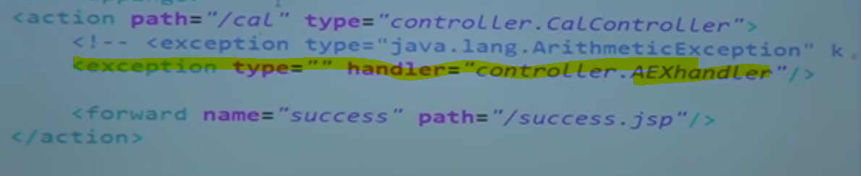
    13. Add type as arithmetic exception and msg attribute to it
43. Struts Frameworks Plug Ins 1
    1. plugins can the following
       1. Integration with other frameworks
       2. Create a sample struts and spring integration application
       3. 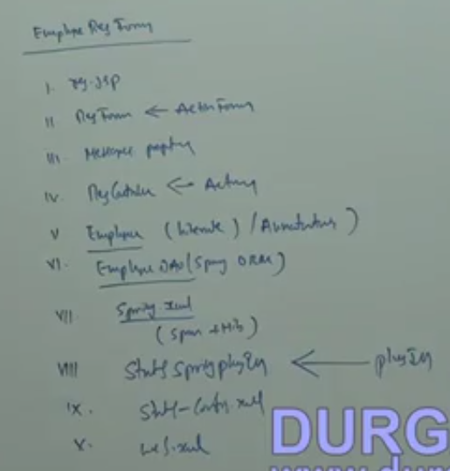
44. Struts Frameworks Plug Ins 2
    1. Create a dynamic web project
    2. Create a model employee class
    3. 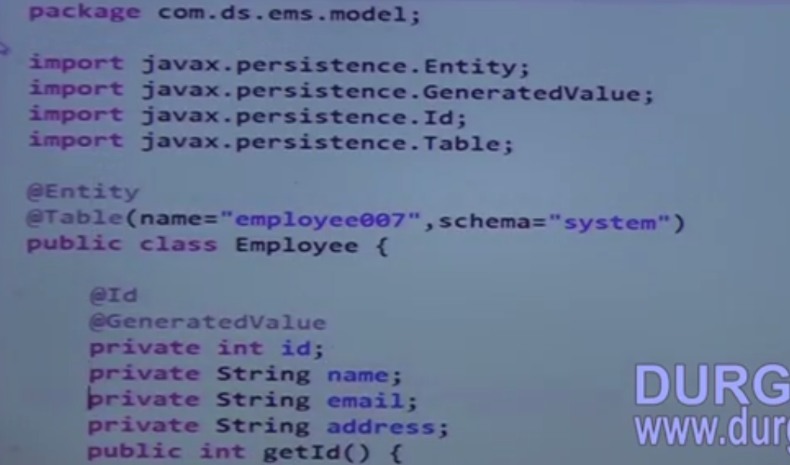
    4. Create a spring.xml file
    5. 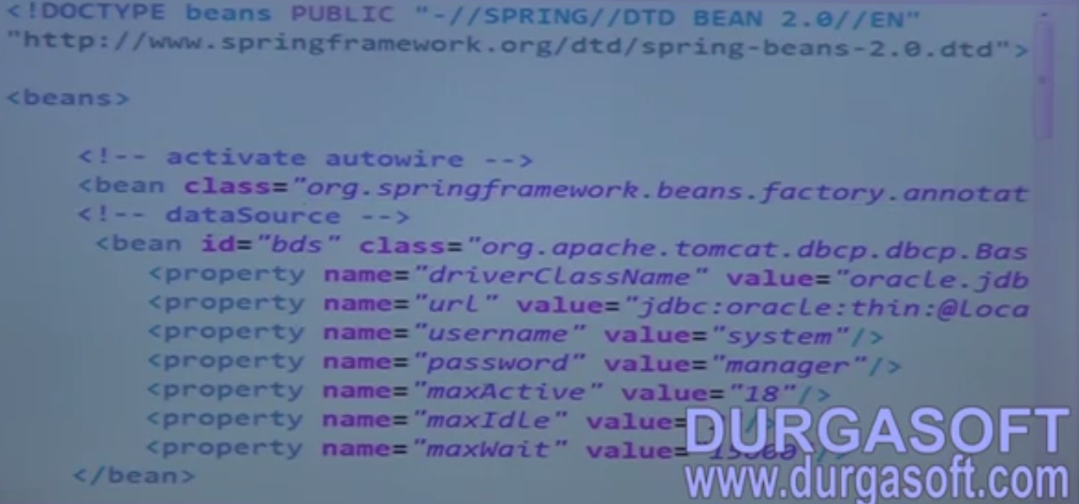
    6. 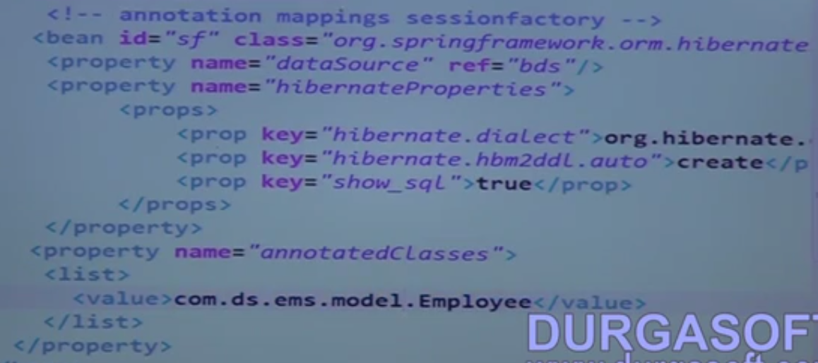
    7. 
    8. Create a Employee DAO class
    9. 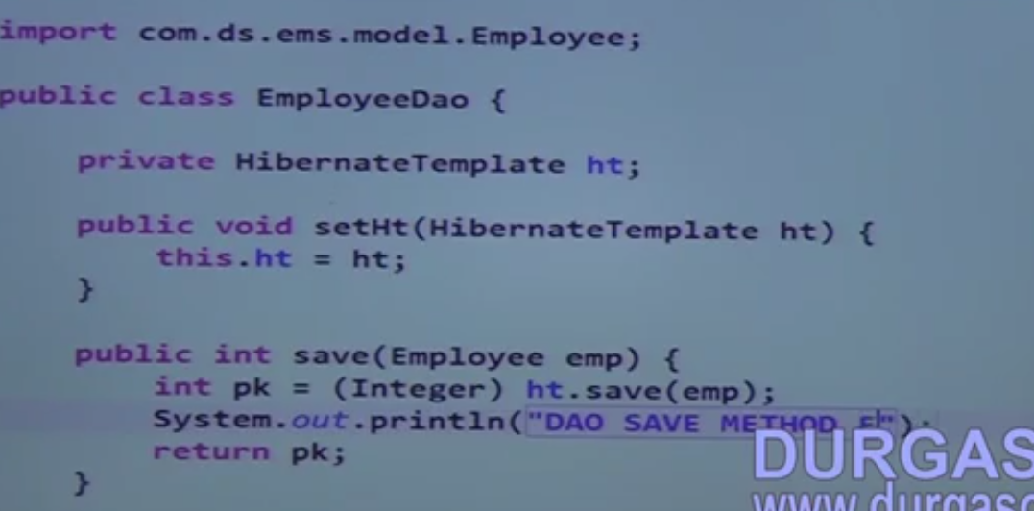
    10. Create a input page
    11. 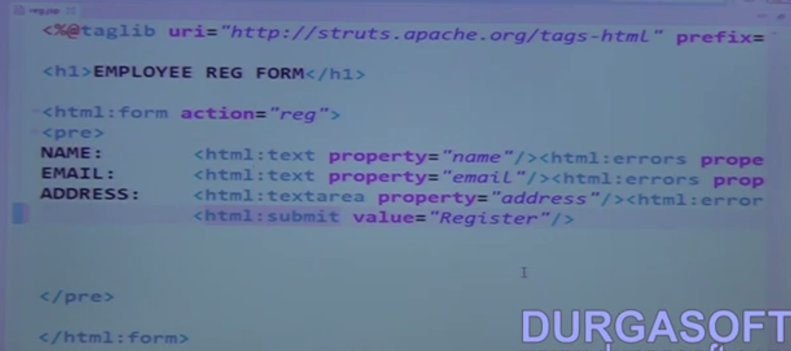
    12. Create Struts-config.xml, Bean class and Controller class
    13. 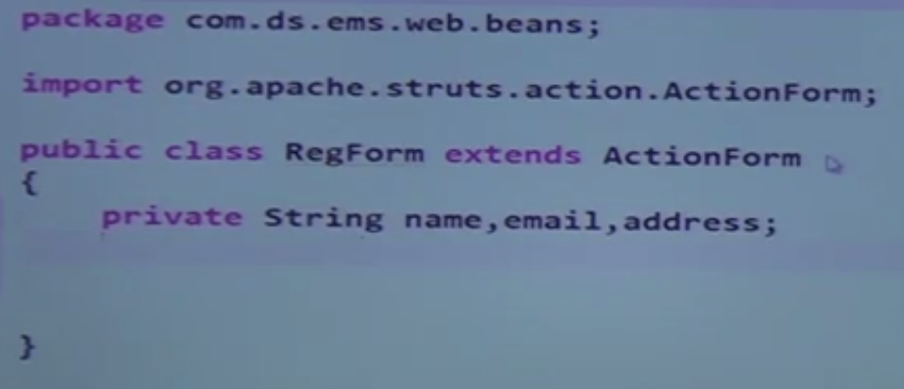
    14. 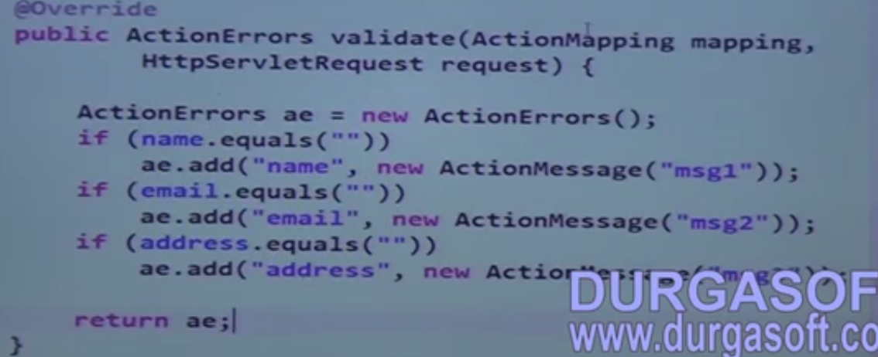
    15. 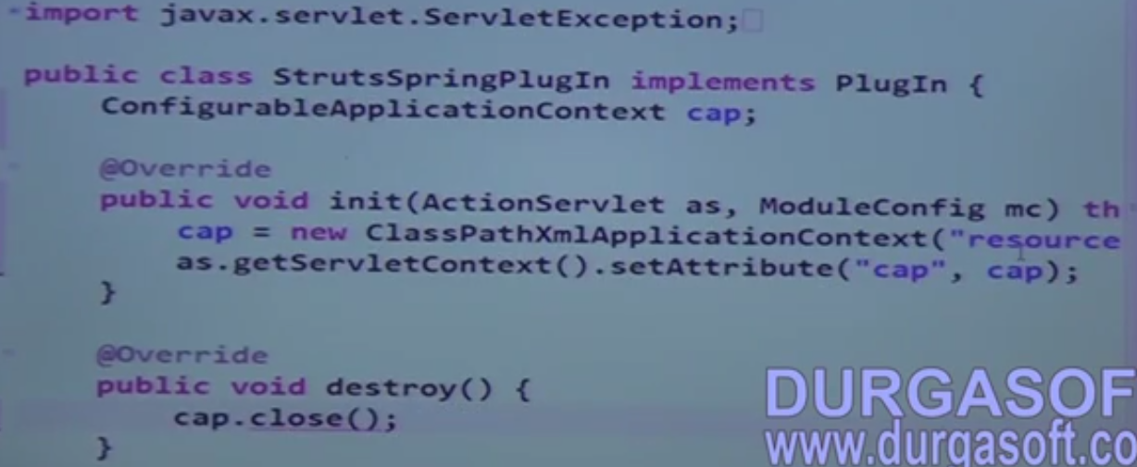
    16. 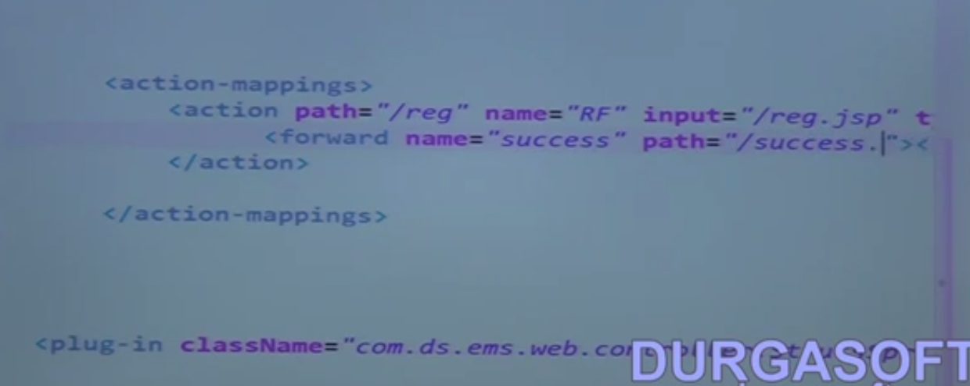
    17. 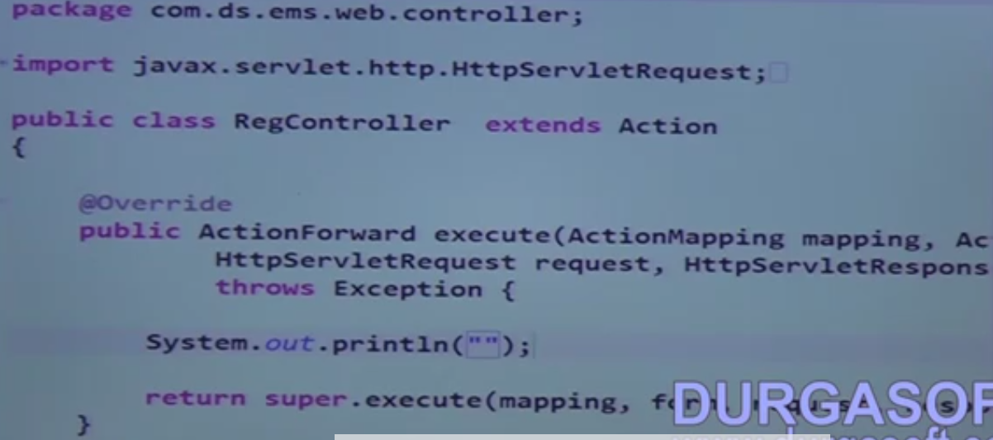
    18. In spring.xml do the following
    19. 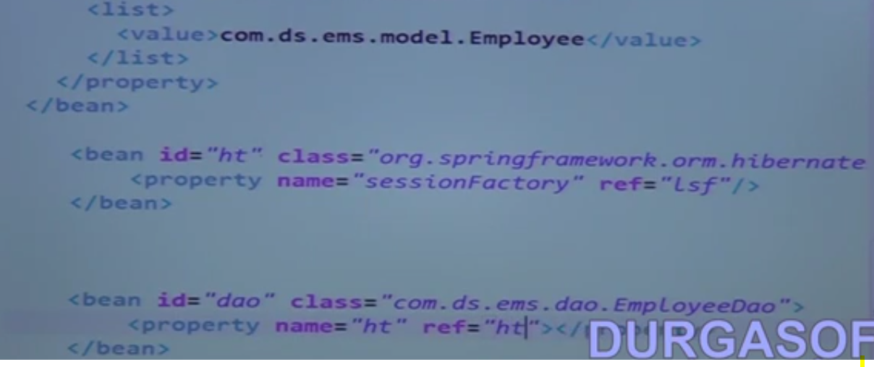
    20. Change the ref from "Lsf" to "sf"
    21. In Reg controller do the following
    22. 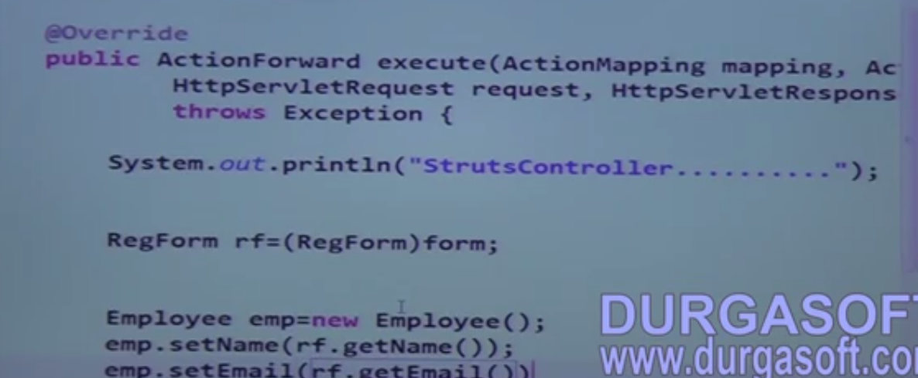
    23. 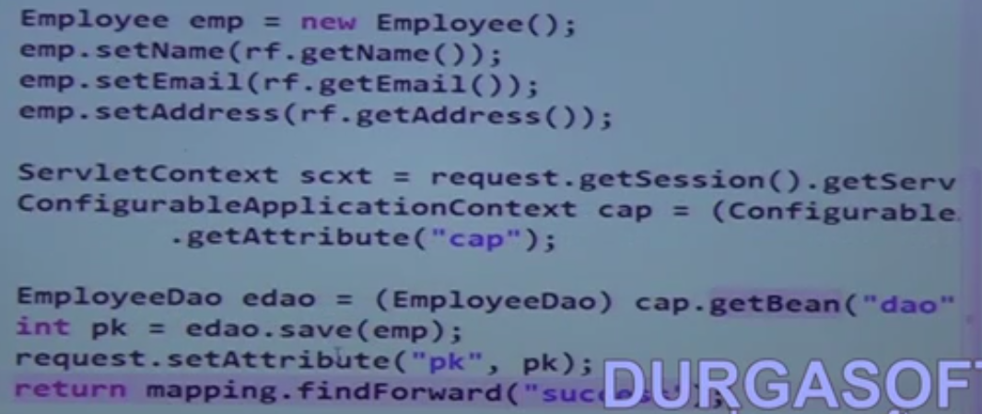
    24. create a message.properties
45. Struts Frameworks Tiles
    1. For designing UI templates
    2. Tiles Architecture
    3. 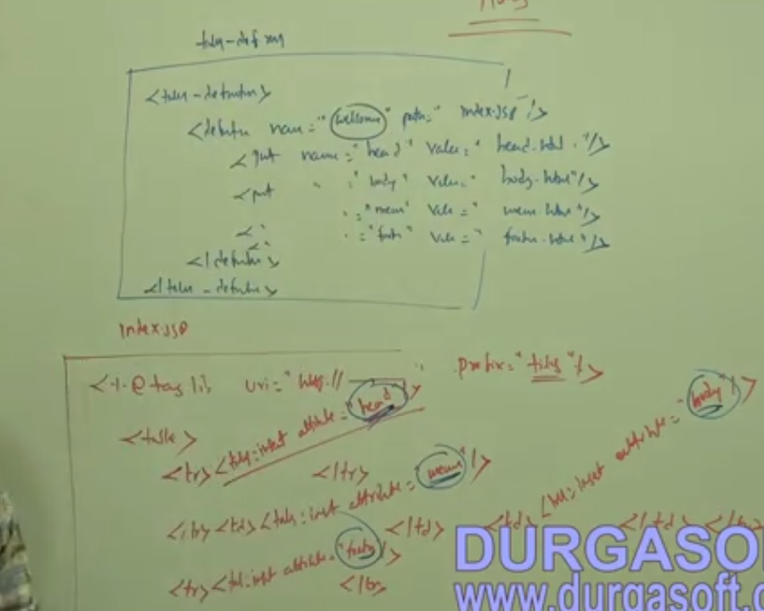
    4. Sample application to do that
    5. 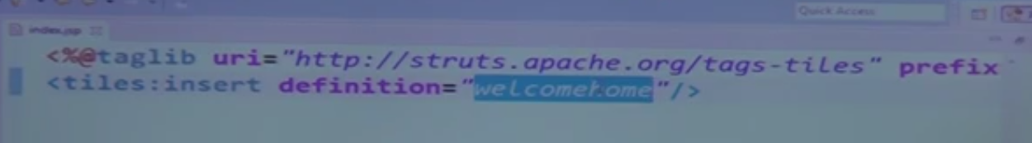
    6. 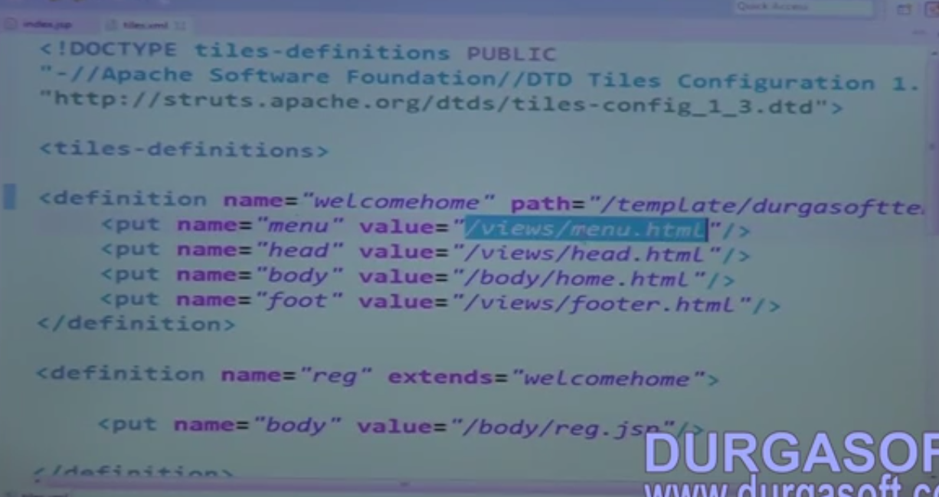
    7. 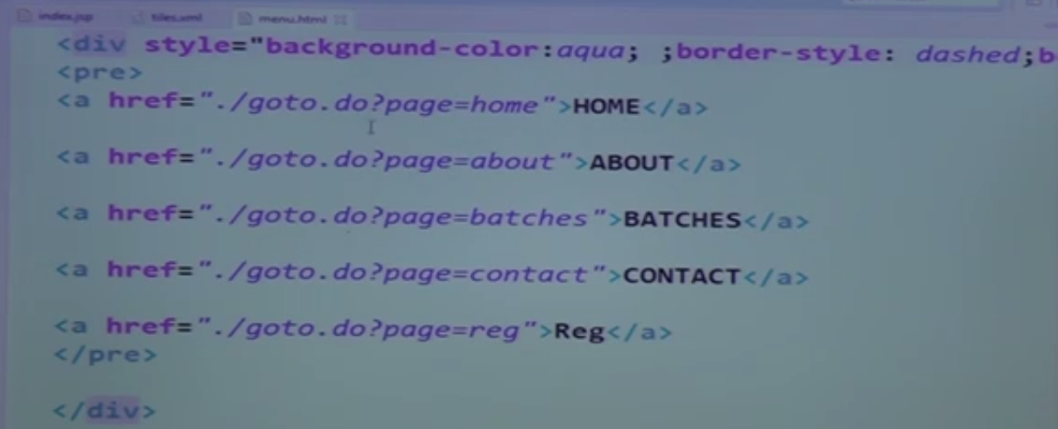
    8. 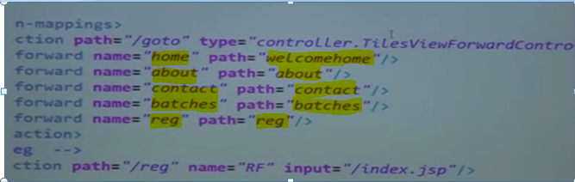
    9. 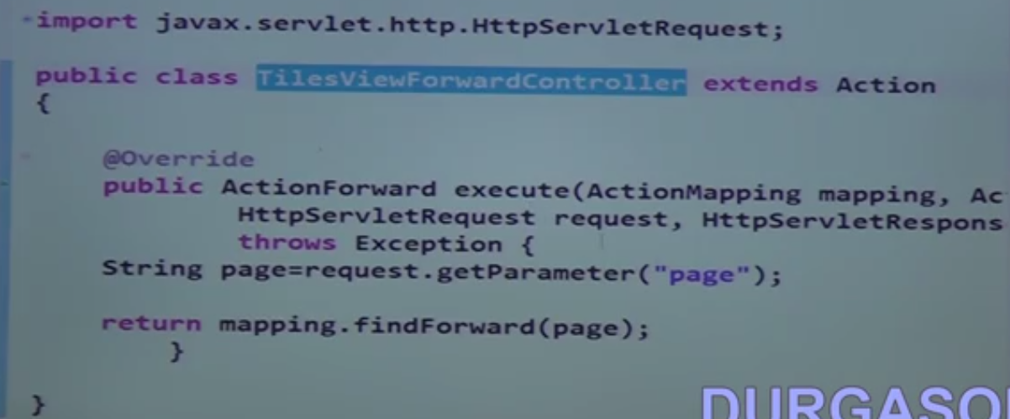
    10. 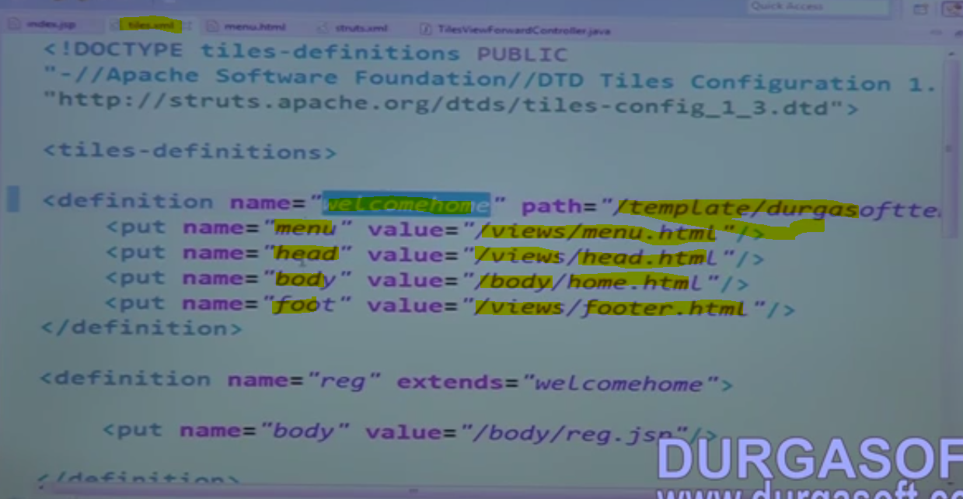
    11. 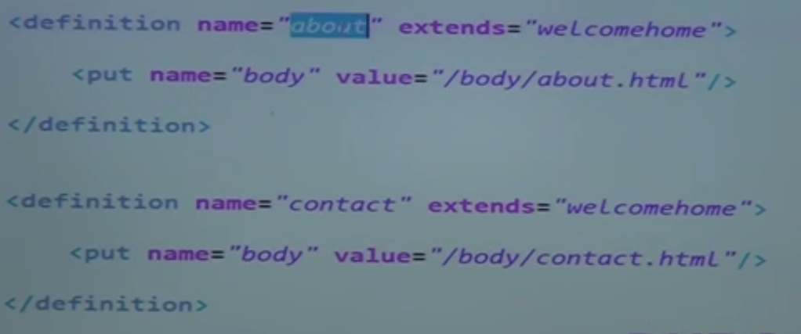
    12. 
    13. 
46. Struts Frameworks Custom Request Processor
    1. Create a Dynamic web project
    2. Create a JSP page
    3. 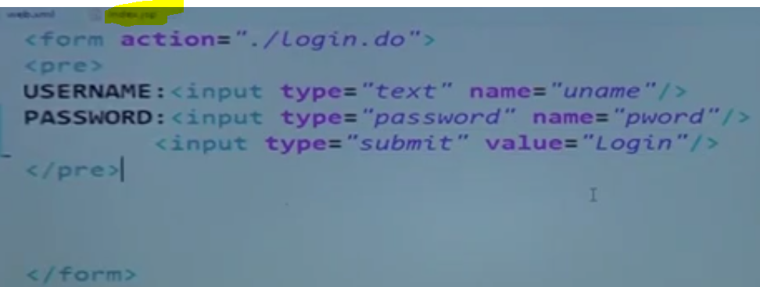
    4. 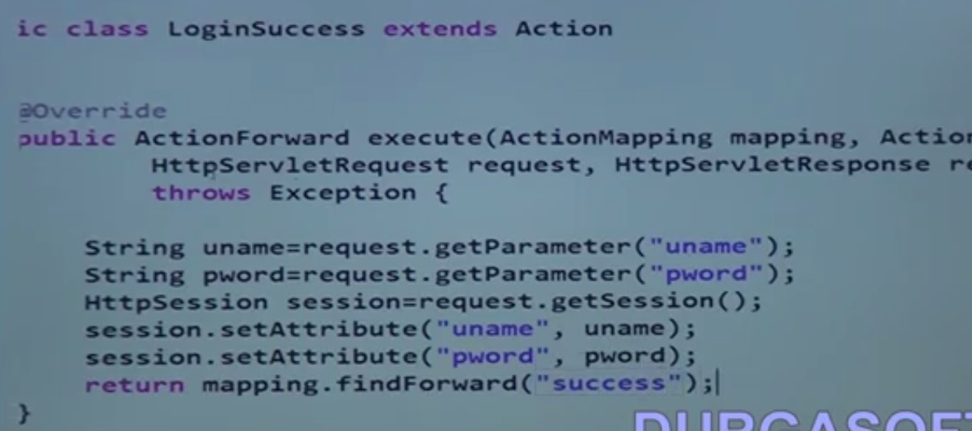
    5. 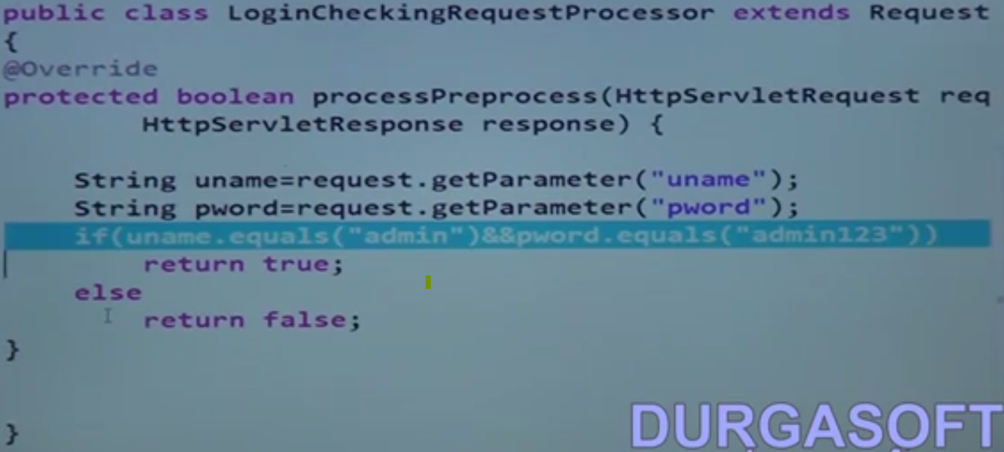
    6. Extend it from request processor
    7. 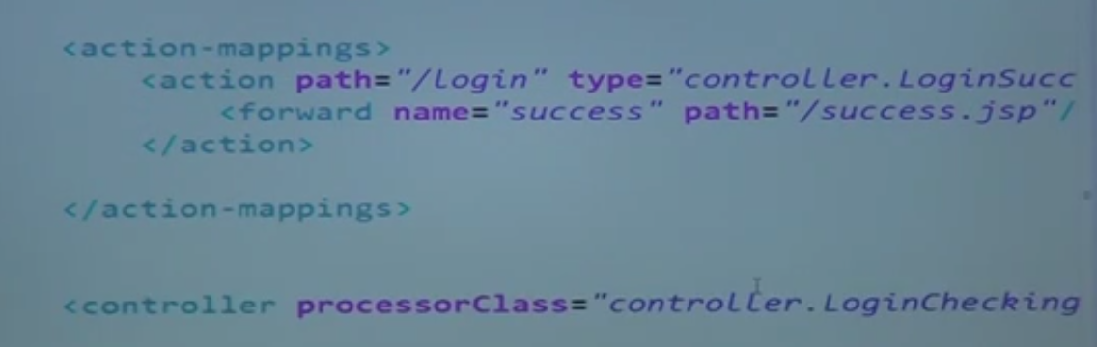
47. Struts Frameworks Struts2 X Part 1
    1. 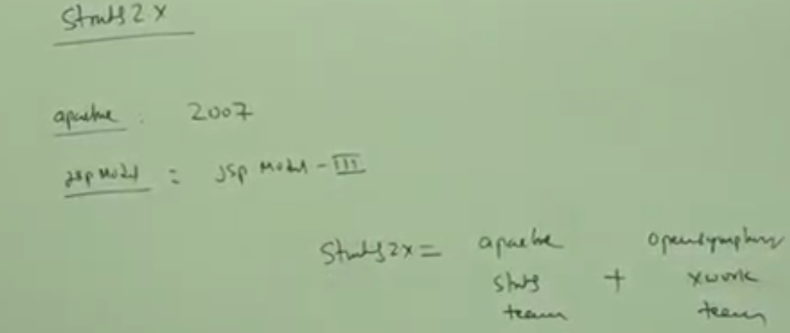
    2. The Filter FilterDispatcher is used for version less than 2.1.3
    3. The filter StrutsPrepareAndExecuteFilter is used in version 2.1.3 and greater
    4. Features:
       1. Form backup support
       2. input validations
       3. Action Support
       4. interceptor
       5. AJAX
       6. OGNL expression support
       7. Tiles Support
       8. Values tags
       9. Pull MVC
    5. Action mapper - transfer the request to action
    6. 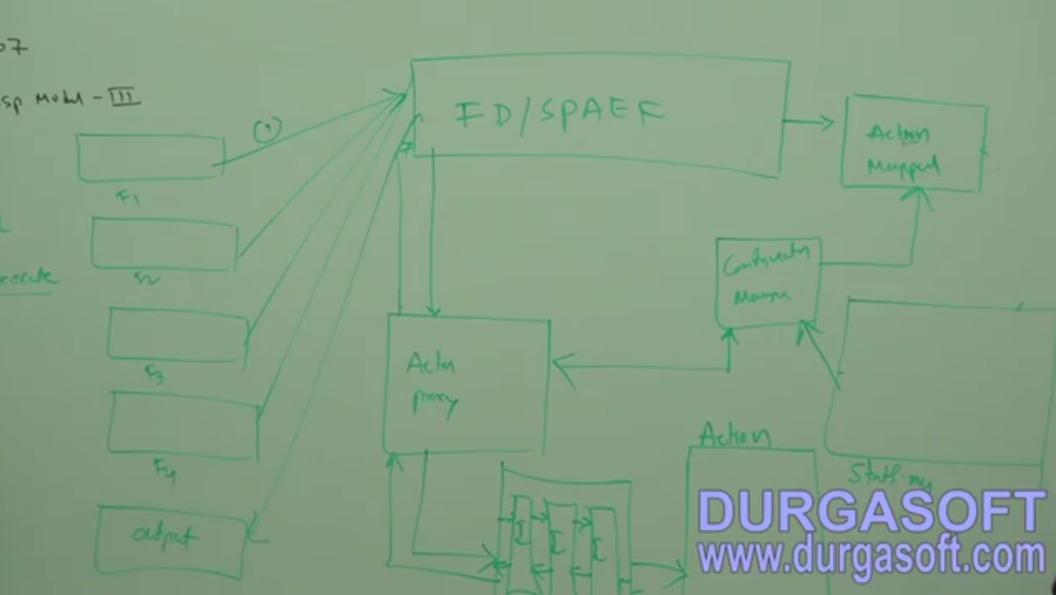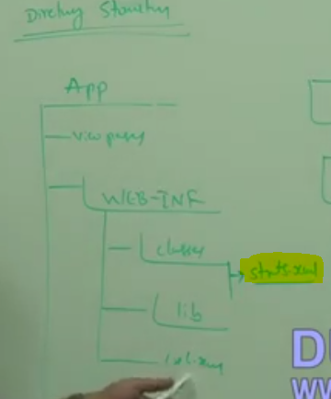
    7. this is the default recommended location
48. Struts Frameworks Struts2 X Part 2
    1. Sample Hello world
49. Struts Frameworks Struts2 X Part 3
    1. Three ways of doing validation
       1. Using validate method
       2. using XML
       3. Using annotations
50. Struts Frameworks Struts2 X Part 3
    1. This example is done using MyEclipse
    2. 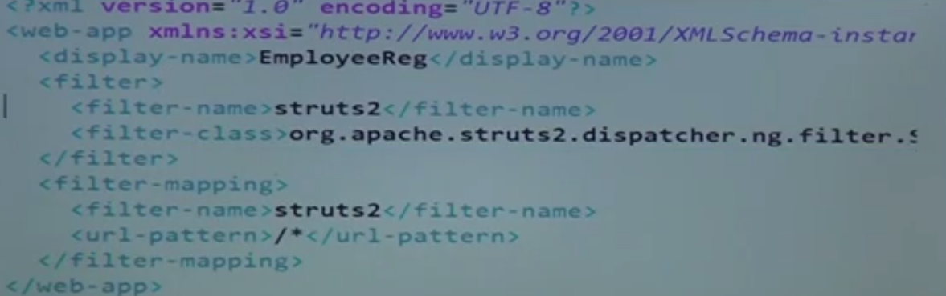
    3. 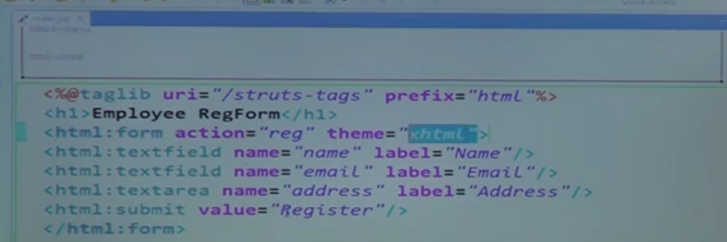
    4. 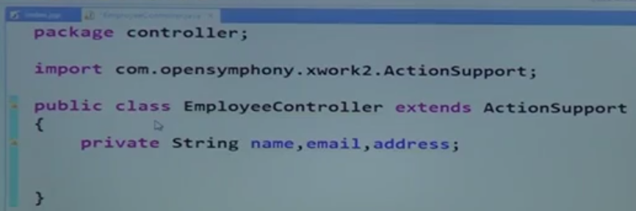
    5. 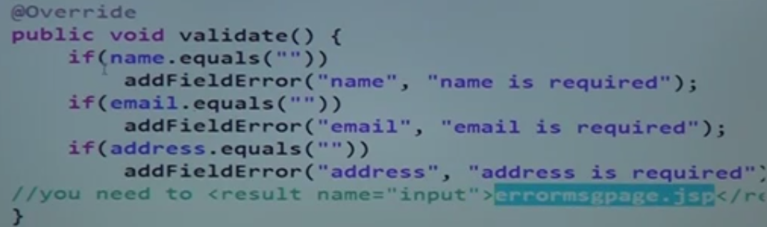
    6. 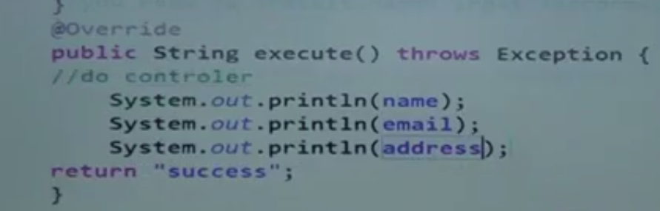
    7. Extends Struts-default
    8. 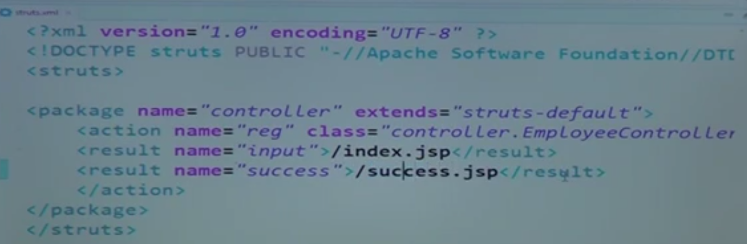
    9. 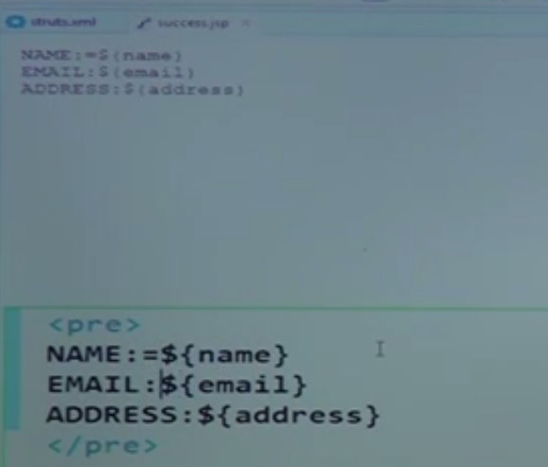
    10. But we need to configure the messages in properties file
    11. 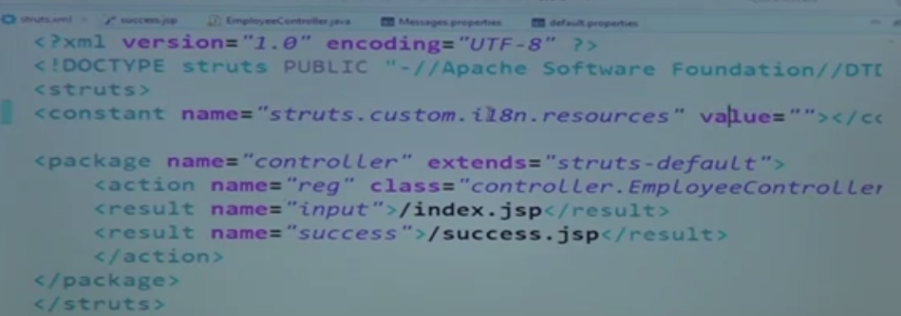
    12. 
51. Struts Frameworks Struts2 X Part 5
    1. Validation thru annotations
    2. 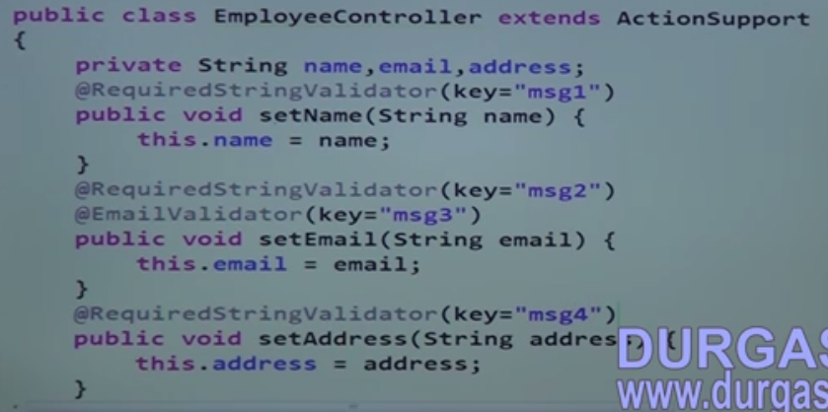
    3. Using XML File
    4. 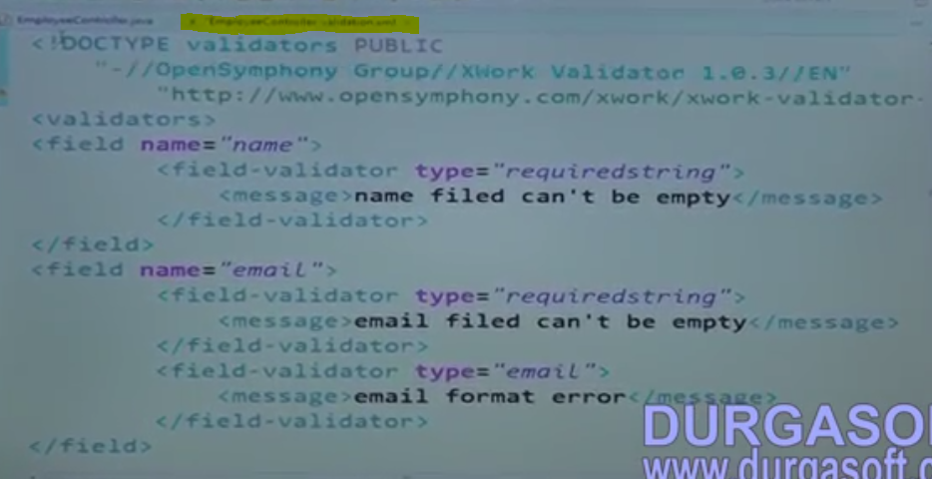
    5. 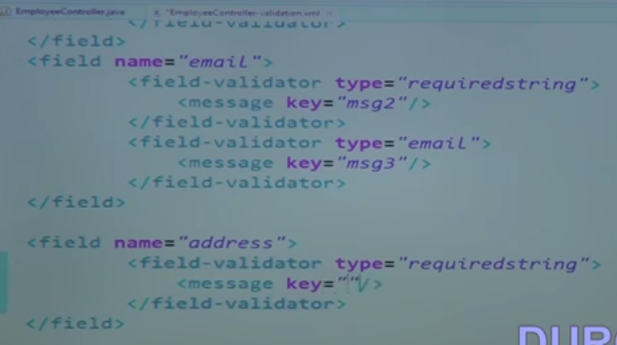
52. Struts Framework Struts2 X Part 6
    1. Controllers
       1. Single Action
       2. MultiButton Action
53. Struts Framework Struts2 X Part 7
    1. Sample calculator using Action support
    2. 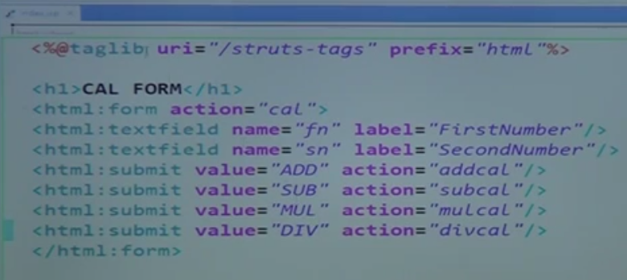
    3. 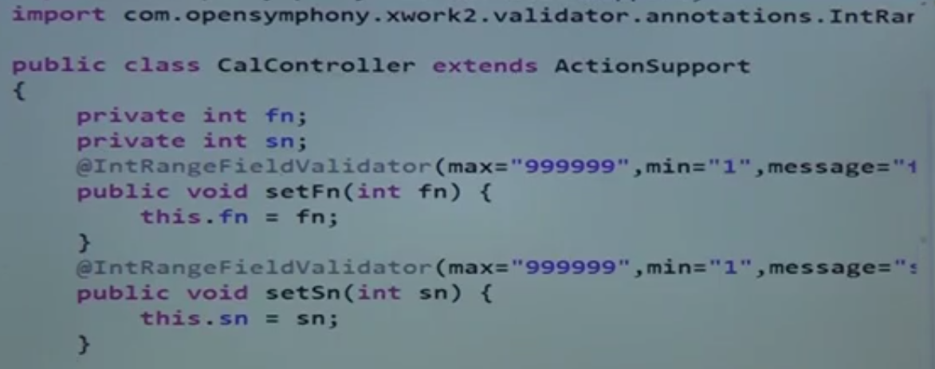
    4. 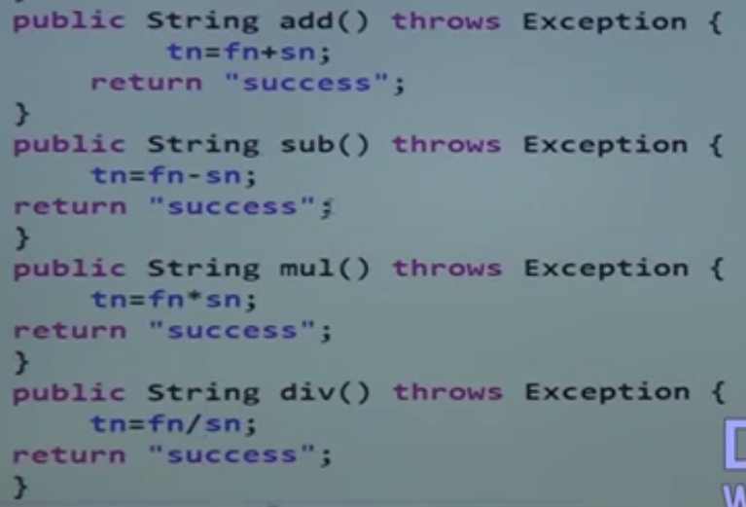
    5. 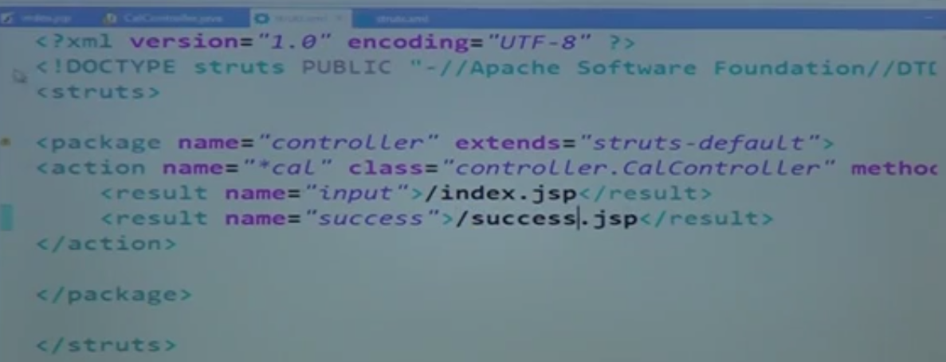
    6. 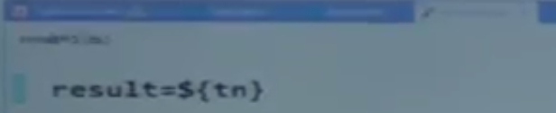
    7. AJAX Tags
    8. 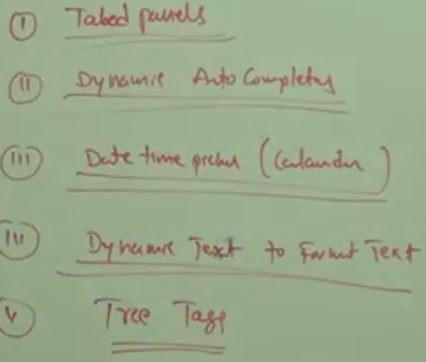
    9. Creating a sample application using AJax having three links and load the relevant page on clicking the link without refreshing the page.
54. Struts Framework Struts2 X Part 8
    1. create a new dynamic web site adding struts 2 jars
    2. 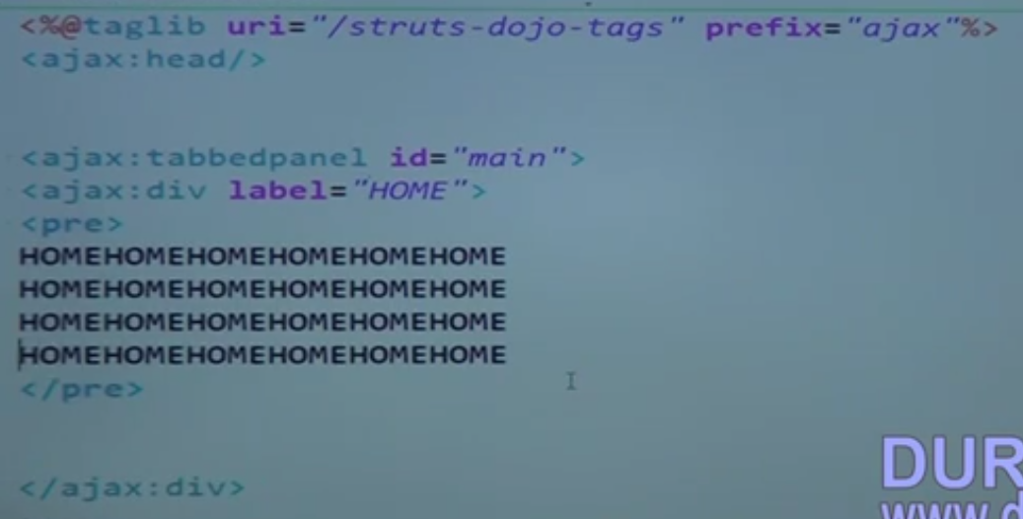
    3. 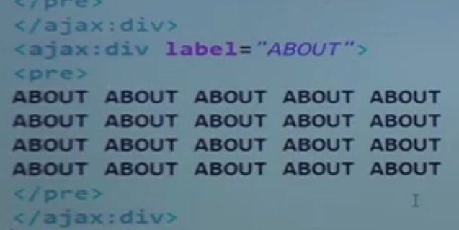
    4. 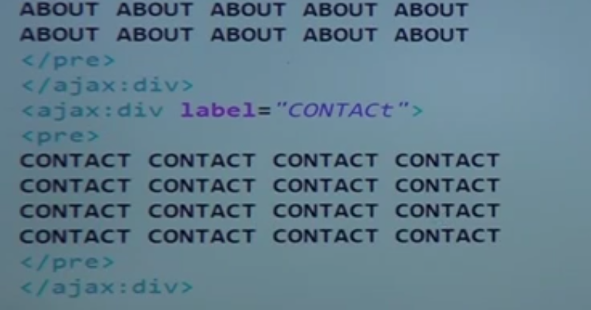
    5. Java script need to be enabled to perform this activity
    6. 
    7. The above two tags will allow the tabs to close the tabs
    8. Autocompleter tags
    9. 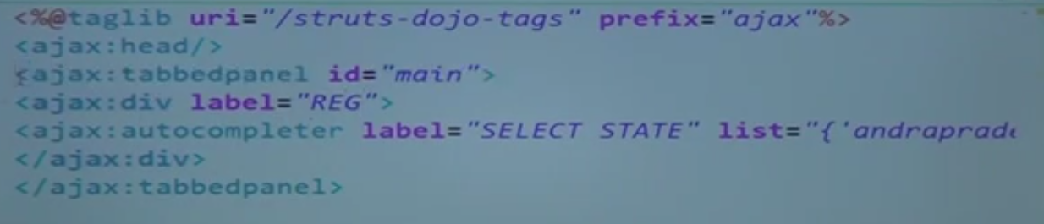
    10. 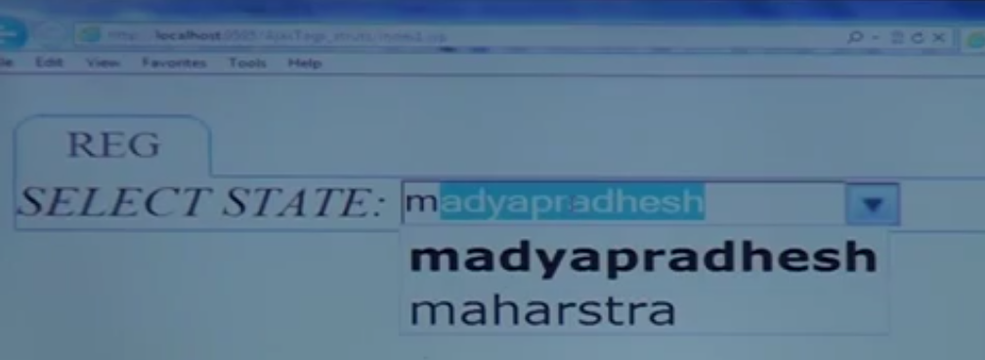
    11. DateTimeicker
    12. 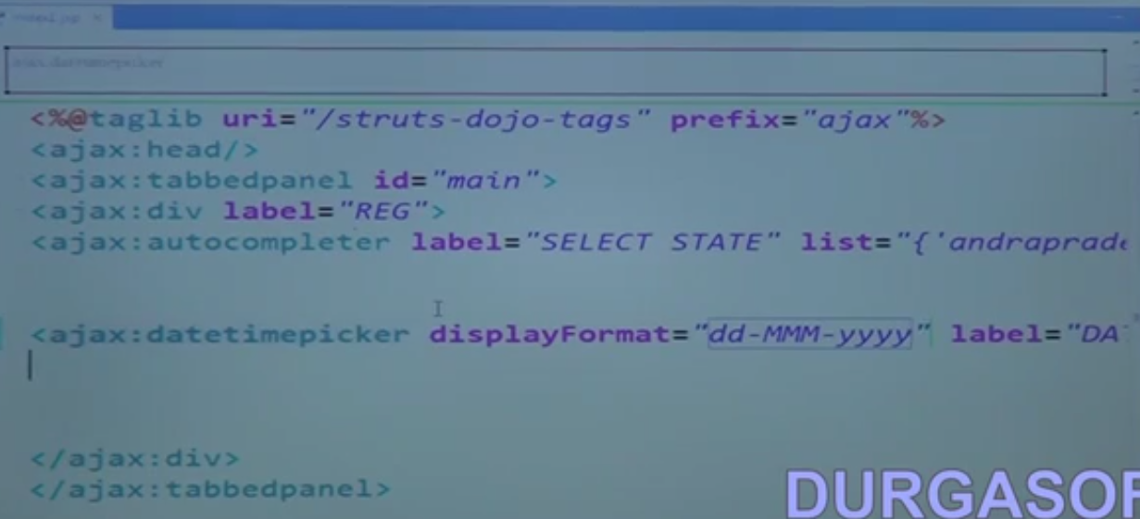
    13. Ajax text area
    14. 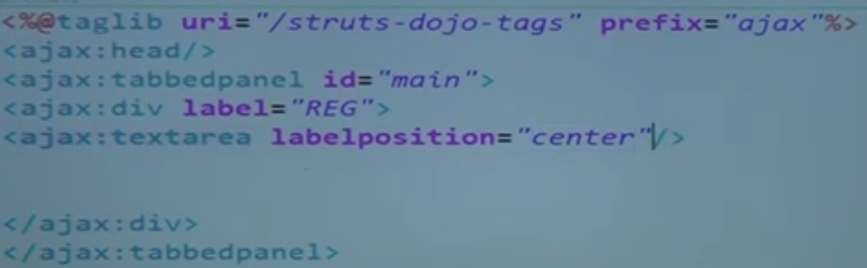
    15. 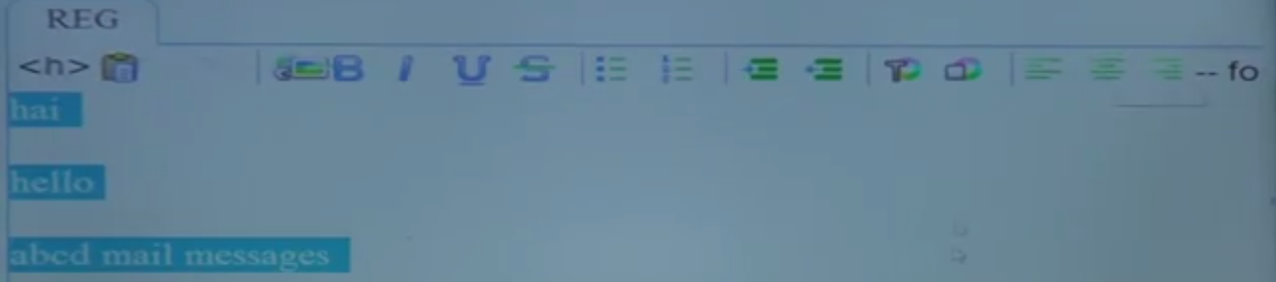
    16. Ajax tree
    17. 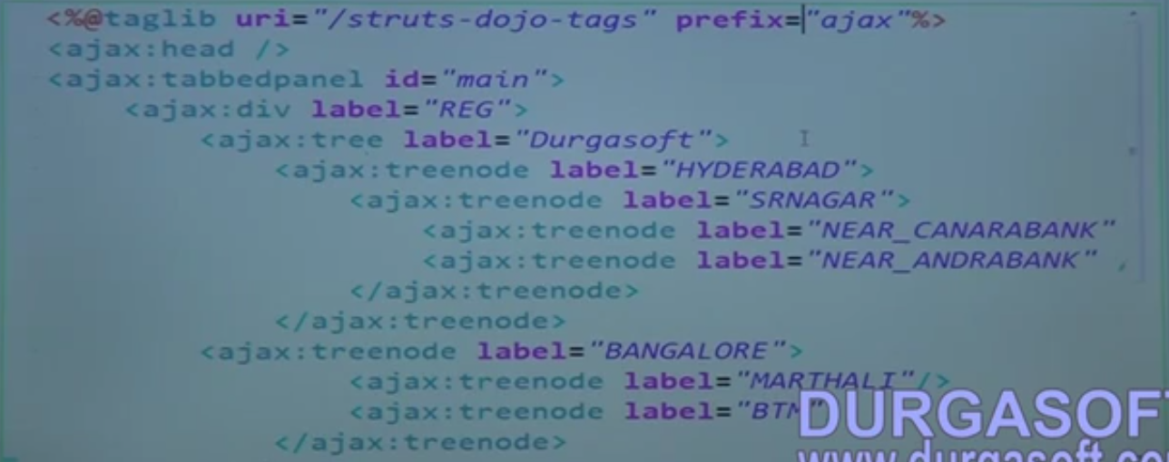
    18. 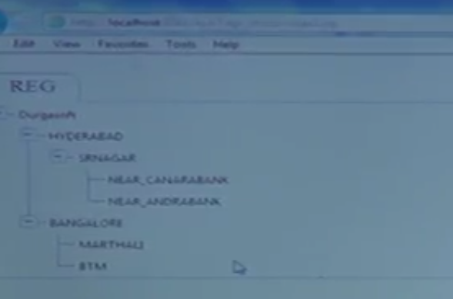
55. Struts Framework Struts2 X Part 9
    1. OGNL
    2. We can read request, session, context, class instance, value stack
    3. 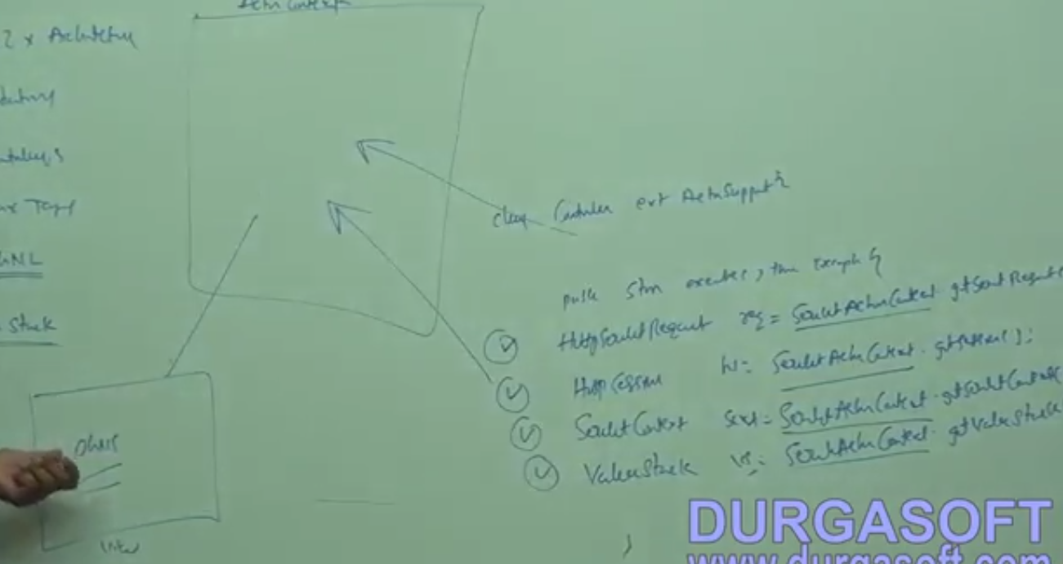
56. Struts Framework Struts2 X Part 10
    1. 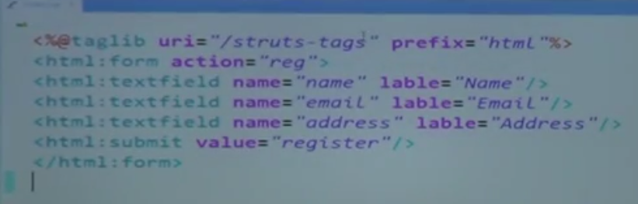
    2. 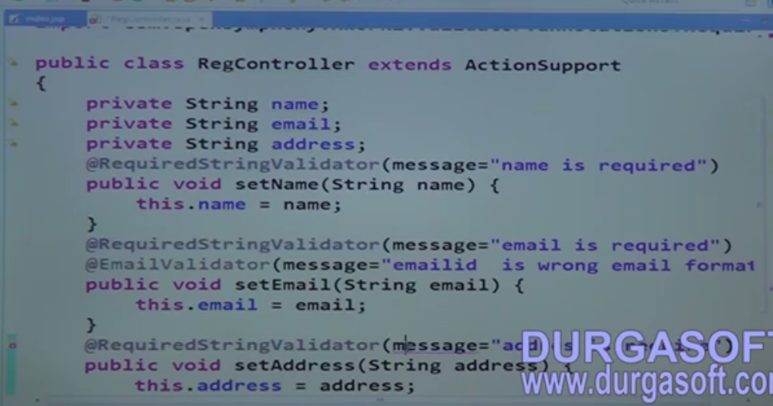
    3. 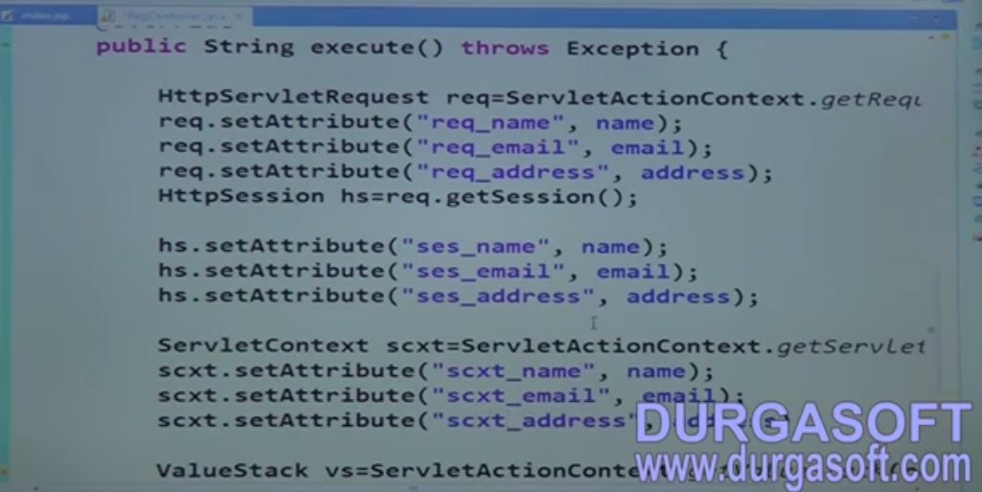
    4. 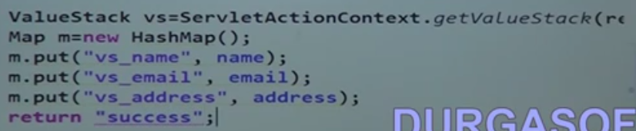
    5. 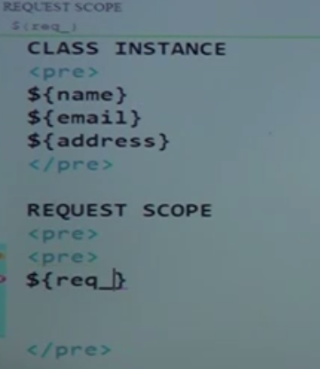 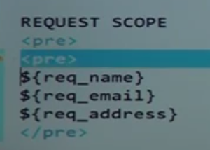
    6. 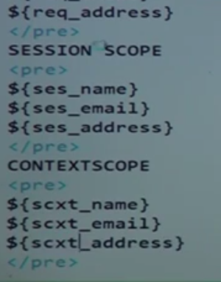 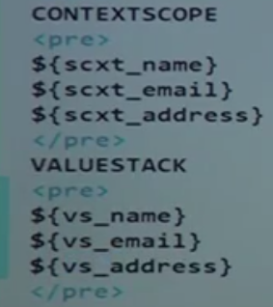
    7. 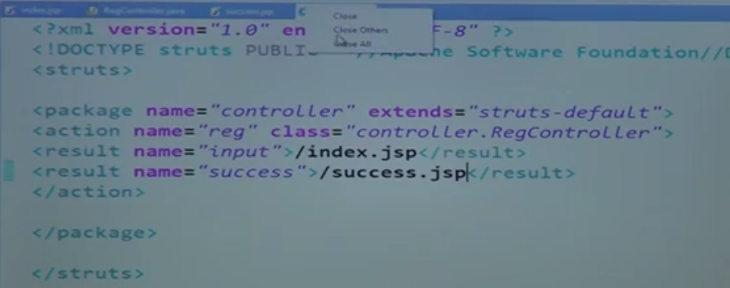
    8. 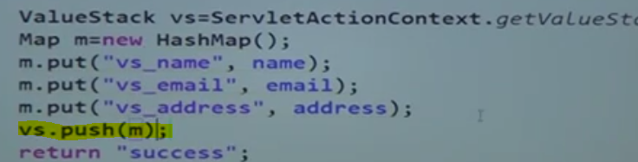
57. Struts Framework Struts2 X Part 11
    1. Exception handling
    2. 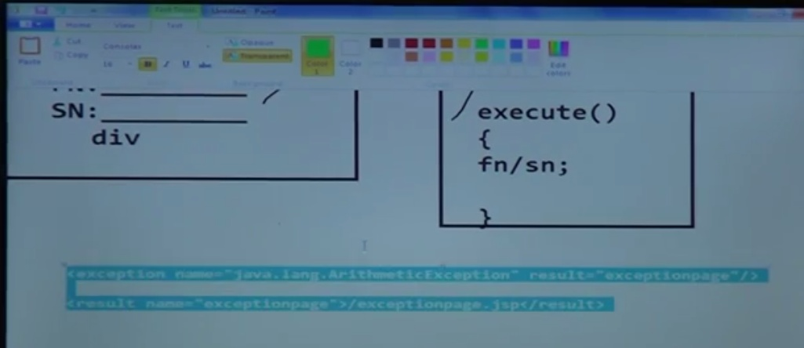
    3. 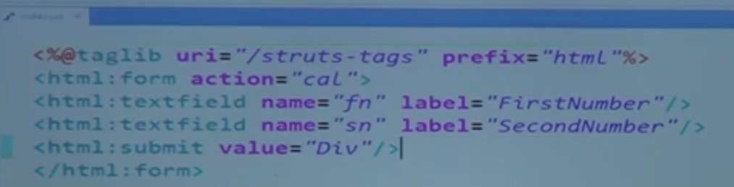
    4. 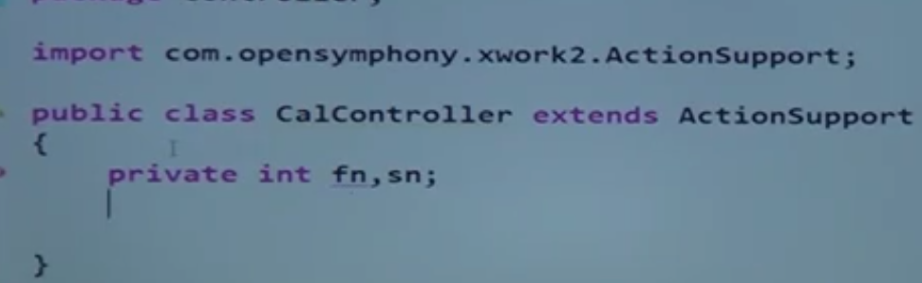
    5. 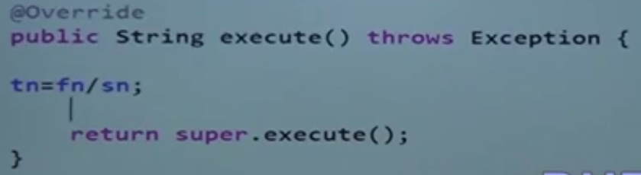
58. Struts Framework Struts2 X Part 12
    1. Interceptor
    2. 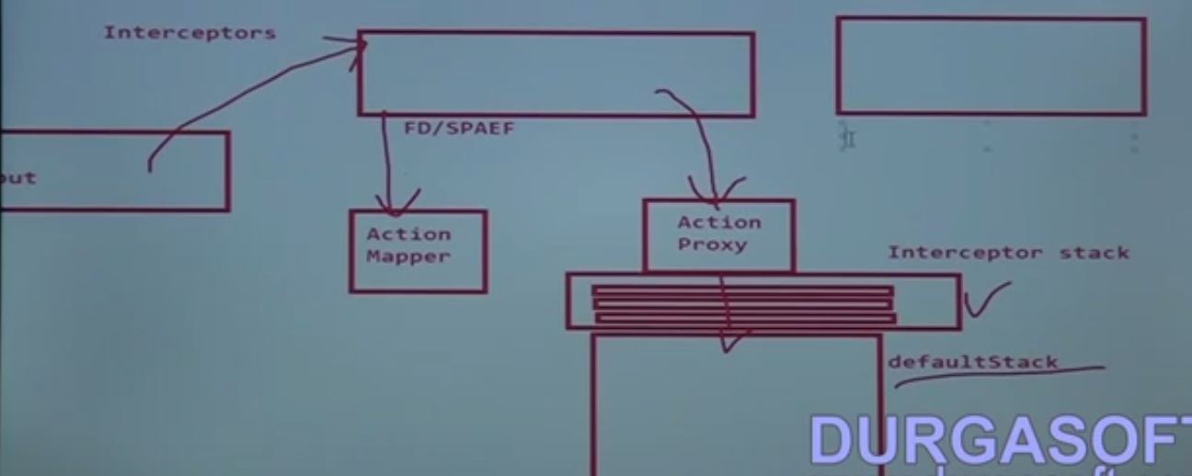
    3. Sample application
    4. 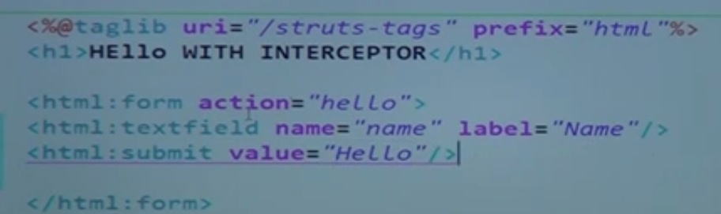
    5. 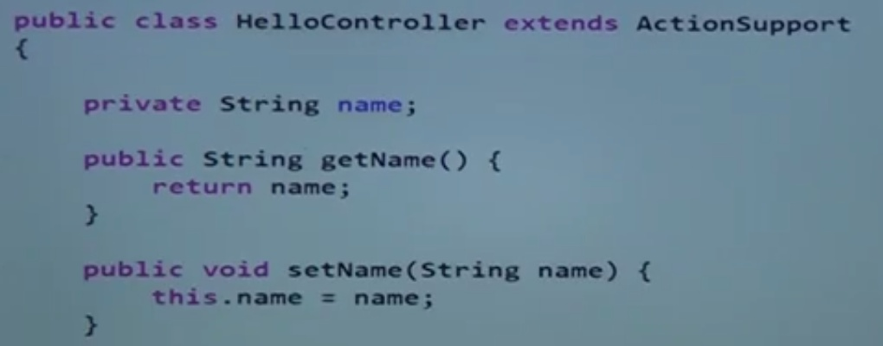
    6. 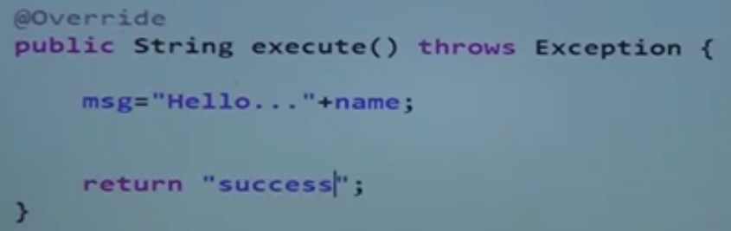
    7. 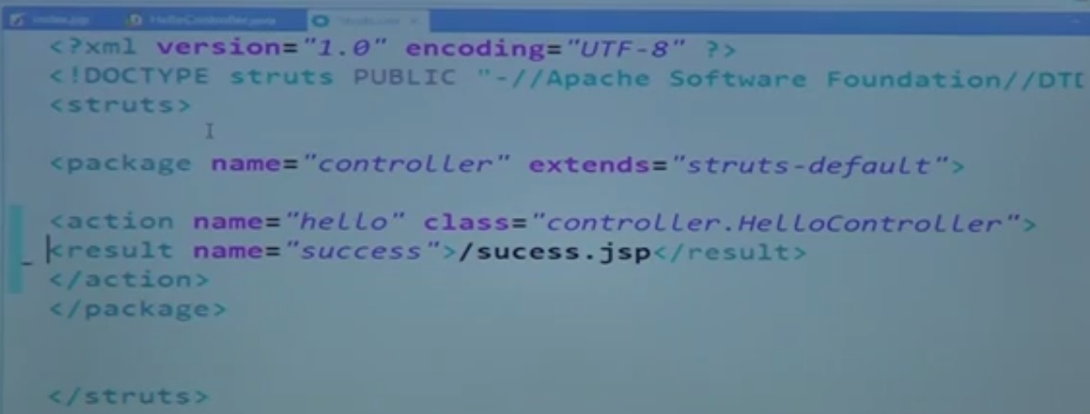
    8. 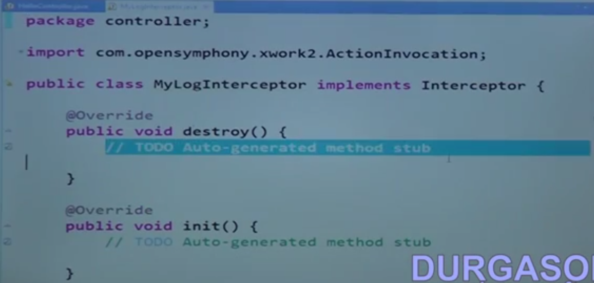
    9. 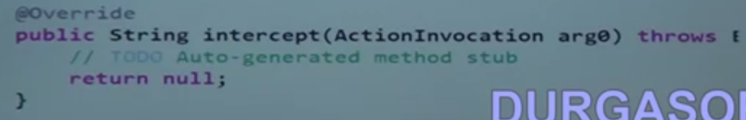
    10. 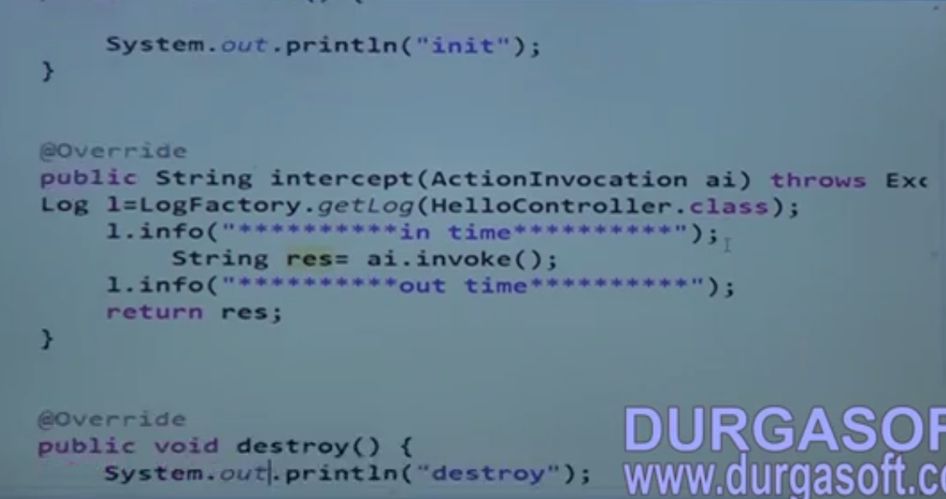
    11. 